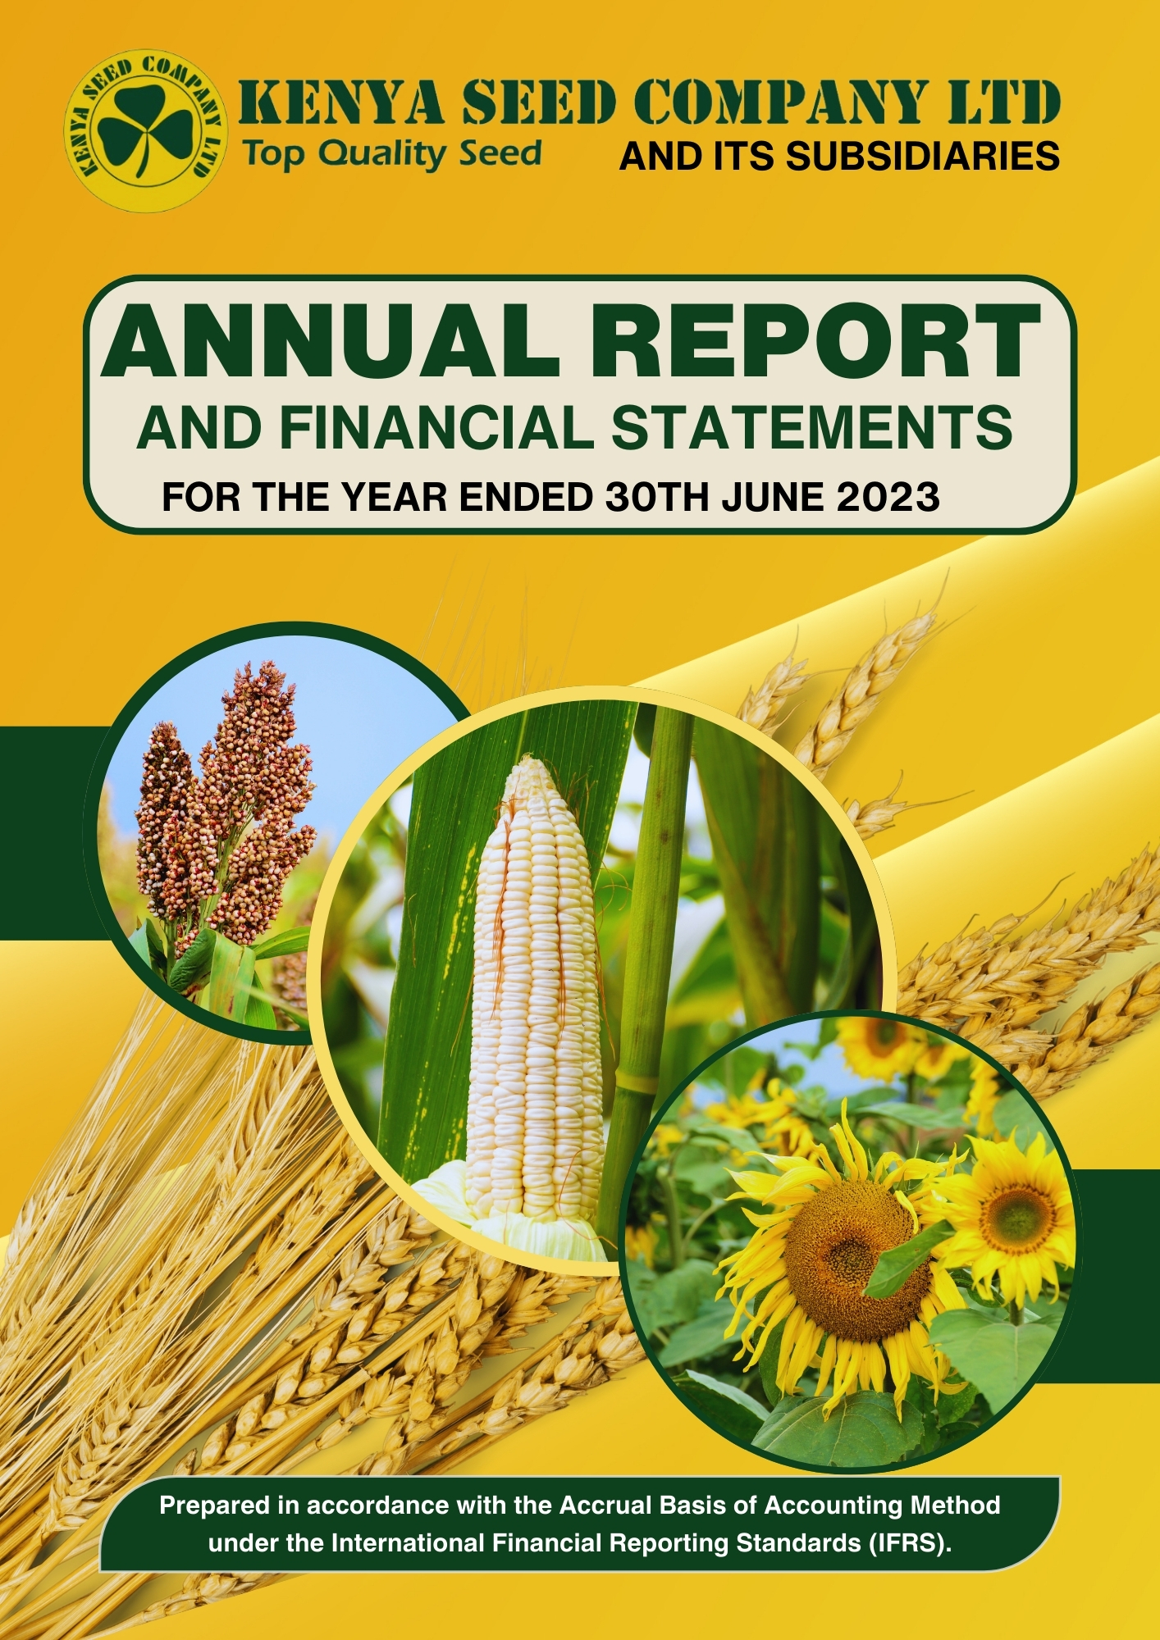

table of contents

**Contents**

KEY ENTITY INFORMATION iv

OUR BOARD OF DIRECTORS xvi

OUR MANAGEMENT TEAM xix

CHAIRMAN’S STATEMENT xxiv

CEO’S STATEMENT xxvi

CORPORATE GOVERNANCE STATEMENT xxxii

MANAGEMENT DISCUSSION AND ANALYSIS xxxix

ENVIRONMENTAL AND SUSTAINABILITY REPORTING l

REPORT OF THE DIRECTORS lxi

STATEMENT OF DIRECTORS’ RESPONSIBILITIES lxii

REPORT OF THE AUDITOR GENERAL ON KENYA SEED COMPANY LTD & IT’S SUBSIDIARIES lxiii

STATEMENT OF PROFIT OR LOSS AND OTHER COMPREHENSIVE INCOME FOR THE YEAR ENDED 30 JUNE 2023. 1

STATEMENT OF FINANCIAL POSITION 2

STATEMENT OF CHANGES IN EQUITY FOR THE YEAR ENDED 30 JUNE 2023. 4

STATEMENT OF CASH FLOWS FOR THE YEAR ENDED 30 JUNE 2023. 6

STATEMENT OF COMPARISON OF BUDGET AND ACTUAL AMOUNTS FOR THE YEAR ENDED 30 JUNE 2023 7

APPENDIX I: PROGRESS ON FOLLOW UP OF AUDITOR RECOMMENDATIONS 66

# 

# CROPS/ ACTIVITY PHOTOS

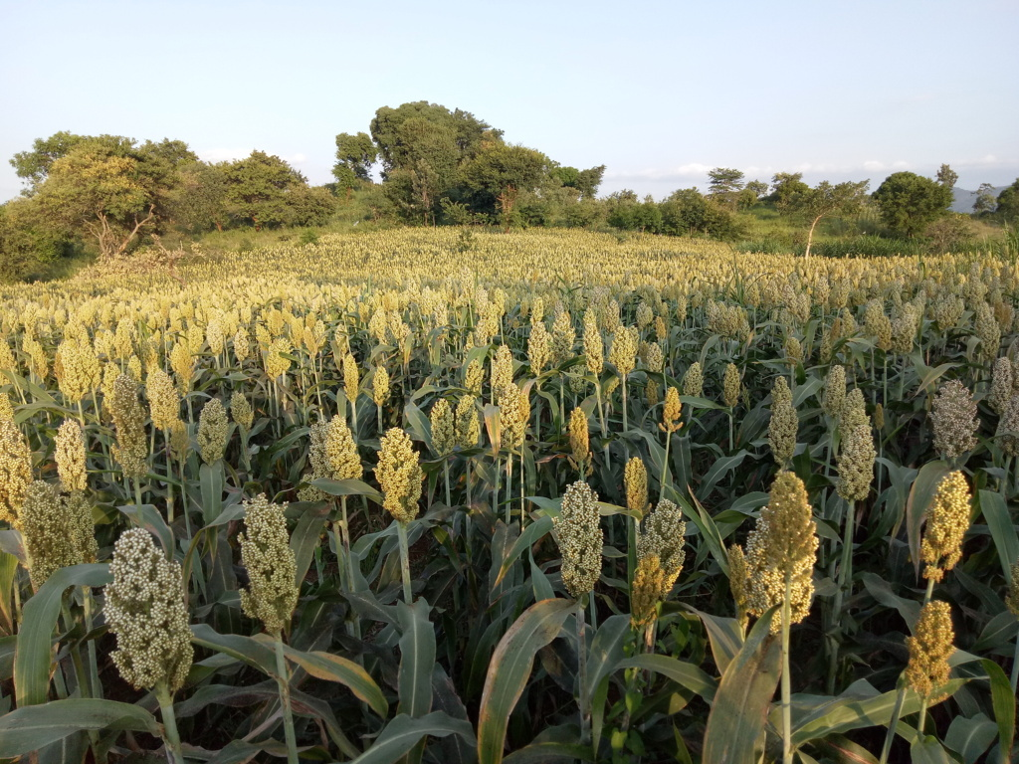

Sorghum Dryland Seed

.

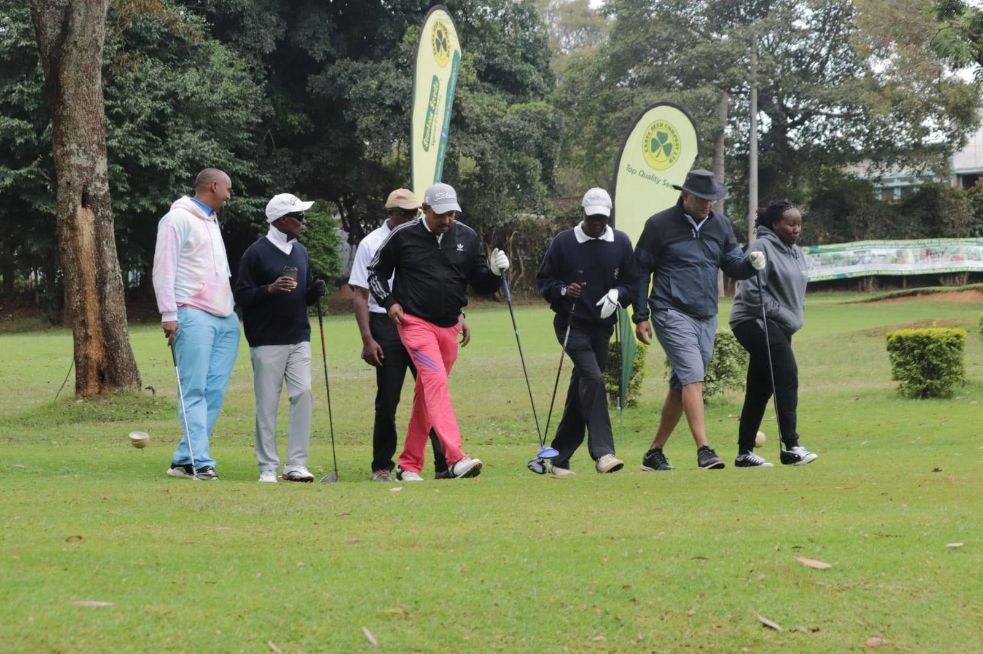

*Enhancing relationship with stakeholders*

# KEY ENTITY INFORMATION

**Background Information**

Kenya Seed Company Limited is a State Corporation by virtue of majority shareholding by Government through Agricultural Development Corporation (ADC) at 52.88% shareholding. Established under the Companies’ Act, Cap 486 of the Laws of Kenya and is governed by the State Corporations Act Cap 446, the PFM Act 2012 and other relevant legislation. At the Cabinet level the Company is represented by the Cabinet Secretary for Ministry of Agriculture, Livestock, Fisheries and Irrigation, who is responsible for the general policy and strategic direction of the Company.

The Company was incorporated in Kenya on 2nd July 1956 to produce and market high quality certified seeds. The Company is domiciled in Trans Nzoia County, Kenya and has established various branches in Kenya to serve the farmers. As an expansion strategy into Eastern Africa market, the Company has incorporated subsidiaries namely Simlaw Seeds Kenya, Kibo Seed Tanzania, Simlaw Seeds Uganda and Kenya Seed Rwanda.

**Where we operate:**

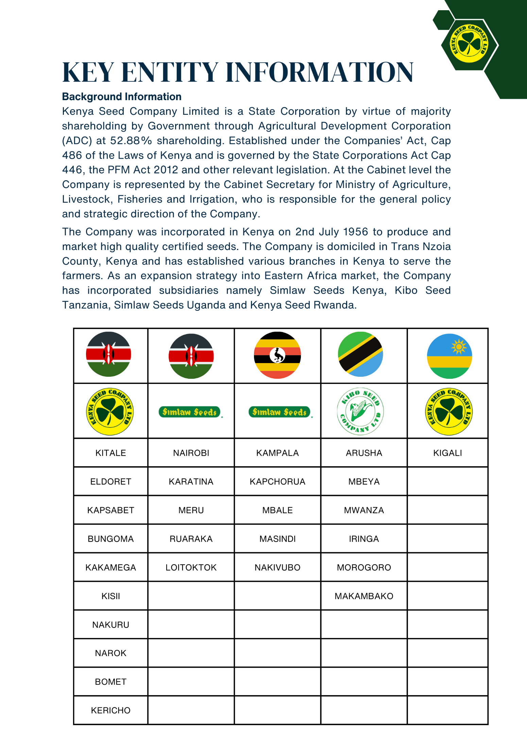

**KEY ENTITY INFORMATION (continued)**

**Principal Activities**

The Company’s main mandate is to carry out focused research and facilitate production of high yielding, better quality certified seed and to enhance food security and quality living standards for sustainable economic development. The Company’s range of products has expanded to over 60 Certified Seed Varieties suitable for different agro-ecological zones in the region. The seed varieties are:

**Maize Varieties**

|  |  |  |  |  |  |
| --- | --- | --- | --- | --- | --- |
| **Variety** | **Altitude (Mtrs) Above Sea Level** | **Maturity Period (Days)** | **Yield (90kg Bag/ Acre)** | **Special Attributes** | **Recommended Growing Areas** |
| **H6218** | 1500-2800 | 175-210 | 56 | Blight tolerant, good husk cover, Semi-flint. | These are Highland hybrids grown particularly in Trans-Nzoia, Uasin-Gishu, Nakuru, Laikipia, Kisii, Narok, Bungoma, Kakamega, Nandi, and Kericho, Tea zones of central Kenya, Nyahururu, Southern Highlands of Tanzania, Mt. kilimanjaro slopes, Bomet, Nyeri, Kiambu and Meru Tea Zones, Timau, Nkubu, Nanyuki, Kirinyaga, Igembe, Bukwa, Mbale, Bumula, Lanet, |
| **H6213** | 1500-2800 | 160-190 | 52 | Tolerant to lodging, ear rot, rust, Grey Leaf Spot and leaf blight |
| **H6210** | 1500-2800 | 160-190 | 50 | Tolerant to lodging, ear rot, rust, Grey Leaf Spot, Stem and leaf blight. |
| **H629** | 1500-2800 | 160-190 | 48 | Has good husk cover, very tolerant to lodging, ear rot, rust, stem and leaf blight. |
| **H628** | 1500-2800 | 150-180 | 46 | Producer of more than one cob, Tolerant to most leaf diseases, blight and rust, tolerant to lodging. |
| **H626** | 1500-2800 | 150-180 | 42 | Tolerant to most leaf diseases, blight and rust, Tolerant to lodging. |
| **H625** | 1500-2800 | 150-180 | 40 | Tolerant to lodging, has good husk cover |
| **H624** | 1500-2800 | 90-110 | 32 | Tolerant to Grey Leaf Spot, leaf blight and rust, excellent husk cover with flint kernels. |
| **H614** | 1500-2800 | 160-190 | 38 | Tolerant to blight, leaf and ear diseases and weevil attack |
| **PH1** | 500-1300 | 75-90 | 16 | Has better husk cover and can be intercropped with other crops. | The Lake region and the Coastal strip, Kilifi, Mpeketoni, Hola, Gariseni, Voi, Mwatate, Kwale, Kinangop. |
| **PH4** | 500-1300 | 90-120 | 16 | Tolerant to most leaf and ear diseases, excellent husk cover and tolerant to lodging |
| **H520** | 1700-2000 | 90-110 | 32 | Tolerant to leaf rust, Grey Leaf Spot, lodging, has flint kernels and excellent husk cover | Western Kenya, Elgeyo Marakwet, Coffee growing areas of Central Kenya and Nyanza. |
| **H517** | 800-2400 | 120-130 | 30 | Tolerant to foliar diseases and pests. Has an excellent husk cover | Western Kenya, Elgeyo Marakwet, Coffee growing areas of Central Kenya and Nyanza. |
| **H516** | 800-2400 | 100-110 | 28 | Good husk cover, very tolerant to lodging, ear rot, rust, Grey Leaf Spot, Stem and leaf blight. | Early to medium transitional zones and lowland areas of Kirinyaga, West Pokot, Bungoma, HomaBay, Kerio Valley, Kagio, Mwea, Makueni, Kitui, Marakwet, Baringo and Koibatek, Voi, Mwatate, Mariakani, Garissa. Western Kenya, elgeyo marakwet, coffee zones of central Kenya, Tharaka Nithi, Nyanza (Migori, Kisii, Nyamira), Baringo, Embu, Chuka Lowland |
| **H522** | 800-2400 | 100-110 | 26 |
| **H515** | 800-2400 | 100-110 | 26 | Tolerant to lodging, leaf blight, leaf rust and GLS. |
| **H513** | 800-2400 | 100-110 | 24 | Partially tolerant to Maize streak virus |
| **DH01** | 500-1300 | 70-90 | 16 | Long stay Green trait, drought tolerant, good level of tolerance to leaf blight, common rust and ear rot. | Arid and Semi-arid areas of Makueni, Machakos, Kangundo, Siaya, Kibos, Busia, Kibwezi, Kitui, Mwangi, Voi, Mwatate, Makayo, Turkana, Sigor, West Pokot, Isiolo, Mandera, Karachuonyo, Nyando, Kisumu, Bondo and some parts of Butere |
| **DH02** | 500-1300 | 70-100 | 18 | Early, tolerant to MSV, water stress, has a long stay green trait |
| **DH03** | 500-1300 | 95-120 | 22 | A good level of tolerance to blight and MSV, good husk cover, better standability and drought tolerance |
| **DH04** | 500-1300 | 100-130 | 24 | Short, drought tolerant, good husk cover and standability | Early to medium transitional zones and lowland areas of Kirinyaga, West Pokot, Bungoma, Homa Bay, Kerio Valley, Kagio, Mwea, Makueni, Kitui, Marakwet, Baringo Koibatek, Voi, Mwatate, Mariakani, Garissa. |

**KEY ENTITY INFORMATION (continued)**

**Wheat Varieties**

|  |  |  |  |  |
| --- | --- | --- | --- | --- |
| **Variety** | **Altitude (Mtrs) Above Sea Level** | **Yield (90kg Bags/ Acre)** | **Maturity Period (Days)** | **Special Attributes** |
| **KS Mwamba** | 1800-2400 | 22-25 | 125 | High yielding. Tolerant to field stress conditions. Widely adapted to East African Conditions (especially in Trans– Nzoia, Uasin Gishu, Laikipia, Narok and Mt. Kenya areas. |
| **Ks Farasi** | 1800-2400 | 16-30 | 119 (+/-5) | Tolerant to most foliar diseases Good Baking Quality. High Yielding Hard red wheat highly recommended for Mount Kenya, Samburu, Laikipia West, Narok, Subukia, Rongai, Nyandarua, Nakuru, Trans-Nzoia, Kericho, Bomet and Uasin Gishu areas. |
| **KS Chui** | 1800-2400 | 37-75 | 119 (+/-5) | Good Tolerance to foliar diseases Adapted to high potential and marginal environments. High tillering ability, high yields. Hard red wheat. |
| **KS Simba** | 1500-2400 | 17-32 | 116-120 | Good baking qualities. Good tillering ability. Hard red wheat. Hard red wheat highly recommended for Mount Kenya, Samburu, Laikipia West, Narok, Subukia, Rongai, Nyandarua, Nakuru, Trans-Nzoia, Kericho, Bomet and Uasin Gishu areas. |
| **KS Ndume** | 1800-2400 | 37-75 | 100-110 | High yielding. Good Tolerance to foliar diseases Resistant to sprouting and lodging. High tillering ability. Good baking qualities |
| **KS Nyota** | 1800-2400 | 30-75 | 120-130 | High yielding. Newly released with moderate resistance to stem rust Ug99 Good tillering ability. Bred for sprouting tolerance Makes a very stable dough. |
| **KS Kanga** | 1800–2500 | 53-89 | 120-130 | High yielding. Product of KSC CIMMYT Collaboration. Newly released with moderate resistance to stem rust Ug99 Good tillering ability. Good baking and milling qualities. Tolerant to most foliar diseases. Newly released with adult plant resistance to stem rust UG99 (slow rusting). |

**Sorghum Varieties**

|  |  |  |  |
| --- | --- | --- | --- |
| **Sorghum Type** | **Duration to Maturity** | **Yield (90kg Bags/ Acre)** | **Special Attributes** |
| **Serena** | 3 - 4 months | 12 | It is a brown seeded variety It has a long stem and good root system It is widely adaptable Fairly tolerant to Striga, Rust, Leaf blight and Grey leaf spot. Performs well in the moist mid altitude regions and the semi-arid lowlands. |
| **Seredo** | 3 - 4 months | 12 | It is a brown seeded variety It is taller than Serena with good tolerance to lodging Its head is conical and semi compact in shape with brown grains which are slightly bigger than those of Serena Sorghum Performs well in moist altitude and the semi-arid lowlands It is widely adaptable |
| **Gadam** | 3 months | 8 | It is whitish in colour Has excellent malting qualities Good for human consumption (ugali) Does well in lowland to medium altitude. |
| **E 1291** | 5 months | 15 - 20 | It is brown in colour Dual purpose variety with good beverage quality Performs well in the cool semi-arid highlands of Nakuru, Baringo, Laikipia, Naivasha, Narok, Trans Nzoia, Uasin Gishu, Kuria, Kericho, Trans Mara, and Taita Taveta. Good for silage making. |

**Finger Millet Varieties**

|  |  |  |  |  |
| --- | --- | --- | --- | --- |
| **Finger Millet Type** | **Altitude (Mtrs) Above Sea Level** | **Duration to Maturity** | **Yield (90kg Bags/ Acre)** | **Special Attributes** |
| **P 224** | 1150 - 1750 | 3 - 4 months | 10-15 | It is a brown seeded variety It is a tall type with uniform plant height It is tolerant to lodging. Average nutrient intake. |
| **Katumani** | 250 –1150 | 3 months | 7-10 | It is a red seeded variety It is a short variety Drought tolerant. Average nutrient intake. |

**KEY ENTITY INFORMATION (continued)**

**Pasture Varieties**

|  |  |  |  |
| --- | --- | --- | --- |
| **Pasture Type** | **Optimal Production Altitude** | **Duration to Maturity (Days)** | **Special Attributes** |
| **Boma Rhodes Masaba rhodes** | 1000 - 2500 | 90 – 105 Days | Soft and excellent herbage Slow growing and hence suited for lower stocking rates. Gives bottom tillers and forms a thick grass It is very popular in all altitude. It is drought tolerant |
| **Elmba Rhodes Mbarara rhodes Pokot rhodes** | 110 - 130 | 15 to 20 Bags | Red mottled (Red with white specks) |
| **Nandi Seteria** | 1000 – 2500 | 70 – 80 Days | Suitable for the high altitude and high rainfall areas Very persistent but good seed bed essential for proper establishment. Good forage quality Tolerant to mild water logging. |
| **Nasiwa Seteria** | 1000 - 2500 | 75 – 90 Days | Good persistence under grazing Drought tolerant Good forage quality Tolerant to mild water logging. |
| **Coloured Guinea** | 50 - 2000 | 50 – 60 Days | Good herbage quality Thrives well in a wide range of rainfall regimes Can withstand severe water lodging Establish well in coastal strips. |
| **Desmodium** | 0 - 3000 | 3-4 Months | High crude protein levels Rich in minerals and vitamins Improve soil fertility through nitrogen fixation Controls Striga weed growth. Grows in all altitudes. |
| **Lucerne** | 1000 - 3000 | 3-4 Months | Very palatable, nutritious and can sustain high milk production levels when fed to dairy cattle. Can last up to four years under good management. Can be fed to goats, rabbit and chicken. |
| **Sudan grass** | All altitudes | 3 Months | A quick growing annual with smaller stems and thin leaves. Very palatable. Very good for making silage |
| **Columbus grass** | All altitudes | 3 Months | A quick growing biannual crop with broader leaves which under good management can be harvested twice per annum. Good for silage making. |
| **Oats** | All altitudes | 135 days | Suitable for forage and grain milling Tolerant to stem rust. High palatability. Good for human porridge. |

**Dry Shell Beans**

|  |  |  |  |
| --- | --- | --- | --- |
| **Bean Type** | **Duration to Maturity (Days)** | **Yield (90kg Bags/Acre)** | **Special Attributes** |
| **GLP 92 Mwitemania** | 90 - 95 | 8 | Cream seeds with black-brown spots Has a spreading growth habit with nearly flat pods which contain oval seeds Prefers the medium altitude and is tolerant to drought Tolerant to halo blight |
| **GLP 2 Rose coco** | 75 - 90 | 10 | Large, dark red with white flecks grains the plant is tall, erect and very vigorous with flat pods Prefers medium altitude zones Tolerant to bean common mosaic virus and anthracnose |
| **GLP 1004 Mwezi moja** | 80- 90 | 6 | Large beige or light brown speckled purple with long broad pods Medium yielder and performs best in warmer areas Well adapted for planting during the short rains |
| **GLP 24 Canadian wonder** | 110 - 120 | 10 | Shiny dark purple or reddish-purple seeds Vigorous plant with slight climbing tendency and flat pods Performs best in cool areas |
| **GLP 1127 New mwezi moja** | 85 - 90 | 8 | An improvement of GLP 1004 on yield and disease tolerance Relatively widely adaptable than GLP 1004 The colours are similar to those of GLP1004.Wairimu |
| **Wairimu dwarf** | 70 | 6 | An extra early bean type that performs well in most ecological zones but suited to medium to dry areas. It has excellent eating quality Good for intercropping. |
| **Soya Beans**  SB 19 | 110 -120 | 10 | High oil content High podding ability. |

**KEY ENTITY INFORMATION (continued)**

**Sunflower Varieties**

|  |  |  |  |  |
| --- | --- | --- | --- | --- |
| **Variety** | **Optimal Production Levels** | **Yield (90kg Bags/ Acre)** | **Special Attributes** | **Recommended Growing Areas** |
| **Hungarian White** | 12-2400 | 150-160 | 3.5-4 t/ha | Long white grains for bird feed Average oil content Livestock feed. |
| **Kenya Fedha** | 12-2000 | 130-135 | 3.-3.5 t/ha | Open pollinated Uniform maturity Suited to all altitudes high oil content |
| **H8998** | 12-2000 | 120-125 | 3.-3.5 t/ha | Uniform in plant height and maturity Tolerant to several plant diseases Has strong stems Matures earlier than the other varieties. High oil content Suited for all altitudes. |

**Nerica Rice Varieties**

|  |  |  |  |  |
| --- | --- | --- | --- | --- |
| **Nerica Type** | **Optimal Production Altitude (M) A.S.L** | **Duration to Maturity (Days)** | **Yield (Kg / Ha)** | **Special Attributes** |
| NERICA 1 | 0 – 1700 | 100 – 115 days | 4500 | Aromatic Medium tolerance to blast Good tolerance to lodging Long grains |
| NERICA 4 | 0 – 1700 | 100 – 130 days | 5000 | Medium tolerance to blast Good tolerance to lodging Long grains. High aromatic rice |
| NERICA 10 | 0 – 1700 | 90 – 105 days | 6000 | Early maturing Long grains Good tolerance to blast Moderate tolerance to lodging. High aromatic rice. 6000 |
| NERICA 11 | 0 – 1700 | 130 days | 7000 | Long grains Good tolerance to blast tolerance to lodging |

**Groundnuts**

|  |  |  |  |
| --- | --- | --- | --- |
| **Crops** | **Optimal Production Altitude (M) A.S.L** | **Duration to Maturity (Days)** | **Special Attributes** |
| KEN-G NUT 1 | 200—1000 | 101 - 110 | Mid-brown in color High in oil content tolerance to rosette disease |

**SimSim**

|  |  |  |  |
| --- | --- | --- | --- |
| **Crops** | **Optimal Production Altitude (M) A.S.L** | **Duration to Maturity (Days)** | **Special Attributes** |
| KSS-6 (KENYA SEED SIMSIM SIX) | 200 – 1200 | 90 – 105 | Highly aromatic when roasted High podding ability (average of 52% per plant) Shoot fly tolerance. Tolerance to rust. High oil content. |

**KEY ENTITY INFORMATION (continued)**

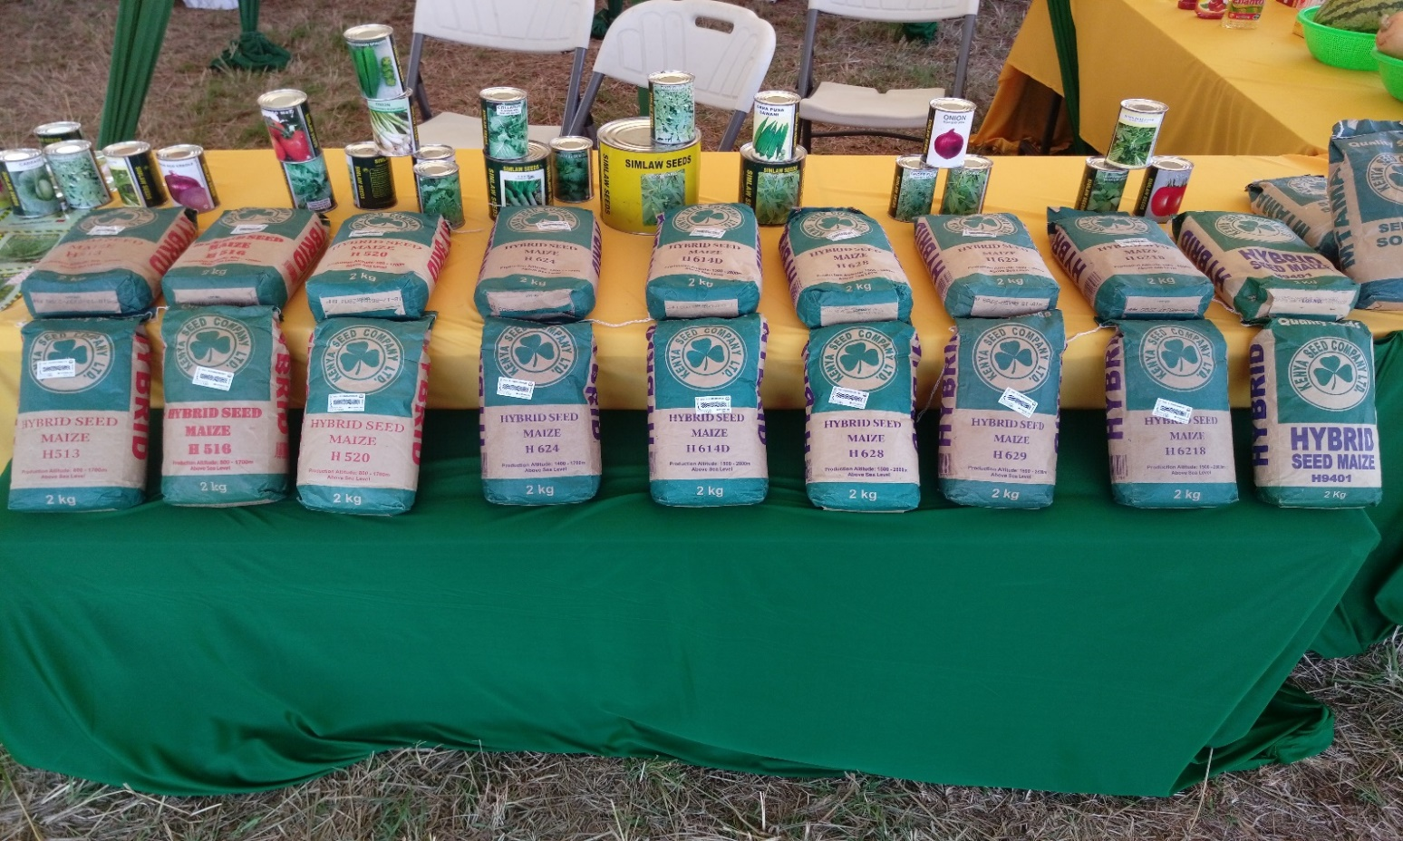

*Our top-quality seed packaged and ready for sale to farmers*

**Simlaw Seeds Company Ltd Products**

**Tomato**

Prostar F1, Libra F1, New Fortune Maker F1, Kentom F1, Cal J, Money Maker, Joy F1, Marglobe, M82, Simlaw Rio Grande, Superstar F1, Galaxy F1, Monica F1 and Novelle F1

**Cabbages**

Riana F1, Pruktor F1, Gloria F1, Rotanda F1, Thomas F1, Queen F1, Serena F1, Dunny F1, Karen F1, Polo F1, Chinese Cabbage, Copenhagen Market, Sugar Loaf , Red Rock, Queen F1, and Serena

**Value vegetables**

Cauliflower amazing f1, Brocolli conde f1

**Eggplant**

Black Beauty and Early Long Purple

**Okra**

Pusa Sawani and Crimson Spineless

**Onions**

Red Passion F1, Ruby F1, Red Nice F1, Spring Green Bunching, Texas Grano, Bombay Red and Red Creole

**Carrots**

Carrot Nantes, Napolitana f1

**Pepper**

California Wonder, Yolo Pepper Lafayette f1, Long Red Cayenne and Fresno (Bullet), Double up, Citrine.

**Indigenous vegetables**

Amaranthus (Terere), Spider Plant (Saga, Saget), Black Night Shade (Managu), Crotalaria (Mito) and (Murere) and Jews Mallow (murere, mrenda)

**Water Melons**

Sweet Rose f1, Sugar Belle f1, Julie f1 and Daytona f1, Sugar Baby, Charleston Grey and Crimson Sweet

**Leafy vegetables**

Spinach Fordhook Giant, Lucullus, Collard Sukuma Wiki- Simlaw Select, Kale 1000 Headed.

**Herbs**

Coriander Dhania, Parsley and Celery

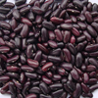    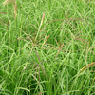       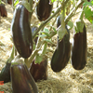 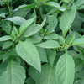 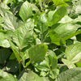  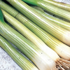 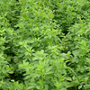   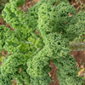 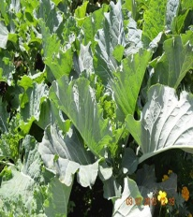

**OUR VISION**

To be the leading supplier of Top-Quality Seed in Africa and beyond

**OUR MISSION**

To avail sufficient quality certified seed competitively through research and development to the satisfaction of stakeholders

**OUR CORE VALUES**

* **Integrity**: In discharging our functions, we consistently uphold the highest ethical standards, demonstratinghonesty and fairness in all our operations at all levels of the organization.
* **Teamwork and effective partnerships**: KSC staff work as a team committed to the realization of theCompany goals. We endeavor to pull in one direction internally and externally in delivering on our mandate.
* **Professionalism**: We take a professional and objective approach in all our operations. We upholdcompetence, high standards, reliability and excellence in our work.
* **Innovativeness**: KSC recognizes that innovation and creativity in processes and products is key inimproving service delivery. The Company is therefore committed to fostering innovation and creativity in the entire work force. Towards this, the Company supports and encourages learning among its staff.
* **Passion for quality**: We recognize that our customers are the reason we exist. We therefore endeavor toprovide high quality services which meet customer needs and honor commitments that we have made to them.
* **Client focus**: We provide services that satisfy customer needs and exceed expectations. We strive todeliver reliable products and services to our customers.
* **Efficiency**: We provide services with the minimum time, resources and the rightful number of resources.We strive to eliminate wastages in discharging our mandate

**Directors**

The Directors who served the company during the year were as follows:

|  |  |  |
| --- | --- | --- |
| Mr. Mohammed Bulle | Chairman | From 7th Feb 2017 to 30th June 2023 |
| Mr. Eliud Mathu | Alt.Dir, Min. of Agriculture, Livestock, Fisheries. | From 1st July 2021-26th Aug 2021 |
| Mr. Elijah Obebo | Alt Dir., Min. of Agriculture, Livestock, Fisheries | From 26 Aug, 2021 to 30 Jun, 2022 |
| Ms Edna Atisa | Alt Dir., The National Treasury |  |
| **Executive** |  |  |
| Mr. Fred Oloibe | Ag. CEO from 17th April 2020-7th Nov, 2021  Appointed on 8th Nov 2021-7th Nov 2024 (Gazette Notice 12168) | 8th Nov 2021-7th Nov 2024 |
| **Company Secretary** |  | |
| Ms. Wilkister Simiyu, CPS (K) | P.O. Box 553 – 30200 | |
|  | Kitale, Kenya. |  |
| **Registered office and** | Wamalwa Street |  |
| **Principal place of** | P.O. Box 553 – 30200 |  |
| **Business** | Kitale, Kenya |  |
| **Corporate contacts** | Tel: (054)-31909-14 | |
|  | Mobile: 0722205144, 0726141856, 0733623668 | |
|  | Email: [info@kenyaseed.co.ke](mailto:info@kenyaseed.co.ke) | |
|  | Website: www.kenyaseed.com | |
| **Principal Bankers** | Kenya Commercial Bank Limited | |
|  | P.O. Box 1974 – 30200 |  |
|  | Kitale, Kenya. |  |
|  | National Bank of Kenya Limited | |
|  | P.O. Box 1192 – 30200 |  |
|  | Kitale, Kenya. |  |
|  | Barclays Bank of Kenya Limited; Eldoret Branch | |
|  | P.O. Box 22 – 30100 |  |
|  | Eldoret, Kenya. |  |
|  | Equity Bank Kenya Limited |  |
|  | Kitale Branch; P.O. Box 801 – 30200 | |
|  | Kitale, Kenya. |  |
|  | Cooperative Bank of Kenya |  |
|  | P.O. Box 1058 - 30200 |  |
|  | Kitale, Kenya |  |

|  |  |  |
| --- | --- | --- |
| **KEY ENTITY INFORMATION (continued)** | | |
| **Independent Auditors** | Office of Auditor General  P.O. Box 30084 – 00100 GPO |  |
|  | Nairobi, Kenya | |

**Principal Lawyers** Kidiavai & Company

Advocates, Commissioners for Oaths and Notaries Public

2nd Floor, Mazop Building

P.O. Box 437 – 30200 Kitale, Kenya.

Albert Kamunde & Company

Advocates, Commissioners for Oaths, Notary Public and

Certified Public Secretaries, 4th Floor, Blue Violets Plaza

Kindaruma Road, off Ngong Road

P.O. Box 56936 – 00100 Nairobi, Kenya.

Namachanja & Mbugua

Advocates, Notaries Public and Commissioners for Oaths

A4, Hurlingham Park, Arwings Kodhek Road

P.O. Box 26301 – 00100

Nairobi, Kenya.

**Subsidiaries** Simlaw Seeds Company Limited

Kijabe Street

P.O. Box 40042 – 00100

Nairobi, Kenya.

Kibo Seed Company Limited

Mbegu House, Opposite Golden Rose Hotel

Plot No. 355 Block X, Area F

P.O. Box 25 Arusha, Tanzania.

Simlaw Seeds Company Tanzania Limited (Dormant Entity)

Mbegu House, Opposite Golden Rose Hotel

Plot No. 355 Block X, Area F

P.O. Box 25 Arusha, Tanzania.

Simlaw Seeds Company Uganda Limited

6th Street, Industrial Area

P.O. Box 21303

Kampala, Uganda.

Mount Elgon Seed Company (Dormant Entity)

Nakivubo Place

P.O. Box 23810 Kampala, Uganda.

Kenya Seed Rwanda Limited

P.O Box 6312,

Kigali, Rwanda

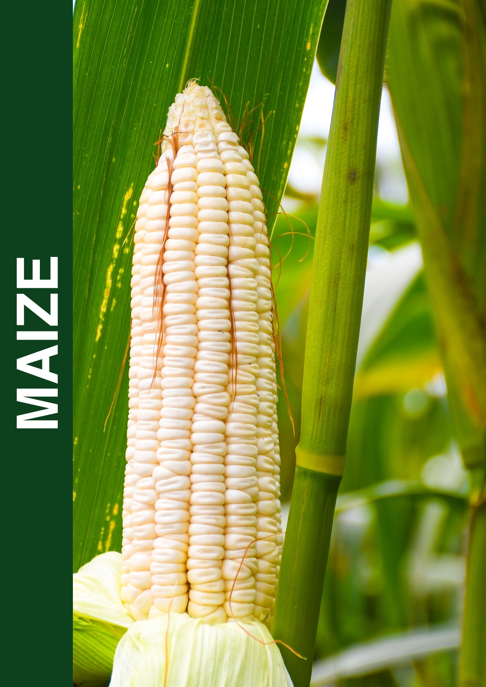

|  |
| --- |
|  |

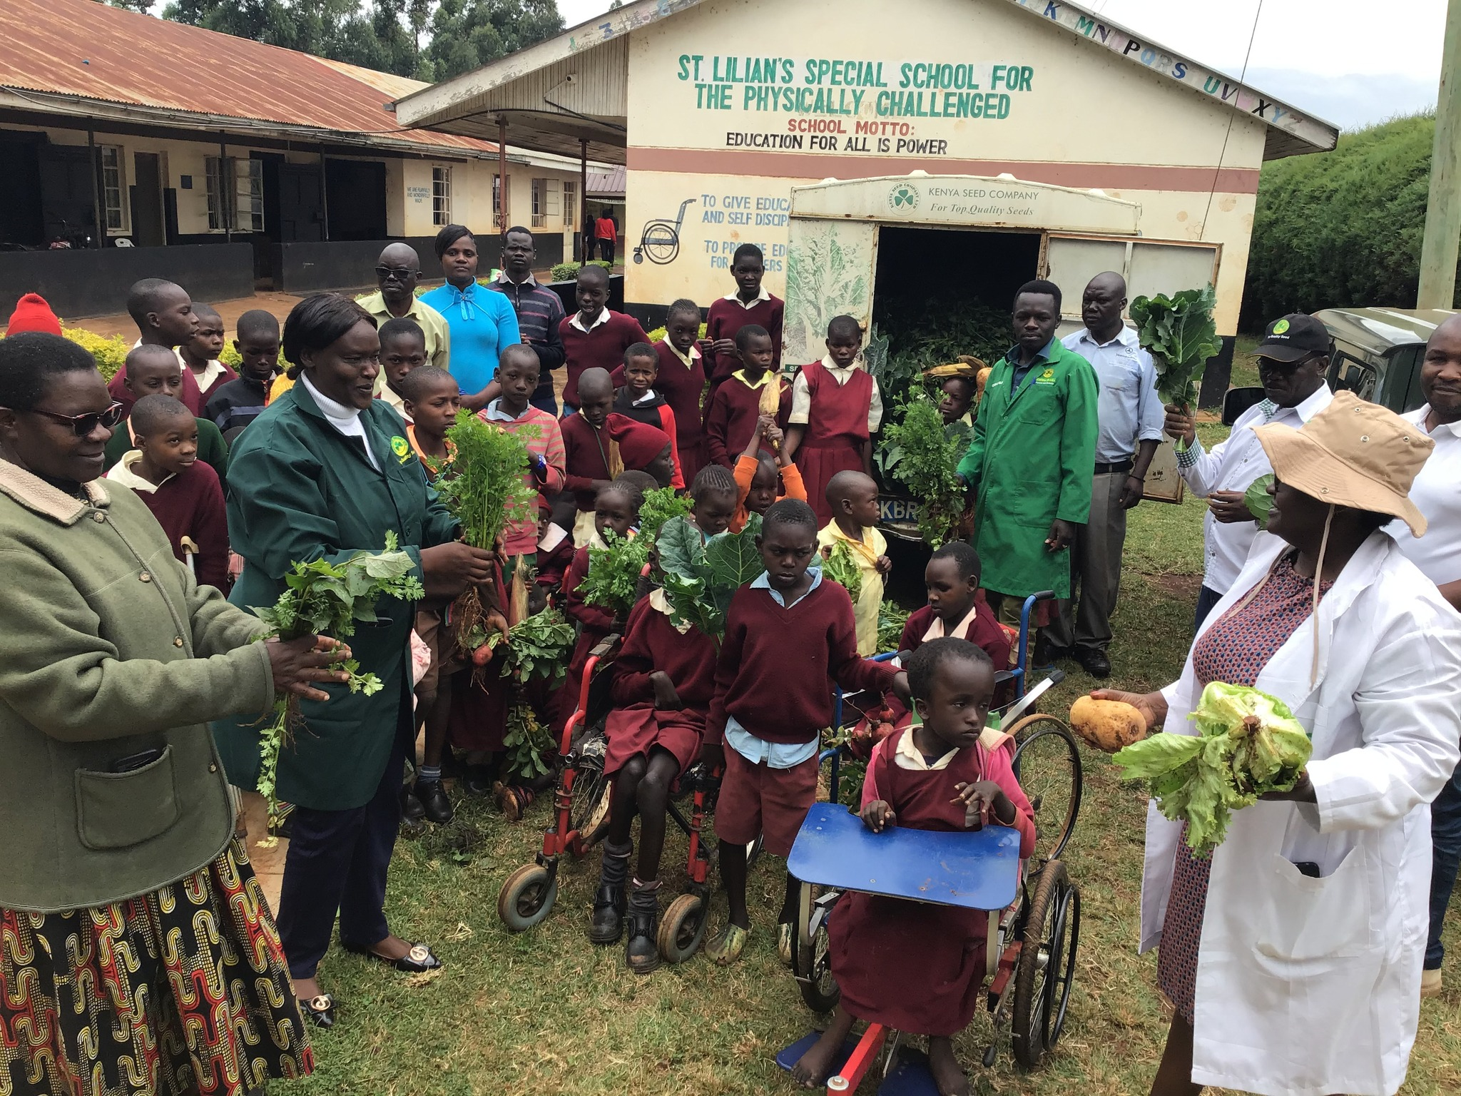

*A visit to St Lilian school for the physically challenged by Kenya seed Company staff as part of Corporate social Responsibilty.*

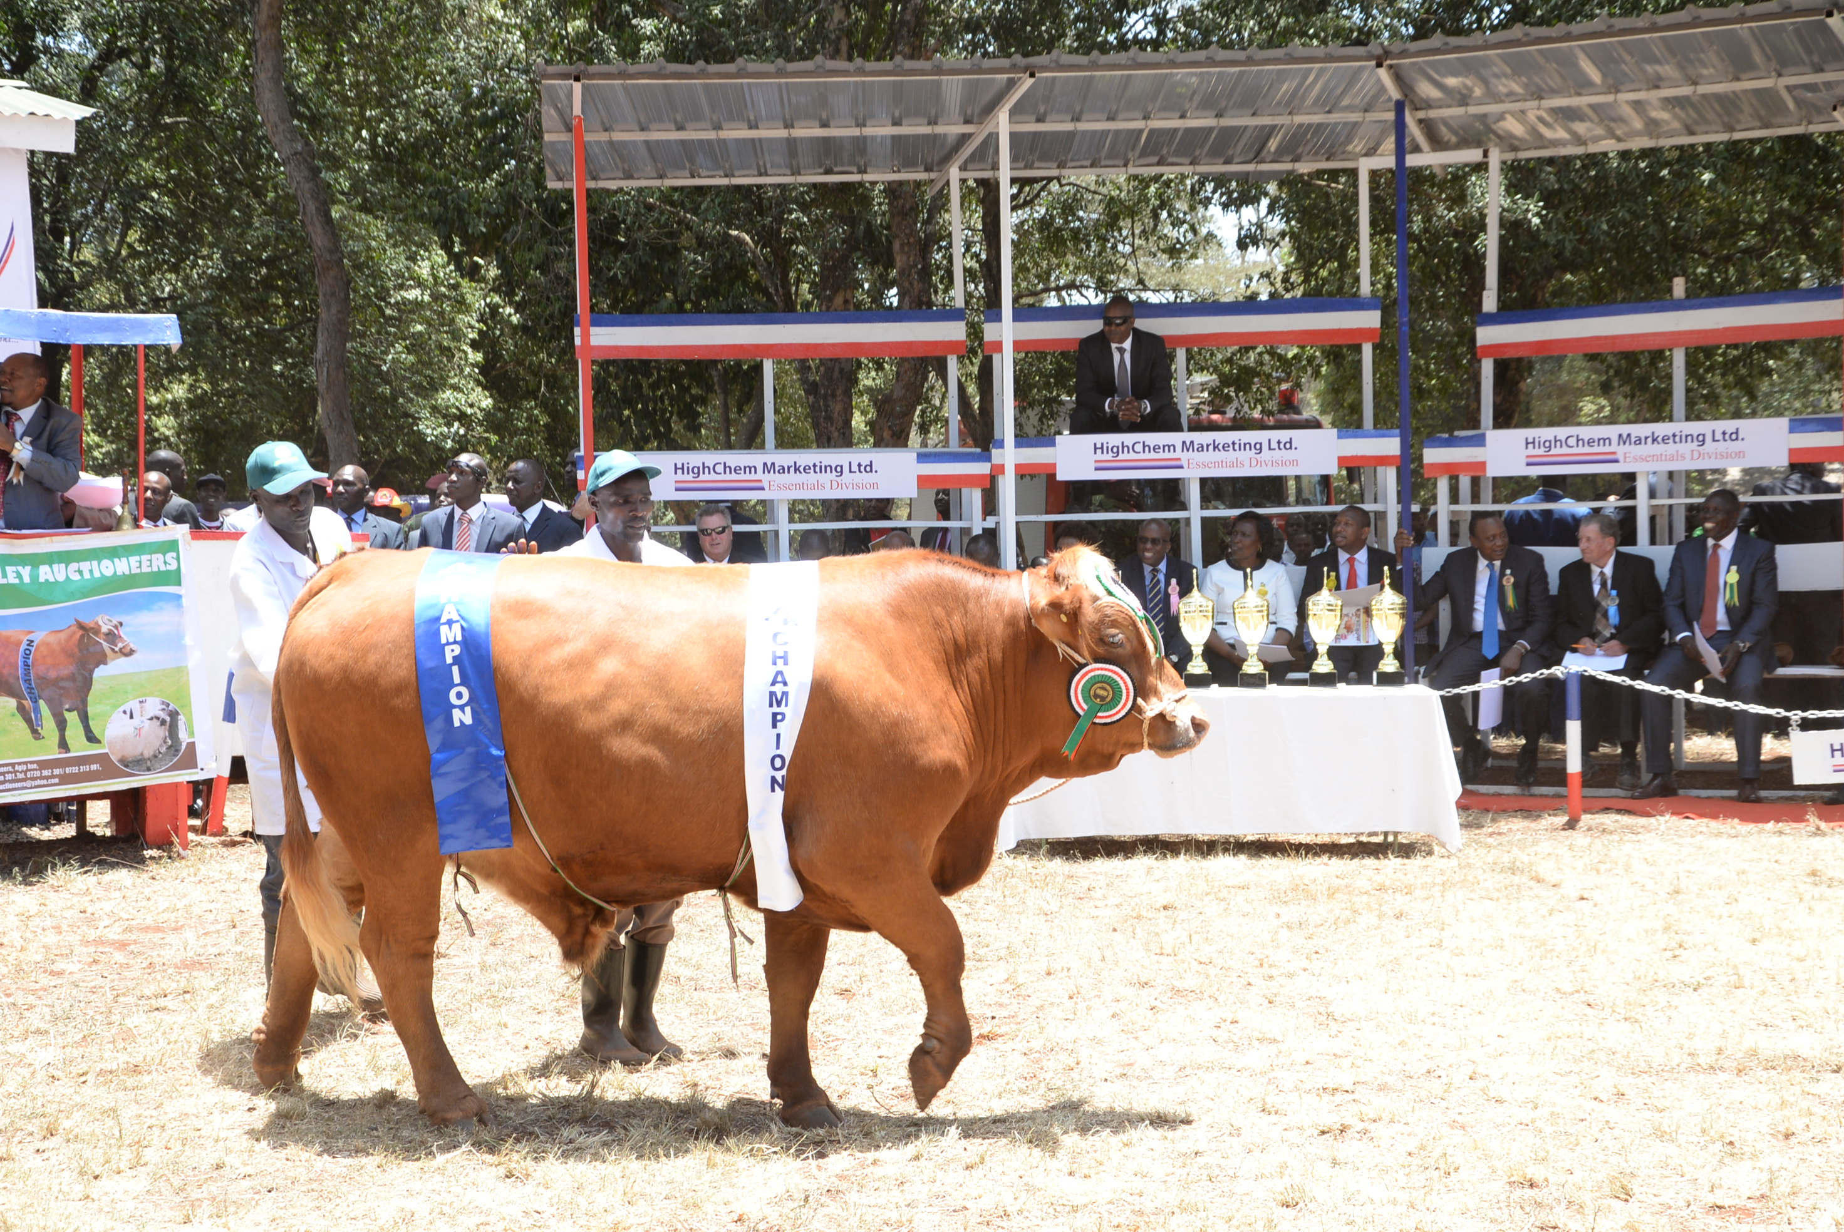

*Champion bull being paraded during the Nairobi International Trade Fair Exhibition*

# OUR BOARD OF DIRECTORS

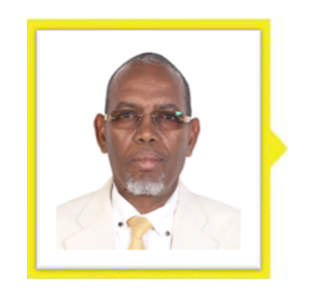**Mr. Mohamed M. Bulle**

Mr. Mohamed Bulle was born in 1958.He is the chairman of the Board of directors of Kenya Seed Company Limited, He is the Managing Director of ADC. Prior to being appointed MD he was the Director of Operations at ADC. He has over 30 years’ experience. He holds a Master of Environmental Science from Antioch University, USA and Bachelor of science in Agricultural Education and Extension and a Diploma in Agriculture from Egerton university. He is a member of the Environmental Institute of Kenya-EIK and has accreditation with NEMA as an environmental impact assessment and audit (EIA and Audit) Lead Expert. He is also a member of the board of directors of Young Muslim Association (YMA) and North-Eastern Muslim Welfare Society

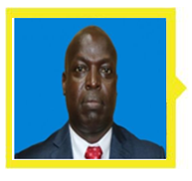**Mr. Fred Oloibe**

Mr. Fred Oloibe was born on the 18th September 1974 and is the Acting Managing Director from 17th April 2020 and Head of Strategy and BusinessDevelopment at Kenya Seed Company. He holds masters of Business Administration (MBA) from Jomo Kenyatta University of Agriculture and technology and a Bachelor of Science degree (Mathematics) from the University of Nairobi. He joined Kenya Seed on 1st October 2012 as a Planning and Strategy Manager. He previously worked in the cement industry with experience in Strategy, Performance Management, Corporate Planning and he is a full member of the Kenya Institute of Management (KIM). He is a Fellow on seed policy from the University of California.

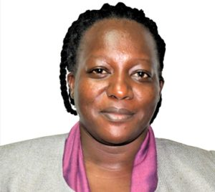**MS Edna Atisa, Alternate Member, The National Treasury**

Ms. Edna Atisa was appointed to the Board of Kenya Seed on 05.05.2021 as an alternate member representing the Cabinet Secretary for the National Treasury. Ms. Atisa holds a Master's Degree in Economics, Bachelor of Arts in Economics and Postgraduate Diploma in Education all from the University of Nairobi. She is an Economist with vast experience in the public sector specializing in economic policy formulation and implementation and is a member of the Economics Society of Kenya. She is currently a Deputy Director at the National Treasury.

**OUR BOARD OF DIRECTORS (continued)**

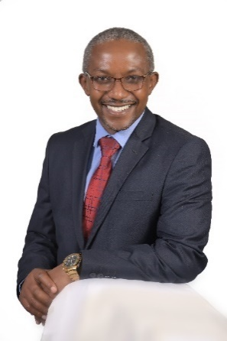 **Mr. Eliud Mathu**

Mr. Eliud Mathu was born on 27th August 1968. He is a seasonedAgricultural economist with over 25

years combined working experience impacting Agricultural policy and its development at the State Department for Crop Development, including hands-on technical support to farmers at the grassroots. A versatile leader with a broad Corporate Governance experience representing the State Department in various state corporation Boards championing ethical and professional governance and policy formulation for execution of their mandates in regulation, delivery of services to Kenyans, economical processing of agricultural produce, Training and research. An avid reader who constantly develops his knowledge in new technologies in practical agricultural practices in developing countries and passionate for efficient and effective service delivery by state corporations. Current scope of influence includes senior government officials, senior executives and boards of State Corporations.

Eliud is well versed in modern agricultural economic and management trends and has consistently acquired modern skills through training and personal development attending global trainings and seminars in the United States, India, Brazil, Pakistan, Mozambique, Uganda, Japan, South Africa, China and Kenya to keep abreast with emerging trends in modern agricultural practices in developing countries. He has a Master of science in Agriculture and applied Economics at Egerton, with university of Pretoria partnership 4-month residency, Bachelor of science Agricultural Economics at Egerton University).

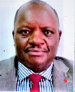

**Mr. Elijah Obebo-Alternate Director, Ministry of Agriculture, Livestock, Fisheries & Cooperatives**

Mr. Elijah Obebo was admitted to the Board of Kenya Seed Company on 26.08.2021 to 30th June 2022.

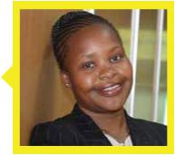**CS. Wilkister Simiyu**

CS. Wilkister Simiyu was born on 16th June, 1981 and is the Company Secretary and Head of Legal Services. She has 15 years’ work experience both as a practicing advocate and an in-house counsel having worked as a practicing advocate at Kitiwa & Co. and Nyaundi Tuiyot & Co. and an in-house counsel at Moi University and its affiliates. She has an LLM specializing in Commercial and Corporate Law and a Post Graduate Diploma in Law and Development both from University of London She holds LLB degree (Hons) from Moi University and postgraduate diploma in Law (KSL). She is a Certified Public Secretary (CPSK), Certified Governance and Legal Auditor and currently pursuing a Masters of Law degree. She joined the company in October 2016.

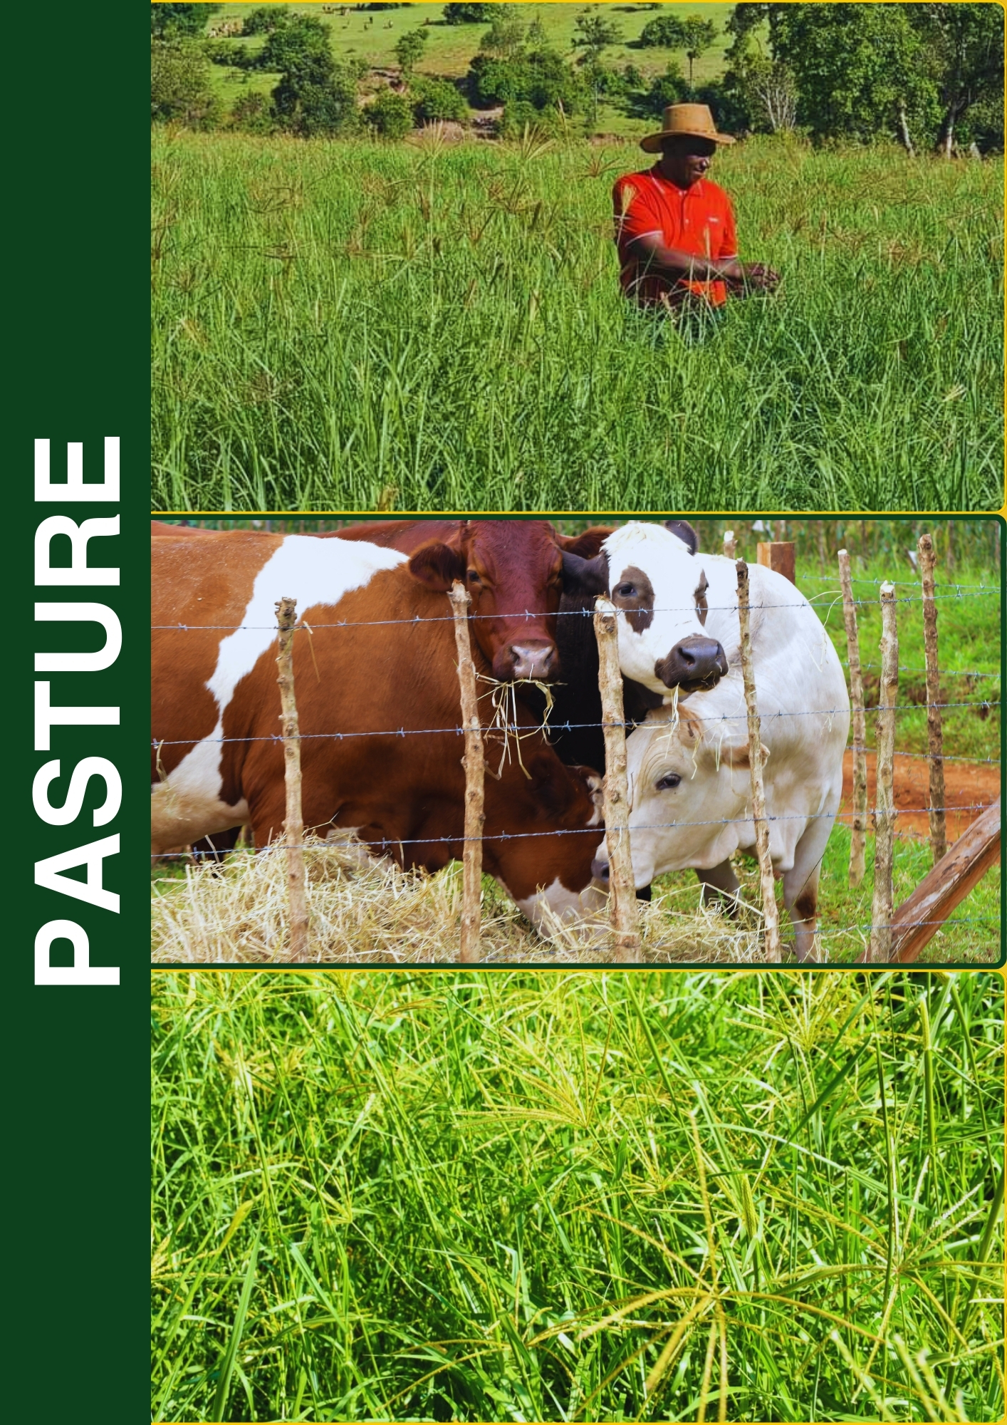

|  |
| --- |
|  |

# OUR MANAGEMENT TEAM

The Company has a diverse and dedicated management team that assists the Managing Director in his role of achieving the company’s strategic objectives.

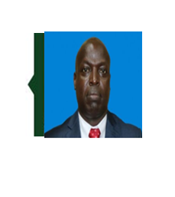

**Mr. Fred Oloibe** was born on the 18th September 1974 and is the Acting Managing Director from 17th April 2020 and Head of Strategy and BusinessDevelopment at Kenya Seed Company. He holds masters of Business Administration (MBA) from Jomo Kenyatta University of Agriculture and technology and a Bachelor of Science degree (Mathematics) from the University of Nairobi. He joined Kenya Seed on 1st October 2012 as a Planning and Strategy Manager. He previously worked in the cement industry with experience in Strategy, Performance Management, Corporate Planning and he is a full member of the Kenya Institute of Management (KIM). He is a Fellow on seed policy from the University of California



**CS. Wilkister Simiyu** was born on 16th June, 1981 and is the Company Secretary and Head of Legal Services. She is an Advocate of the High Court since 2006. She has over 15 years’ work experience as a practicing advocate at Kitiwa & Co. Advocates and Nyaundi Tuiyot & Co. and an in-house counsel at Moi University and its affiliates. She has an LLM specializing in Commercial and Corporate Law and a Post Graduate Diploma in Law and Development both from University of London. She holds LLB degree (Hons) from Moi University and a Postgraduate Diploma in Law (KSL). She is a Certified Public Secretary (CPSK), Certified Governance and Legal Auditor. She joined the company in October 2016.

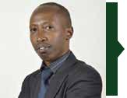

**CPA Leonard Kibet** was born in 2nd August 1980 and is the Internal Audit Manager. He is a Certified Public Accountant (CPAK) and a Certified Internal Auditor (CIA), a member of the Institute of Internal Auditors (IIA) and Institute of Certified Public Accountant (ICPAK). He has over 15 years of leadership and managerial experience having worked with Nation Media Group, Kenya Bureau of Standards, Vision Fund and University of Eldoret. He holds a Master’s Degree in Finance and a Bachelor’s Degree in Business Management. He joined the company on 2nd October 2017.

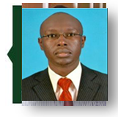

**Mr. David Kiplagat Tum** was born in 1978 and is the General Manager of Simlaw Seeds Company Kenya Ltd, a subsidiary of Kenya Seed Company. Mr Tum holds a BSc in Business Administration from USIU and Masters of Business Administration from Staffordshire University in UK. Mr Kiplagat worked as an Accountant at Simlaw Seeds between 2000 and 2003. He was a Director of Soet Group from 2003 to 2007 and the Managing Director of Commercial Grain Services Ltd from 2008 to 2016. Mr Kiplagat resigned from the Board in September 2016 when he was appointed as the General Manager of Simlaw Seeds Company Limited.



**Mrs. Sylvia Nanteza Kyeyune** was born in 1976 and is the General Manager of Simlaw Seeds Company Uganda Ltd, in Uganda, a subsidiary of Kenya Seed Company. She is responsible for coordinating all the activities of the Subsidiary to ensure its smooth operation. Mrs. Kyeyune holds a Master of Science degree in Crop Science and a Bachelor of Science degree in Agriculture from Makerere University, Kampala, Uganda. She has over 13 years’ leadership and managerial experience in the seed sector and is currently serving as the Chairperson, Uganda Seed Trade Association. She joined the company in August 2003.

**OUR MANAGEMENT TEAM (continued)**

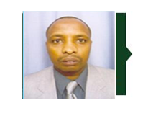

**Mr. Francis Chege Mwaura** was born on 3rd June 1970 and is the General Manager, Kibo Seed Company Tanzania Ltd, a subsidiary of Kenya Seed Company since June 2014. Previously he was the Head of sales and marketing for the Group. He holds Bcom degree in Marketing from University of Nairobi and Msc. in Global Marketing from Liverpool University and a Diploma in Marketing and is a member of MSK and C.I.M. He has been in the company for 11 years and has over 20 years’ experience in management and marketing.

**CPA Patrick Thuo** was born on 20th August 1972 and is the Head of Finance. He holds a Bachelorof Commerce and is pursuing a Master’s in Business Administration from the University of Nairobi. He is a member of the Institute of Certified Public Accountants of Kenya (ICPAK), the Kenya Institute of Management (KIM), a graduate of Advanced Management Programme (Strathmore IESE Business School, Barcelona Spain) and a Certified Public Secretaries (CPSK) finalist. He has over 20 years managerial and leadership experience from key sectors of the economy including banking, public and private organizations having worked with Coca-Cola, Citibank and United Bank for Africa (UBA). CPA Thuo has also served in the management committee of Kitale club and joined Kenya Seed in November 2011.

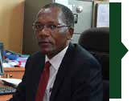**Mr. Stephen Malakwen** was born on 12th July 1966 and is the Head of Human Resources. Hehas over 20 years’ experience in human resource, administration, marketing and finance sectors. He holds a Masters in Human Resource Management from Open University of Tanzania, BA degree in Business Administration from Coventry University, United Kingdom and a Higher Diploma in Human Resource Management. He is a member of the Governing Council of the Institute of Human Resource. He is also a member of the Rural Employers’ Association. He has been a member of National Industrial Training Authority (NITA) representing Federation of Kenya Employers. He joined the Company in 2004.

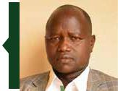**Mr. Chepsiror Kiplagat Sammy** was born on 12th December, 1966 and is the Head of Salesand Marketing. Mr. Chepsiror has over 25 years’ experience in strategic Marketing, Sales, Operations, Banking and Customer Service management. He holds MBA in Strategic Management, Master of Management and Leadership, Bachelor of Commerce (Marketing), Diploma in Management & Development. He is a member of Marketing Society of Kenya (MSK) and Public Relations Society of Kenya (PRSK). He joined the Company in 2006 as Sales and Marketing Manager in Simlaw Seeds Company. He previously worked in banking sector. He is a National Council member of Agricultural Society of Kenya.

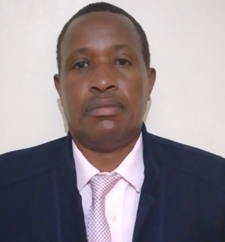

**Mr. Joseph Kamau**: He is the acting head of research and development. He joined the company in 2007 as maize breeder. He had previously worked as agricultural officer with the Ministry of Agriculture and as a research officer at KALRO. He is spearheading research in the company. He holds a M.Sc. Degree in plant breeding from University of Nairobi, BSc. Agriculture from the University of Nairobi, and certificate in maize improvement from CIMMYT, Kenya. He has developed and released several maize varieties of like H529, H533, H534 and H535. He is a member of the Plant Breeders Association of Kenya.

**OUR MANAGEMENT TEAM (continued)**

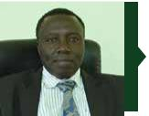**Mr. Hosea Sirma** was born on 28th August 1962 and is the Head of Production in charge of earlygeneration Seeds. Mr. Hosea Sirma holds a BSC degree from University of Nairobi. Hosea Sirma joined the Company in 1991 and now has 25 years’ hands on experience in seed Business Management and Quality Management Systems, having worked in Research Department as a Research officer, Basic Seed Unit Seed maize production, Nakuru wheat production and also a Quality Management Systems Auditor. He was the company’s management representative from 2008 up to 2011.

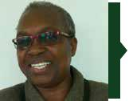

**Mrs. Joyce Aleyo Agufana** was born on 25th November 1962. Mrs. Agufana has a diploma in Agriculture from Egerton University and BBA (Marketing) from Kenya Methodist University. She joined the company in 1989 as Computer Operator at Elgon Downs Farm and has held various positions in the company namely Production officer (1992-2006), Deputy Manager Pastures and Sunflower (2006-2010). She is currently the Production Manager, Kitale.

.

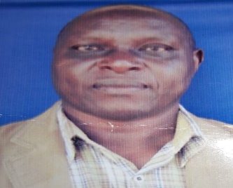

**Mr. Paul Tonui** was born on 12th August 1962. Mr. Tonui has a diploma in Farm management from Egerton University. He joined the company in 1st June 1988 as a management farm trainee at Elgon Downs Farm for one year, he was then posted to production seed maize as a field officer, where he has vast experience as the wheat and Maize production field officer for a period of twelve years, in Nakuru (1989-2015), (2016-2020) was the acting production manager seed maize, He is currently the Operations Manager, Nakuru Branch.

**Eng. Erick Nyamburi** was born on 30th April 1973 and is the Head of Processing and Engineering. Eng. Nyamburi is a holder of B.sc in Engineering (Mechanical), Master of Business administration from the University of Nairobi and training in Program for Management Development at Strathmore Business School joined the Company in 2016. He is a corporate member of the Institution of Engineers of Kenya (IEK) and a Registered Professional Engineer with Engineers Board of Kenya (EBK). Eng. Nyamburi has over 16 years of diverse experience in Engineering projects, Maintenance and Operations management from various companies.

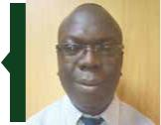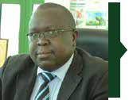

**Mr. Erick Tegei** was born on 8th October 1978 and is the Quality Assurance Manager. He holdsa Bachelor of Science in Biochemistry from Kenyatta University, post graduate Diploma in Quality Management from Kenya Institute of Management, and pursuing MBA in strategic Management from JKUAT, MSc. Seed Science and Trade (Ongoing). He is a member of International Seed Testing Association based in Zurich, Switzerland. He joined Kenya Seed Company Ltd in 2010. He has over 14 years’ experience in Quality Management systems and laboratory testing management.

**Mr. Philip Chemwetich** was born on 2nd August 1969 and is the ICT Manager. He is responsible for the Preparation of strategic and operational plans for the ICT and ensures ICT systems comply with regulatory and legal requirements. He has over 20 years’ experience in the implementation and maintenance of technology infrastructure. He holds a Bachelors Science Degree (Maths/Computer Science) from Kenyatta University. He is a Fellow of the Computer Society of Kenya (FSCK). He joined the company in October 1995 as a Systems Analyst/Programmer.

**OUR MANAGEMENT TEAM (continued)**

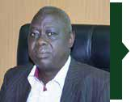

**Mr. Thomas Kiptoch Mukung’** was born on 8th April 1962 and is the Security Manager. He holds a Diploma in Public Administration from Moi University and a Bachelor’s Degree in Public Administration from Kisii University. He started his career in 1982 at Kenya post and telecommunications until 1998 when he joined Kenya Seed Company as a Security officer.

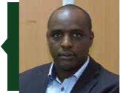

**Mr. Bethuel Bett Chemitei** was born on 24th November 1978 and is the Manager Procurement and supplies. He has over 16 years’ experience in Procurement, Supplies, Operations, Sales and Marketing having worked in private sector and banking industry and joined the company in 2016. He holds a Master of Science in Procurement and Logistics from JKUAT, Bachelor of commerce (Procurement & Supply Chain management) from University of Nairobi, Diploma in Procurement & Supply Management (CIPS), Diploma in Sales and Marketing from Technical University of Kenya. He is Member of Kenya Institute of Supplies Management (KISM), Chartered Institute of Procurement and Supply (CIPS). He has verse knowledge in procurement & Supply laws.

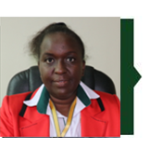

**Ms. Jane Gitau** was born on 2nd April 1967 and is the Senior Corporate Communications Officer. Ms. Gitau has over 30 years of experience in public relations and communications. She was previously the President of Public Relations Society of Kenya (PRSK). She holds Masters in Journalism Studies from Cardiff University in UK. She joined the company in August 2019. She is a fellow of Public Relations Society of Kenya (PRSK) and Secretary General of Africa Public Relations Association (APRA). She has previously worked for the International Livestock Research Institute (ILRI), the Eastern African Sub Regional Support Initiative for Advancement of Women (EASSI) and the media.



|  |
| --- |
|  |

# CHAIRMAN’S STATEMENT

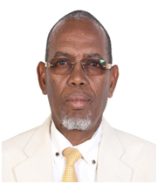

Dear Shareholders,

It is with great pleasure that I present to you the annual report and financial statements of Kenya Seed Company for the year ended 30th June 2023.

**Business Environment Overview**

With a GDP growth at 4.8 percent in 2022, economic performance softened after the strong rebound from the COVID-19 crisis at 7.5 percent in 2022. The growth rate, however, has remained in line with Kenya’s long-term growth trajectory, even though the economy faced challenging global financial conditions, fuel, and food price shocks coupled with the elections, and a historic drought that affected the economy, especially in the second half of 2023.

The growth momentum was driven by the service sector which contributed about 80 percent of the increase in total GDP. Financial services, tourism, and transport sectors performed especially strongly.

Fiscal consolidation, that Kenya embarked on in recent years to address mounting debt sustainability challenges and which was interrupted by the pandemic, continued in 2023 helping to reduce external and domestic imbalances.

While climate change is recognized as a major threat to Kenya’s growth profile, global efforts to address climate change, especially reducing greenhouse gas emissions, also offer positive opportunities for the Kenyan economy.

Kenya’s Big Four economic plan, focuses on manufacturing, affordable housing, universal health coverage, and food and nutrition security. It envisages enhancing structural transformation, addressing deep-seated social and economic challenges. By implementing the Big Four strategy, Kenya hopes to reduce poverty rapidly and create the much-needed decent jobs for the youth.

The agricultural sector, which continues to be the mainstay of Kenya’s economy contributing 26% of the GDP, experienced mixed results. The seed subsector faced challenges in land subdivision which has reduced acreage suitable for seed production. The implementation of the Comesa protocol on commodities has seen the flooding of cheap commercial maize into the country from member countries, has led to low commercial maize prices.

**Financial Review**

We are hereby delighted to report that we posted a performance of Kshs 7.15 billion and Kshs 5.033 billion for group and company respectively in 2023 as compared to the same period last year of Kshs 6.94 billion and Kshs 5.12 billion for the company and the group respectively. The recorded profit before tax was Kshs 418 million and Kshs 263 million for group and company respectively in the period ended 30th June 2023 from Kshs 359 million and Kshs 247 million recorded for the period ended 30th June 2022.

The Group asset base increased by 32% from Kshs 13.97 billion to Kshs 18.38 billion and the company asset base increased by 30% from Kshs 13.62 billion in the previous year to Kshs 17.74 billion respectively in the year under review.

**Seed Supply**

The company made significant progress in increasing seed acreage under irrigation by enhancing partnership with key seed growers who have installed irrigation capacity in their farms. Following this initiative, the Company was able to avail sufficient quantities of seed of all the major varieties for all agro-ecological zones.

**Future Outlook**

The future outlook of Kenya Seed Company is bright. The Board has continued to develop more strategies to grow the market and enhance financial management in order to increase profits and optimize operations. The Board is also putting in place strategies to expand business in the regional markets which include Tanzania, Uganda, Rwanda, Burundi and Democratic Republic of Congo. In addition to expanding the regional market, the Company has made strides in expanding her product portfolio to include vegetable seeds, pastures, and sunflower seeds among others. The Board of Directors will continually review the various business strategies in place to ensure sustained business profitability and growth. In the financial year 2022/23, the board will initiate strategies which will enhance governance and compliance practices to relentlessly focus on risk management.

**Appreciation**

I wish to extend my sincere appreciation to all our shareholders, business partners, advisors, esteemed customers, our farmers, the Board of Directors, the Management team and the entire staff for their unwavering support and confidence in the Company and our products.

God bless Kenya Seed Company and each one of you.



**Mr.Mohammed Bulle**

**Chairman.**

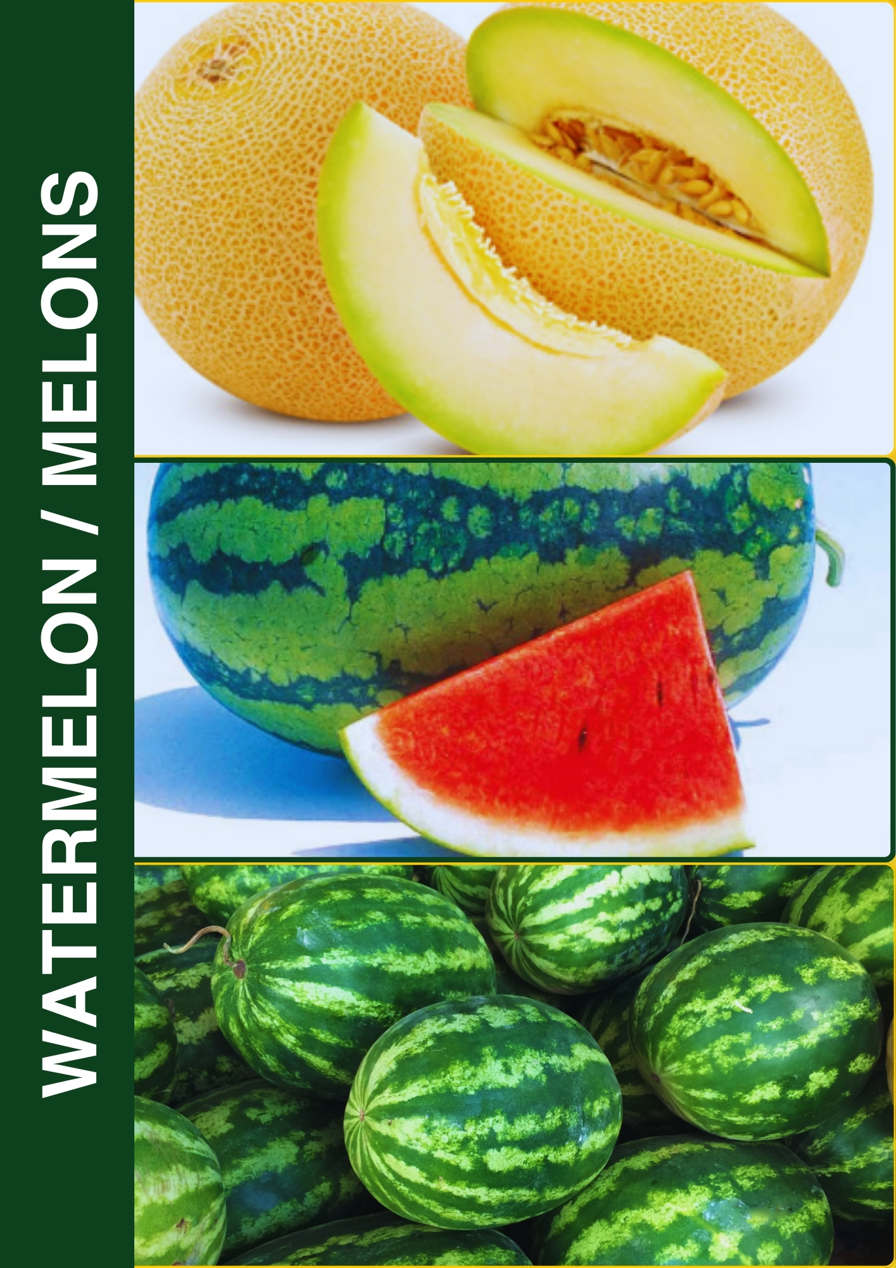

|  |
| --- |
|  |

# 

# C:\Users\elizabeth.furaha\Downloads\MD PASS.jpegAG. MANAGING DIRECTOR’S STATEMENT

I am delighted to present to you the performance of Kenya Seed Company for the year ended 30th June 2023.

**Financial Performance**

During the period the company turnover decreased by 2% from Kshs. 5.12 billion in the year 2022 to Kshs 5.03 billion in the year ending 30th June 2023 while Group turnover increased by 3% from Kshs 6.94 billion in 2022 to Kshs 7.15 billion in 2023.

. The company posted a pretax profit from Kshs 248 million in 2022 to Kshs 263 million in 2023, while the Group posted an increase from Kshs 359 million in 2022 to Kshs 418 million in 2023.

The company’s closing Cash and Cash equivalent position increased from Kshs 2.35 billion in 2022 to Kshs 2.60 billion while Group Cash and Cash equivalent increased from Kshs 2.52 billion to Kshs 2.94 billion. The Group asset base increased by 30% from Kshs 13.97 billion to Kshs 18.38

billion and the company asset base increased by 30% from Kshs 13.62 billion in the previous year to Kshs 17.74 billion respectively in the year under review.

**Research and Development**

The company will continue to invest in research which has enabled her to release new seed varieties. Once these new varieties are fully commercialized shall afford farmers an opportunity to maximize their productivity and diversify into other food crops. Already Kenya Seed Company has forwarded new seed varieties to National Performance Trials (NPT) and we expect that most of these varieties shall be released soon. This is geared towards ensuring that there is food security and nutrition in support of the government’s Bottom up economic transformation Agenda.

**Operations**

In order to improve our performance and ensure sustainability, some initiatives have been made to harness potential in the external markets by releasing our varieties in countries such as Rwanda, Burundi and DRC, whose objective is to expand the market and increase earnings and fight competition.

**Future Outlook**

Going forward, we are on the right path to greater prosperity with numerous opportunities for business growth and expansion supported by anticipated national economic growth. Our future growth will come from:

* Focus on adequate supply of short to medium season seed varieties whose demand is increasing with the changing weather patterns,
* Commercialization of MLND tolerant varieties which are high yielding,
* Commitment to provide resources towards promoting and expanding the vegetable seed market to increase profit margins,
* Turning around external subsidiaries to profitability, thus transforming them into profit generating units,
* Diversifying to non-maize seed product portfolios thus reducing over reliance on maize seed,
* increasing the supply of pasture seeds to support the growing Dairy industry,
* Enhancing the efficiencies and effectiveness in the entire value chain through complete automation of the new AMS/SAP systems.

**Acknowledgement**

I take this opportunity to express my gratitude to our customers for their loyalty and continued support. My appreciation also goes out to our Shareholders for their commitment to our Strategy, to the Directors of Board whose leadership and guidance have continued to inspire and challenge us, to our regulators and the government whose invaluable oversight and assistance have been key to our progress so far, to our stakeholders and to the communities that we have the privilege of serving. We remain indebted to you all, and look forward to your continued support and goodwill towards jointly building the company envisaged in our Corporate Vision – “*The Leading Supplier of Top-Quality Seed in Africa”.*

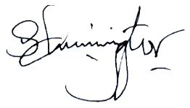 Thank you and God bless you.

**Mr. Sammy Chepsiror**

**Ag.Managing Director**

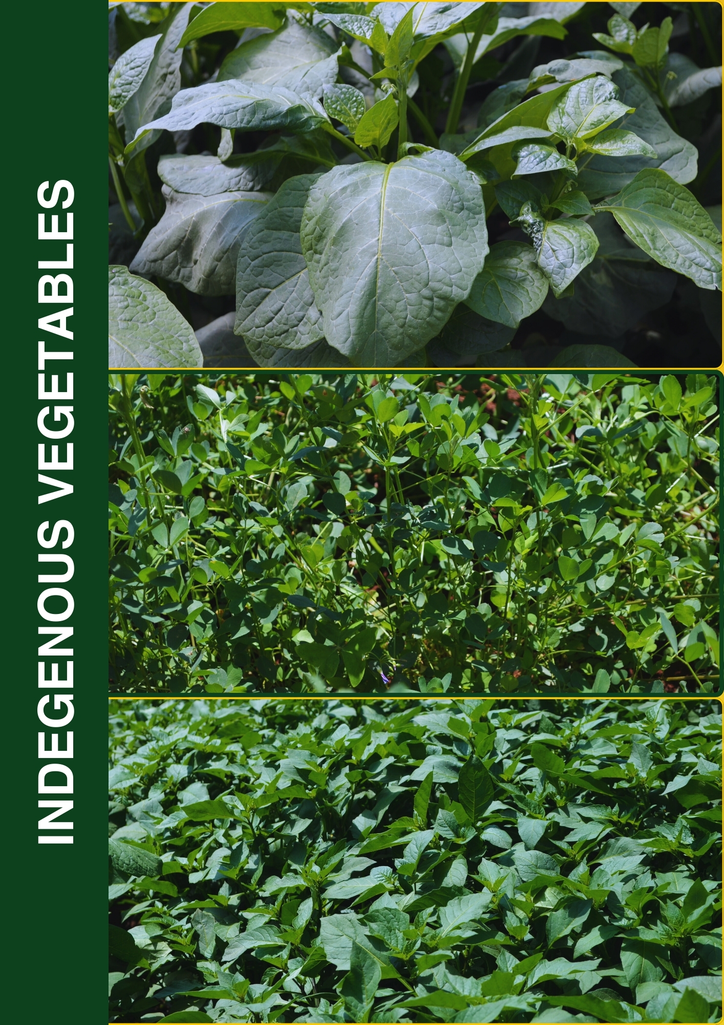

|  |
| --- |
|  |

#### 

#### REVIEW OF KENYA SEED COMPANY ’S PERFOMANCE FOR FY 2022/2023

Section 81 Subsection 2 (f) of the Public Finance Management Act, 2012 requires the accounting officer to include in the financial statement, a statement of the national government entity’s performance against predetermined objectives.

The company has 10 strategic pillars and 12 objectives within its Strategic Plan for the FY 2018/2019- 2022/2023. These strategic pillars are as follows:

* Pillar 1: Corporate communication
* Pillar 2: Technology uptake
* Pillar 3: Seed production
* Pillar 4: Quality of seeds
* Pillar 5: Productivity of subsidiaries
* Pillar 6: Governance and risk management
* Pillar 7: Human resources management
* Pillar 8: Financial sustainability
* Pillar 9: Marketing growth
* Pillar 10: Engagement/collaboration/partnerships with stakeholders

The company develops its annual work plans based on the above 10 pillars. Assessment of the Board’s performance against its annual work plan is done on a quarterly basis. The company achieved its performance targets set for the FY 2022/2023 period for its 10 strategic pillars, as indicated in the diagram below:

| **Strategic Pillar** | **Objective** | **Key Performance Indicators (KPI)** | **Activities** | **Achievements** |
| --- | --- | --- | --- | --- |
| Corporate Communication. | Ensure effective real time internal & external communication. | Communication Report | Improve use of existing modes of communication | Addition of five new lines i.e. Safaricom and Airtel added to the existing ones within our switchboard making it convenient for customers to reach us.  There was also increased email usage from 200 to 250 users and migration of the entire mailing system to the cloud. |
| Embrace emerging modes of communication | Acquisition of social media software (meltwater) which is used to track information about Kenya Seed Company in social media and online bloggers both locally and internationally.  Existence of social media chat groups i.e. Whatsapp especially for functional committees |
| CSR policy | Develop and implement a CSR policy | The Company is in the process of developing a CSR policy; however the company spent Kshs 11.7 million on CSR activities in the year where seed and fruit seedlings were issued, a public primary school was built among other community development activities.. |
| Technology uptake. | Develop, release and commercialize market driven varieties and agronomic advice on crop varieties by 2020. | Number of varieties developed | Developing superior crop varieties for each of the macro ecological zones | The following varieties were submitted by R&D to the National Performance Trial (NPT);  8 for maize varieties for different agro zones  4 for wheat varieties. One wheat variety and 2 oat varieties were released for commercialization. |
| Number of collaborating institutions | Collaborating with relevant institutions to develop and commercialize crop varieties | The company collaborated with 3 institutions namely University of Nairobi, Kenya Agricultural Research Organization (KALRO) and University of Eldoret. (UOE).  The collaboration mainly focuses in breeding with new technologies expected to result in commercialization of new superior varieties. |
| Number of recommendations made | Use of cost-effective Agronomic practices | Several recommendations were made to growers on the best Fertilizers, herbicides and insecticides to be used. |
| Improve operational efficiency | Number of machinery and equipment’s acquired. | Modernize farm machinery and equipment at EDF | The company acquired 2 (Two) tractors of 130 Hp each in its effort to modernize farm machinery and equipment at EDF. |
| Number of subsidiaries Linked up | Link up subsidiaries to parent company ERP systems | The Company has begun the process of linking and automating the subsidiaries to parent company ERP systems. Infrastructural assessments have been done for Simlaw Uganda and Kibo seed Tanzania. |
| Number of Upgraded equipment and storage. | Upgrade of equipment and storage facilities | The Company is working on a distribution model that ensures early movement of seed to Agents and Stockiest as opposed to keeping the seed in our stores; this will also reduce the pressure on additional storage requirement. |
| Electrical energy consumption report | Reduce electrical energy consumption | There is reduced electric energy consumption by use of modern electric energy saving equipment. |
| No of outsourced non-core activities | Outsource non-core activities | The company has outsourced non-core activities e.g., Security and staff welfare (tea serving) |
| ISTA accreditation certificate | Attain ISTA accreditation by 2023 | An approval was issued for the acquisition of additional lab equipment and some laboratory infrastructure adjustments. A compliance audit was done in the 2nd quarter by the regulators and gaps identified were addressed. The Company fulfilled KEPHIS authorization requirements and was awarded Certificate of Authorization as Seed Inspection and Testing Entity on the 19th January 2021. |
| Seed Production | Optimize seed production to meet 100% of annual planned target | Kilos per unit area | Increase yields per unit area by 10% by 2023 | In the year 2022/2023 the Company Produced 22.544MT against a target of 31.43MT of maize seed. The average yield per acre was 850 Kilos which is below optimal average of 1,000 Kilos. This was due to bad weather leading to post harvest losses. |
| Percentage increase of irrigated seed production area | Increase irrigated seed production area by 25% by 2023. | The Company decreased irrigated seed production area to 5,070 acres in 2022/23 from 5,388 in 2021/22 due to reduced production area in the Wei wei irrigation scheme. |
| No of new acreage identified | Explore new areas for seed production | Maize seed production commenced within the foreign subsidiaries mainly in Tanzania and Rwanda with support from the mother company. In Tanzania production is done on 1,071 acres and 58 acres in Rwanda. |
| Quality of seeds. | To ensure compliance with Seed Act Cap 326 as well as customer and stakeholder expectations on seed quality. | Reduced number of customers complains of seed quality | -Continuously implement and review effectiveness of quality assurance programs to enhance seed quality  -Build capacity to attain ISTA accreditation and be an authorized institution in execution of OECD seed schemes.  -Seek for authorization by KEPHIS to carry out delegated seed certification | The company has ensured there is effectiveness of quality assurance programs to enhance seed quality hence registering minimal customer complaints.  The company attained the ISTA accreditation and KEPHIS Authorization. Training has been done for 12 members of staff from Quality Assurance as Seed inspectors and analysts and who have been gazetted. |
| Productivity of subsidiaries. | Invest required resources to revitalize subsidiaries | Assessment report | Establish need assessment for subsidiaries requirements | The subsidiaries have developed five-year strategic plans. |
| Kilos produced in host country | Lease land to do production of seed in host countries | There is production of seed maize in Tanzania and Rwanda. In Tanzania 1,071 acres was planted with estimates yield of 1,071,000 kilos and in Rwanda 58 acres was planted with an estimated yield of 58,000 kilos. |
| Financial report | Convert subsidiary debt into equity and sell shares to host country | The company has commenced plans to convert subsidiary debt into equity. |
| Governance and Risk management | Improve the risk management frame work | Risk management policy. | Develop and implement a risk management policy. | The company has developed and is implementing the risk management policy, as well as departmental risk champions who have developed respective risk registers. |
| Company assets status report | Secure company assets | To ensure the safety of property the Company has insured all property and has also installed CCTV cameras in all buildings. |
| Human Resources Management | Attract, retain and develop a competent motivated staff complement | Reviewed organization structure | Review and implement an organizational structure. | The company has a reviewed organization structure and implementation is ongoing. |
| Succession management system | Develop and implement a Succession management system | The process of developing a Succession Management system has been initiated and will be concluded in 2022/23. |
| Employee satisfaction index report | Enhance employee satisfaction index by 2% annually | The company commenced the employee satisfaction survey which will be concluded in 2022/23. |
| Performance Management system | Enhance the Performance Management system | Top management were trained on Performance management and the company is in the process of reviewing its performance management tools. |
| Reward/ sanction report | Enhance the reward/ sanction and remuneration system | The company has a HR policy which guides on the reward/ sanction and remuneration system.  The company also rewards its members of staff with a bonus pay based on the organizational performance. |
| Training Needs Assessment Report | Ensure Staff Training and Development | The company has developed and is implementing the Training Needs Analysis (TNA). |
| Work environment report | Develop and maintain a work environment that stimulates team spirit, passion, engagement and achievement | The company has continued to maintain a work environment that stimulates team spirit, passion, engagement and achievement through departmental team building forums. |
| Financial Sustainability | Improve Profit Before Tax by 20% annually | Audited Financial Statements | Increase gross profit margins by 1% annually | The Company has put in place strict internal control measure to prevent against losses. It has also negotiated for more favorable trading terms with suppliers. The gross profit margin declined from Kshs 2.2 billion in 2021/22 to Kshs 2.0 billion in 2022/23 translating to a 10% decline. |
| Sales reports | Attain the Targeted Sales Volume of all Products | The company has always strived to attain the Targeted Sales Volume of all Products. In the flagship product maize, it attained a sales volume 25,875MT against a target of 28,000MT. |
| Audited Financial Statements | Reduce overheads by 1% annually | There is reduced electric energy consumption by use of modern electric energy saving equipment. It has also ensured that the Seed maize producer price to selling ratio should not be more than 40%. It has also worked towards reducing overheads by outsourcing non-core functions and using internal resources. e.g. Training. The overheads increased from Kshs 1.4 billion in 2021/22 to Kshs 1.8 billion in 2022/23 translating to a 22% increase. |
| Marketing Growth | Increase sales volume | Sales volume report and Promotion report. | Carry out aggressive marketing research in all regional markets | The Company achieved a sales volume of 27,171 MT of its flagship product maize against a target of 28,000 MT translating to 97% achievement.  To attain the sales volumes in the subsequent years, the marketing team has done market segmentation and assigned targets to its outlets to step up visibility and sales. It has also intensified planned product promotion activities.  There is synchronized Production, Processing and marketing demand to ensure product availability. |
| Export report | Timely Supply of the required quantities of seed to all subsidiaries | The Company has continued to support its subsidies in Uganda and Tanzania and its sales outlet in Rwanda through timely Supply of the required quantities of seed. |
| Sales Volume report | Product diversification i.e. Sale of complementary products | The company is in the process of partnering with suppliers of complementary products e.g. fertilizers and herbicides. |
| Feedback and Market audit report. | Market 4 established seed varieties per eco zone | The company is in the process of conducting a market survey in 2022/23. |
| Sales Volume report | Enhance Sale of slow adoption products | Establishment of business partnership and relationship with strategic stakeholders e.g. the County Governments and NGOs who purchase and distribute orphaned crop seeds e.g. finger millet and soya beans etc to groups. |
| Improve Customer satisfaction level from 75% to 80 % in 5 years | Survey report | Conduct quarterly market research /intelligence. | Plans to carry out a market research/survey have commenced will be done by an external service provider. |
| Engagement/collaboration/partnerships with stakeholders | Enhance inter departmental & subsidiary linkages | Reviewed SLAs | Review SLA between departments and subsidiaries. | Ensured enhanced inter departmental linkage in Company and in the value chain. |
| Quarterly Reports | Incorporate subsidiary in the parent company plans. | The company has ensured that critical subsidiaries plans have been incorporated into the Parent Company plans. The subsidiaries reports are sent to the parent company and are subsequently discussed at management meetings. |
| Reviewed company service charter | Review company service charter | The Citizens Service Delivery Charter was reviewed and approved and subsequent implementation is ongoing. |

# CORPORATE GOVERNANCE STATEMENT

Corporate governance is the system of rules, practices, and processes by which a company is directed and controlled. Corporate governance essentially involves balancing the interests of a company's many stakeholders, such as shareholders, senior management executives, customers, suppliers, financiers, the government, and the community. Since corporate governance also provides the framework for attaining a company's objectives, it encompasses practically every sphere of management, from action plans and internal controls to performance measurement and corporate disclosure.

The Board of Directors is the primary direct stakeholder influencing corporate governance. They are committed to the principle that the company and its subsidiaries should operate with integrity and ethics and maintain a high standard of corporate governance in the interest of shareholders and all other stakeholders. The Board believes that the company has complied with the highest standards of Corporate Governance Practices. The spirit and practice of corporate governance in Kenya Seed Company is about commitment to values and ethical business practices. This implies timely compliances and correct disclosures of financial information on performance, ownership and governance of the company.

The key elements of corporate governance are transparency, disclosure, accountability, supervision and internal controls, risk management, internal and external communication and high standards of safety, health environment, accounting, and product and service quality.

The Board has empowered responsible persons to implement its board policies and guidelines and has set up adequate review Process. The Company is committed to optimizing long term value for its stake holders with strong emphasis on the transparency on its operations and instilling pride of association. The company follows best practice of corporate governance and reporting systems

**Board of Directors**

The composition of the Board is compliant with good corporate governance practices. The role of the Chairman and the Managing Director are segregated. The Managing Director is in charge of the day to day running of the business of the Company. A non-executive director acts as Chairman of the Board. The directors are given appropriate and timely information to enable them to maintain full and effective control over all strategic, financial, operational and compliance issues.

The current Board of Kenya Seed Company is composed of one executive director and eight non-executive directors including the Chairman. The directors are committed members with diverse and complementary skills and expertise in the fields of strategy, management, production, finance, marketing and human resource development.

The Board provides leadership, strategic guidance, objective and independent view of the company’s management while discharging its fiduciary responsibilities thereby ensuring the management adheres to high standards of ethics, transparency and disclosure. The composition of board, date of appointment and position held as on 30th June 2023 is highlighted on Page (xi ) of this booklet.

**Board Meetings**

The Board meets at least once quarterly or more often in accordance with exigencies of the business. The Board work plan and calendar of meetings is prepared in advance. Adequate notice is given for each board meeting, the agenda and papers are circulated in good time. The Board held 10 meetings in the financial year ending 30th June 2023. During their meetings the Board reviews the Company’s performance against the planned strategies and also approves issues of strategic nature.

**CORPORATE GOVERNANCE STATEMENT (continued)**

The attendance at the Board meetings during the financial year 2022/23 is as follows:

|  |  |  |  |
| --- | --- | --- | --- |
| **Member** | **Meetings Held** | **Meetings Attended** | **% Attendance** |
| Mr.Mohammed Bulle | 10 | 9 | 90% |
| M/s Edna Atisa | 10 | 9 | 90% |
| Mr. Elijah Obebo | 10 | 1 | 10% |
| M/s Joyce Wesonga | 10 | 1 | 10% |
| Mr. Gerald Mwangi | 10 | 8 | 80% |
| Mr. Tobias Osano | 10 | 3 | 30% |
| Mr. James Wanjohi | 10 | 6 | 60% |

**Governance Principles**

Corporate governance is the system of clearly defined authorities and responsibilities, which results in the establishment, operation and maintenance of a system of internal control that is regularly tested to ensure effectiveness. The system enables the Board of Directors to ensure that the managers of the Company are acting in the interests of the shareholders and other key stakeholders.

At Kenya Seed Company Limited, we place a great deal of importance on robust corporate governance practices and are committed to applying the highest standards of business integrity and professionalism in all our activities. The Company achieves this by using a risk-based approach to establish a system of internal control and by reviewing the effectiveness of the system of internal control on a regular basis.

The Kenya Seed Company Limited has formulated and applies sound internal corporate governance guidelines, which address the responsibilities of management, the Board and its composition, selection procedures for new directors and relationships with stakeholders.

The Company held a success Annual General Meeting on 30th June 2023, where new Board of Directors were elected.

The following are the new Directors appointed, elected and Gazetted in July 2023.

|  |
| --- |
| Ms Purity Ngiricii -Chairperson |
| Mr. Symon Cherogony- Board Member |
| Mr. Job Ndemo - Board Member |
| Hon. Benard Wambwa- Board Member |
| Mr. Edwin Tum - Board Member |

**CORPORATE GOVERNANCE STATEMENT (continued)**

**Board Committees**

The Company has set up three key Board committees to help in the implementation of its policy guidelines and strategy. These committees meet regularly and are chaired by non-executive directors. The committees report their findings to the Board for further vetting and subsequent Approval by the Board. They include:

* The Audit Committee, which is responsible for the oversight of the integrity of financial statements, risk management, internal controls, compliance and ethics and effectiveness of internal and external audit activities in the company and its subsidiaries.
* The Finance, Staff and General Purposes Committee, which handles human resource and finance matters including sourcing and application of funds.
* The Production, Research and Marketing Committee, which handles production; research and development; and sales and marketing matters in the Company.
* The Board of the company’s subsidiaries namely Simlaw Kenya, Simlaw Uganda and Kibo Tanzania.

The structure of the board and the planning of the board’s work are key elements to effective governance. The company’s board of directors has established board committees as one way of managing its work thereby strengthening the board’s governance role. The company has three committees that focus on specific areas thereby allowing the board to concentrate on broader and strategic issues and directions.

The Board has an additional three committees (Boards) for her three subsidiaries. These committees include:

**1. Audit Committee**

The board of directors has entrusted the audit committee to supervise the processes relating to financial reporting and disclosure on financial information in accordance with the financial reporting standards, safeguarding of assets, adequacy of financial systems and reviewing of the company’s financial and risk management policies

**Role of Audit Committee:**

1. Overseeing the Company’s financial reporting process and disclosure of financial information to ensure that the financial statement is correct, sufficient and credible information is disclosed.
2. Reviewing the financial statements and draft audit report, including quarterly information.
3. Reviewing with management the annual financial statements before submission to the Board focusing primarily on:
   * Any changes in accounting policies and practices;
   * Major accounting entries based on exercise of judgment by management;
   * Qualifications in draft audit report;
   * Significant adjustments arising out of audit;
   * The going concern assumption;
   * Compliance with accounting standards;

**Composition and other details of Audit Committee**

The Audit Committee comprises of four members, all of whom are non-executive directors. The Audit Committee Meetings are usually held at the Registered Office of the Company and are usually attended by the Internal Auditor of the Company. The internal auditor acts as Secretary of the Audit Committee. In the year 2022/23 the Committee did have its sitting to deliberate on the Audit Matters as per its mandate. However, considering the dual reporting structure of the department, the reports for the year were channeled to the Managing Director

**CORPORATE GOVERNANCE STATEMENT (continued)**

**2. Research, Production and Marketing committee:** The company has the Research, Production and Marketing Committee that deals with the core mandate of the company-seed production up to ensuring seed reaches the customer. Because of the challenges on constitution of the Board, there was no committee to consider the issues as has been the case when the Board is fully constituted. This committee is usually made up of 3 members of the Board with the Managing Director who step in the circumstances to consider all the issues across the company. Consequently, there was no Research Production and Marketing Committee meeting per se for the financial year 2022/23.

**3. Finance, Staff and General-Purpose Committee**

This committee assists the Board in matters relating to finances including sourcing and uses of Company funds, staff remuneration, recruitment, incentives and filling of vacancies.

There was no attendance at the Finance, Staff and General-Purpose Committee meetings for financial year 2022/23 for the reasons alluded to above under Research, Production and Marketing Committee. The Board Committees were not fully constituted during the period under review. As required by the Company’s Board Charter, each member of the Committee was given induction on the Company’s code of conduct which stresses the importance for each member to fully understand corporate behavior expectations, compliance with Board ethics and regulatory requirements.

**4. Board of Simlaw Seeds Kenya Limited**

This Board oversees the strategies of Simlaw Seeds Kenya Limited.

The was no attendance of the Simlaw Seeds Kenya Limited Board meetings during the financial year 2022/23.

**5. Board of Kibo Seeds Tanzania Limited**

This Board oversees the strategies of Kibo Seed Tanzania Limited.

There was no attendance of the Kibo Seeds Tanzania Limited Board meetings during the financial year 2022/23.

**6. Board of Simlaw Seeds Uganda Limited**

This Board oversees the strategies of Simlaw Seeds Uganda Limited.

There was no attendance of the Simlaw Seeds Uganda Limited Board meetings during the financial year 2022/23.

**Board Evaluation**

The Board undertakes an annual self-assessment to improve its members’ individual and collective Performance for continuous growth and sustainability of the Company. The evaluation covers the Board as a whole, its committees, and individual members, the Chairman, the Managing Director and the Company Secretary. During the year, the Board did not manage to carry out a self-evaluation exercise which they are essentially assisted by the State Corporations Advisory Committee.

**Directors’ Remuneration**

During every Board meeting, Directors are entitled to a sitting allowance, lunch allowance (in lieu of lunch being provided), accommodation allowance and mileage reimbursement where applicable within government set limits for State Corporations. The Chairman receives a monthly honorarium. Directors’ fees are paid annually upon approval by shareholders during the Annual General Meeting in accordance with Government’s guidelines for all state corporations.

**CORPORATE GOVERNANCE STATEMENT (continued)**

Below is a summary of payments per Board Member in **Kshs ‘000:**

|  |  |  |  |
| --- | --- | --- | --- |
|  | **Sitting Allowance** | **Travel & Accommodation allowances** | **Total Allwances** |
| **Director Name** | **Kshs.** | **Kshs.** | **Kshs.** |
| Ms. Edna Atisa | 320,000 | 391,550 | 711,550 |
| Mr. Elijah Obebo | 200,000 | 354,282 | 554,282 |
| Mr. Gerald Mwangi | 200,000 | 382,680 | 582,680 |
| Mr. James Wanjohi | 180,000 | 278,648 | 458,648 |
| Ms. Joyce.Wesonga | 100,000 | 194,750 | 294,750 |
| Mr. Mohammed Bulle | 300,000 | 505,490 | 805,490 |
| Mr. Mathew Tuitoek | 40,000 | 2,000 | 42,000 |
| Mr.S. Indimuli | 40,000 | 2,000 | 42,000 |
| Mr. Tobias Osano | 60,000 | 122,870 | 182,870 |
| **Total** | **1,440,000** | **2,234,270** | **3,674,270** |

Below is a summary of entitlements per Board Member

|  |  |  |
| --- | --- | --- |
| **Type of payment** | **Chairman** | **Member** |
| Honoraria | Kshs 80,000 | N/A |
| Sitting allowance (per sitting) | Kshs 20,000 | Kshs 20,000 |
| Telephone – airtime for mobile phone per month | Kshs 5,000 | N/A |
| Transport /mileage | Equivalent to cost of return air ticket | Equivalent to cost of return air ticket |
| Lunch allowance | Kshs 2,000 | Kshs 2,000 |
| Director’s fees per annum on prorata basis | Kshs 450,000 | Kshs 450,000 |
| Accommodation Allowance when travelling for meeting venues in Kenya | Kshs 18,200 | Kshs 18,200 |
| Accommodation Allowance when travelling for Board meeting in Uganda | US$615 | US$615 |
| Accommodation Allowance when travelling for Board meeting in Tanzania | US$603 | US$603 |

**Code of Conduct**

The Company has a code of conduct which seeks to guide employees in ethical conduct of business. All directors, management and employees are expected to observe high standards of integrity and ethical conduct when dealing with customers, staff, suppliers and regulators.

**Internal Control**

The effectiveness of the internal control is monitored on a regular basis by the Internal Audit function. The Internal Audit function reviews the Company’s compliance with the laid down policies and procedures as well as assessing the effectiveness of the internal control structures. The Internal Audit function focuses their attention to areas where the Company could be exposed to greatest risks. The Internal Audit function reports to the Audit Committee of the Board. The Company has established operational procedures and controls to facilitate proper safeguard of assets and accurate financial reporting.

**Conflicts of Interest**

All directors and management are under duty to avoid conflicts of interest. The conflict-of-interest requirements are embedded in the code of conduct and ethics as well as the directors’ letters of appointment. The board and board committees have standing agenda item on declaration of interest where members declare actual, potential or perceived conflicts of interest. The declared items of interest are part of the minutes. The directors are required to disclose their business interests that would conflict with the Company business.

**CORPORATE GOVERNANCE STATEMENT (continued)**

**Going Concern**

The directors confirm that the Company has adequate resources to continue in business for the foreseeable future and therefore to continue to use the going concern basis when preparing the financial statements.

**Company Shareholding**

ADC acquired shares in KSC through periodic purchases and direct allotments which accumulated in acquiring majority shareholding of 52.88% in 1986. On 30th May 2001, a prospectus was issued for sale of 4 million ordinary shares by private offer to existing shareholders and officers, employees of the company, seed growers, sub-agents and stockists, who were specifically invited to subscribe. The issued and fully paid share capital excludes 3,370,000 ordinary shares worth Kshs 67,400,000 that were issued in the year ended 30 June 2002, which were revoked after the High Court of Kenya ruling on 6 April 2006. These shares are currently a subject matter before the Court in Nairobi HCCC No. 575 of 2004. The nominal share capital together with the premium on these shares was received and is now classified under trade and other payables which amount to Kshs 124.9 Million and has been used in the company’s operations and trading since then.

The ten largest shareholders of the company as at 30th June 2023 were as follows:

|  |  |  |  |
| --- | --- | --- | --- |
| **No.** | **List of Shareholders** | **No. of Shares** | **% Shareholding** |
| **1.** | Agricultural Dev. Corporation | 5,700,720 | 52.88 |
| **2.** | KFA | 1,601,256 | 14.85 |
| **3.** | Soet Kenya Ltd | 1,500,000 | 13.91 |
| **4.** | Burch Colin Mr. | 549,660 | 5.10 |
| **5.** | Tum Nathaniel Kipkorir | 419,131 | 3.89 |
| **6.** | Woodland Kristin Annetta | 206,172 | 1.91 |
| **7.** | Anderson Robert Allen | 103,032 | 0.96 |
| **8.** | Gogar Farms Ltd | 103,032 | 0.96 |
| **9.** | Selly Neville Gordon | 86,760 | 0.80 |
| **10.** | Goes Eufrazio Juliao | 79,470 | 0.74 |

**Distribution of Shareholders**

|  |  |  |  |
| --- | --- | --- | --- |
| **No. of Shares** | **No. of Shares Held** | **No. of Shareholders** | **% Shareholdings** |
| Below 10,000 | 104,784 | 25 | 0.97 |
| 10,000-100,000 | 493,478 | 17 | 4.58 |
| 100,000-1,000,000 | 1,381,027 | 5 | 12.81 |
| Above 1,000,000 | 8,801,976 | 3 | 81.64 |
| **Total** | **10,781,265** | **50** | **100.00** |

**CORPORATE GOVERNANCE STATEMENT (continued)**

**Independence**

All the non-executive directors on the Board are independent of management and free from any business or other relationships, which could materially interfere with the exercise of their independent judgment.

**Activities and Achievements**

The Board meets regularly and has a formal schedule of matters reserved to it. All directors have access to the Company Secretary and Legal Counsel. Currently, the Board comprises eight non-executive directors and a Managing Director.



**Mr. Mohammed Bulle**

**Chairman, Board of Directors**

**30.06. 2023**

# MANAGEMENT DISCUSSION AND ANALYSIS

Kenya Seed Company’s vision is to be the leading supplier of top-quality seed in Africa. The company has issued share capital of 10,781,265 shares of which the Government of Kenya through Agricultural Development Corporation (ADC) owns 5,700,720 shares or 52.88%

**Section A: The entity’s operational and financial performance**

**A1. Five Year Performance Trend**

**Group Trend**

|  |  |  |  |  |  |
| --- | --- | --- | --- | --- | --- |
|  | **2023** | **2022** | **2021** | **2020** | **2019** |
|  | Kshs'000 | Kshs'000 | Kshs'000 | Kshs'000 | Kshs'000 |
| **Turnover** | 7,155,959 | 6,943,124 | 6,453,492 | 6,378,449 | 5,786,404 |
| Profit before tax | 418,966 | 359,215 | 883,076 | 614,059 | 243,811 |
| Tax charge | (192,912) | (188,005) | (273,894) | (276,799) | (280,635) |
| Profit for the year transferred to retained earnings | 226,054 | 171,211 | 609,183 | 337,260 | (36,824) |
| Dividends |  |  | - | - | - |
|  |  |  |  |  |  |
| **Share Capital and shareholders’ Funds** |  |  |  |  |  |
| Ordinary Share capital | 215,625 | 215,625 | 215,625 | 215,625 | 215,625 |
| Share holders' funds | 16,869,332 | 12,657,597 | 12,449,867 | 11,864,138 | 11,270,642 |
|  |  |  |  |  |  |
| **Earnings and Dividend per Share** |  |  |  |  |  |
| Earnings per share | 21 | 15 | 57 | 8 | 54 |
| Dividend per share (Kshs) | 24 | 15 | 5 | 6.31 | 5.25 |
|  |  |  |  |  |  |
| Seed Maize Produced (Kg) | 22,544 | 27,312 | 27,435 | 25,287 | 27,694 |
| CIG Seed Maize Sales (Kg) | 23,881 | 25,875 | 27,154 | 26,578 | 24,032 |

**Company Trend**

|  |  |  |  |  |  |
| --- | --- | --- | --- | --- | --- |
|  | **2023** | **2022** | **2021** | **2020** | **2019** |
|  | Kshs'000 | Kshs'000 | Kshs'000 | Kshs'000 | Kshs'000 |
| **Turnover** | 5,033,701 | 5,127,499 | 5,233,694 | 5,104,171 | 4,580,569 |
| Profit before tax | 263,940 | 247,657 | 823,657 | 720,955 | 396,298 |
| Tax charge | (200,197) | (165,350) | (246,350) | (253,718) | (261,075) |
| Profit for the year to retained earnings | 63,743 | 82,306 | **577,307** | 467,237 | 135,223 |
| Dividends |  |  | - | - | - |
|  |  |  |  |  |  |
| **Share Capital and shareholders’ Funds** |  |  |  |  |  |
| Ordinary Share capital | 215,625 | 215,625 | 215,625 | 215,625 | 215,625 |
| Share holders' funds | 16,595,563 | 12,625,225 | 12,556,386 | 11,977,814 | 11,358,515 |
|  |  |  |  |  |  |
| **Earnings and Dividend per Share** |  |  |  |  |  |
| Earnings per share | 6 | 8 | 54 | 43.34 | 12.54 |
| Dividend per share (Kshs) | 5.25 | 5.25 | 10.73 | 8.63 | 5.25 |
|  |  |  |  |  |  |
| Seed Maize Produced (Kg) | 22,544 | 27,312 | 27,435 | 25,287 | 27,694 |
| CIG Seed Maize Sales (Kg) | 23,881 | 25,875 | 27,154 | 26,578 | 24,032 |

**A2: Revenues**

The Group’s revenue Increased from Kshs 6.9 Billion to Kshs 7.1 Billion as highlighted in the table below:

|  |  |  |  |  |  |
| --- | --- | --- | --- | --- | --- |
| **Product** | **2023** | **Product Contribution (%)** | **2022** | **Product Contribution (%)** | **Increase/decrease**  **2022 to 2023** |
|  | Kshs ‘000 | Kshs ‘000 | Kshs ‘000 |
| Certified Maize Seeds | 5,238,302 | 73% | 5,164,800 | 74% | 73,502 |
| Basic Maize Seeds | 46,939 | 1% | 53,549 | 1% | (6,610) |
| Vegetable Seeds | 1,499,279 | 21% | 1,439,779 | 21% | 59,499 |
| Wheat Seeds | 110,910 | 2% | 144,206 | 2% | (33,297) |
| Pasture Seeds | 164,335 | 2% | 124,887 | 2% | 39,448 |
| Income from Other Seeds | 137,374 | 2% | 99,433 | 1% | 37,941 |
| Biological Assets (IAS41) | (44,385) | -1% | (86,197) | -1% | 41,813 |
| Milk | 3,206 | 0% | 2,667 | 0% | 539 |
| **Total** | **7,155,959** | **100%** | **6,943,124** | **100%** | **212,836** |

The Company’s revenue decreased from Kshs 5.1 billion to Kshs 5.0 billion as highlighted in the table below:

|  |  |  |  |  |  |
| --- | --- | --- | --- | --- | --- |
| **Product** | **2023** | **Product Contribution (%)** | **2022** | **Product Contribution (%)** | **Increase/decrease**  **2022 to 2023** |
|  | Kshs ‘000 | Kshs ‘000 | Kshs ‘000 |
| Certified Maize Seeds | 4,545,964 | 90% | 4,642,939 | 91% | (96,975) |
| Basic Maize Seeds | 44,004 | 1% | 50,802 | 1% | (6,798) |
| Vegetable Seeds | 244,188 | 5% | 281,575 | 5% | (37,387) |
| Wheat Seeds | 110,664 | 2% | 143,161 | 3% | (32,496) |
| Pasture Seeds | 94,618 | 2% | 71,007 | 1% | 23,611 |
| Income from Other Seeds | 35,442 | 1% | 21,546 | 0% | 13,896 |
| Biological Assets (IAS41) | (44,385) | (1%) | (86,197) | (2%) | 41,813 |
| Milk | 3,206 | 0% | 2,667 | 0% | 539 |
| **Total** | **5,033,701** | **100%** | **5,127,499** | **100%** | **(93,799)** |

From the above table the decrease in Maize Seed Revenue was due to decrease in kilos sold from 25 million in 2022 to 23 million in 2023. The selling prices of seed Maize was maintained at Kshs 190 per kilo.

Revenue from Other crops like Rice reduced as a result of availability of cheap imported rice in the market, which makes locally produced rice noncompetitive and most farmers have resorted to using farm saved seed for millet and sorghum production due to its slow consumption adoption in the market.

The following is a chart showing the company revenues and percentage contribution for the year ending June 2023:

**A2: Profit before Tax**

The Group recorded an increase in profit before tax by 14% from Kshs 359 million in the year 2022 to Kshs 418 million in the year ended 30 June 2023. The Company recorded an increase in profit before tax by 7% to Kshs 264 million in the year ended 30 June 2023 from Kshs 247 million in 2022. Despite the decrease in seed maize sales from 25.8 million kilos in 2022 to 23 million kilos in 2023, at a price per kilo of Kshs 190. The total expenses decreased in by 6% from Kshs 1.833 billion in 2022 to Kshs 1.715 billion in 2023 for the company contributing to profit before tax increase of 7%

The Profit before Tax for the company is highlighted in the following chart:

**A3: Cash and Cash Equivalents**

The Group Closing Cash and Bank balance increased from Kshs 2.52 billion in 2022 to Kshs 2.94 billion in 2023 while the Company Closing Cash and Bank Balance Increased from Kshs 2.35 billion in 2022 to Kshs 2.60 billion in 2023. The positive net cash inflows were attributed to stringent financial management.

**A4: Total Assets**

The Group assets increased at 33% in the 2023 from Kshs 13.97 billion to Kshs 18.40 billion while the Company assets increased by 30% in the year ended 30th June 2022 from Kshs 13.62 billion to Kshs 17.74 billion due to revaluation of the company assets, hence increasing the company’s value and facilitate the running of our business.

The table below shows the **Group**’s five-year assets trend in Kshs ‘millions:

|  |  |  |  |  |  |
| --- | --- | --- | --- | --- | --- |
| **Category** | **2022/2023** | **2021/2022** | **2020/2021** | **2019/2020** | **2018/2019** |
| Fixed Assets | 9,364 | 5,031 | 5,165 | 5,371 | 5,551 |
| Deferred Tax asset | 42 | 42 | 43 | 26 | 16 |
| Biological Assets | 298 | 254 | 317 | 258 | 233 |
| Inventories | 3,111 | 3,330 | 3,365 | 2,931 | 3,215 |
| Receivables | 2,230 | 2,374 | 2,131 | 1,916 | 1,791 |
| Tax receivable | 395 | 306 | 47 | 173 | 147 |
| Cash & Bank | 2,944 | 2,529 | 2,813 | 2,476 | 1,541 |
| **Total** | **18,380** | **13,967** | **13,881** | **13,151** | **12,594** |

The table below shows the **Company** five-year assets trend in Kshs ‘millions:

|  |  |  |  |  |  |
| --- | --- | --- | --- | --- | --- |
| **Category** | **2022/2023** | **2021/2022** | **2020/2021** | **2019/2020** | **2018/2019** |
| Fixed Assets | 8,884 | 4,659 | 4,814 | 5,007 | 5,201 |
| Investment in Subsidiaries | 60 | 56 | 56 | 56 | 56 |
| Loan Capital to subsidiaries | 224 | 213 | 211 | 210 | 209 |
| Biological Assets | 297 | 254 | 317 | 258 | 233 |
| Inventories | 1,756 | 2,265 | 2,242 | 2,159 | 2,439 |
| Receivables | 3,552 | 3,538 | 3,314 | 2,889 | 2,712 |
| Tax receivable | 365 | 279 | 13 | 148 | 115 |
| Cash & Bank | 2,607 | 2,359 | 2,581 | 2,214 | 1,446 |
| **Total** | **17,745** | **13,623** | **13,548** | **12,939** | **12,410** |

**A5: Capital expenditures**

The company had budgeted for Kshs 401.87 million to purchase capital items in the year ended 30th June 2023. However, the company incurred capital expenditures of Kshs 471million which includes capitalized assets from work in progress, in the different classes of assets as shown in the table below.

**Section B: Entity’s compliance with statutory requirements**

The Company has complied and enforced the various constitutional and statutory obligations such as follows:

1. Higher Education Loans Board (HELB)
2. National Health Insurance Funds (NHIF)
3. National Social Security Fund (NSSF)
4. Taxes (KRA)
5. Public Procurement Oversight Authority (PPOA)
6. Environmental Management and Coordination Act (EMCA)
7. National Industrial Training Authority (NITA)
8. Cess (County Governments)
9. KEPHIS
10. Disability and Gender Mainstreaming among others

The Company ensured that it obtains the certificates of compliance from KRA, NHIF, NSSF and HELB. The company also ensured timely remittance of staff payroll deductions to the relevant beneficiaries.

**Section C: Key projects and investment decisions the entity is planning/implementing**

The Company planned to spend Kshs 401 million on capital items for the financial year 2022/2023.

The Board has deemed this Investment critical because of the need for efficiency and the fact that most of the assets need replacement. In FY2022/23, the Company acquired Fixed Assets totaling Kshs 471 Million which includes assets capitalized from work in progress, out of the Budgeted figure of Kshs 401 million. This has necessitated the need to buy the items in the Budget for FY2023/24 as listed below:

* **Plant and Machinery**

The Company plans to spend Kshs 24.67 million on modernizing of its processing plant and machinery which have out lived their economic useful life which includes among others;

* Precleaner for Nakuru at Kshs 6 million.
* Modernization of pulping machine for coffee Kshs 5 million
* Chemical seed dresser Kshs 4 million.
* Power generator 240Kva 5.5million respectively.
* **Furniture and Fittings:**

A total of Kshs 7.65 million will be utilized in replacement of old and worn-out furniture of various categories.

* **Buildings**
* The total expenditure proposed for the construction and completion of various buildings during the budget period (2023/2024) amounts to Kshs 134 million in a bid to improve warehouse capacity and reduce on storage/rental costs.
* **Computer Hardware and Software totaling to Kshs 98.50 million are as detailed below**:

1. **Computer Hardware**

The total budgeted amount for the financial 2023/2024 under this vote head is Kshs 26 million with the major item being infrastructure upgrade at Kshs 6.7 million, laptops and Desktops totaling Kshs 7.88 million.

1. **Computer Software**

A total of Kshs 72.5 million has been planned to be utilized under this vote head and includes among others;

* Implementation of success factors at Kshs 6.0 million
* Agricultural management system development at Kshs 20.00 million
* Automating Kibo seed and linking to Kitale Kenya seed servers at Kshs 30 million.
* Implementation of Retail POS in Sap.
* **Motor Vehicles/Motor Cycles**

The Company plans to purchase motor vehicles at a total cost of Kshs 141.45 million. This is meant to replace the aging fleet that is costly to maintain and hence increase efficiency.

* Seven Suzuki at Kshs 24.5 million to be used by the field officers across the fields in the country to reach all the farmers.
* Two Hyster 3T Diesel powered forklifts at Kshs 17 million
* Five 4WD single cab pickups Kshs 25 million and three 4WD double cab pickups Kshs 18 million to assist in promoting sales of company products.
* Three 5tonne Canters Kshs 19.5 million.
* One land cruiser Prado at Kshs 6 million.
* One Lorry Kshs 7 million.
* Seventeen motorbikes at Kshs 5.95 million.
* 10-seater Van at Kshs 7 million.
* **Tools and Lab Equipment**

The company proposes to spend Kshs 26 million in acquisition of various Tools and Equipment and includes among others;

* Solar lighting installation at Kshs 3 million
* Intruder Alarm System at Kshs 2.25 million
* **Irrigation and farm implements totaling Kshs 57 million**
* The company plans to acquire a pivot irrigation system at Kshs 15 million and five tractors at Kshs 24 million for Elgon Downs Farm to enhance farming activities and reduce operating costs. Replacement and modernization of various farm equipment which includes a weighbridge at Kshs 3 million, one electric irrigation pump at Kshs 1.2 million, and a borehole at Kshs 4 million.

**KSC Priority Projects/Programmes (Outcomes aligned to SDGs, MTP III & Sector Performance Standards)**

1. **‘‘Bottom up’’ Initiatives**

One of the five key pillars of Bottom up is Agriculture, where the Company will avail sufficient top-quality seeds to the Kenyan farmers in support of the 100% Food Security and Nutrition. The seeds include; Maize, Wheat, Pasture, Sunflower, Rice, Sorghum, Millet among others. In the medium term we are focusing on developing varieties that are high yielding, drought tolerant resistant to pests and diseases as part of the Vision 2030 project.

1. **Vision 2030 Flagship Projects**

* **Research and Development of New Varieties (3)**
* The Company will continue to focus on the pre-released varieties to be entered for DUS (Distinction, Uniformity and Stability) tests with KEPHIS by 30th June 2023 as follow. (i) 1 Maize (ii) 1 wheat (iii) 1 sunflower. The varieties are at the final cycle of release by the regulator.

NB: It takes two years for a variety to be released i.e. 1st cycle is year one and Final cycle is year two.

* The details are as per the table below;

|  |  |  |  |  |  |
| --- | --- | --- | --- | --- | --- |
|  | **Variety** | **Name** | **Attributes** | **Activity** | **Current DUS percentage Status** |
| 01 | Maize | H1801 | This is a Highland variety that performs better than all existing varieties with a yield of 55 bags per acre. | * Do Preliminary DUS * Generate descriptor for the same * Sent to regulator for DUS verification | 40% |
| 02 | Wheat | KSWH4 | It’s best for the highland zones and has good milling qualities and rust tolerance. | • Do Preliminary DUS  • Generate descriptor for the same  • Sent to regulator for DUS verification | 40% |
| 03 | Sunflower | H4653 | It’s for the late maturity zones, has good yield performance, black seeded and has high oil content. | • Do Preliminary DUS  • Generate descriptor for the same  • Sent to regulator for DUS verification | 40% |

* **Seed Quality Improvement (3)**

The Company will improve three existing maize seed varieties to eliminate the reported defects as follows.

|  |  |  |  |  |
| --- | --- | --- | --- | --- |
| **S/N** | **Variety** | **Defect(s)** | **Activity** | **Current percentage Status** |
| 1 | H6506 | Lack of uniformity | Identify the sources none uniformity from all the three parentals  Select for uniform parentals (KSL 5007) | 30%- The non-inform parental identified and is KSL5007 |
| 2. | H9401 | Open tip cover on cobs leading to rotting | *Identify the parentals causing bare tips*  *Selecting parentals for good husk cover.* | *30%* |
| 3. | H614 | Lodging - Less resistance to wind and storm | *Reduce lodging by selecting parentals against lodging* | *30 %*  *The parental that causes lodging has been identified as inbred A* |

* **Food Security**

*Maize Seed Production (22,544 MT)*

In the FY 2022/2023 seed maize production was 22,544 MT. In the contract period the company will produce 31,430 MT which is higher than the previous year. The production is derived from market demand and availability carryover stocks from the previous season.

*Wheat Seeds Production (1,656MT)*

In the year 2022/2023 the Company produced 1,656 MT of Wheat seed, whereas in the contract year production will increase to 2,862 MT due to availability of carryover stocks that will be sufficient for the market.

*Sunflower Seed Production (200 MT)*

The Company will produce 200 MT of Sunflower seed in the year up from 173 MT produced in the prior year. The increase is being attributed to growing demand.

*Sorghum Seed Production (179MT)*

The Company will produce 179 MT of sorghum seed in the contract year to meet the market demand up from 11MT produced in the prior year.

*Pasture Seed Production (130MT)*

In the contract year the Company will produce 130 MT of Pasture seed, up from 67MT produced in the previous year. The increase in demand being driven by growth in the dairy industry. The varieties to be produced in the current year are Rhode and Oats.

*Finger Millet Seed Production(16MT)*

*The Company will produce 16 MT of Finger millet seed in the year up from 9.00 MT produced in the previous year*

1. **Ease of Doing Business**
2. *Access to Credit facilities (60%)*

The company will continue to facilitate access to affordable credit facilities to growers of all seed crops, by entering into Memorandum of Understanding (MOU) with financial institutions and issuing letters of undertaking for respective growers. The facilitation has always focused on the maize seed growers but in the contract year the other crop growers will be incorporated. The seed maize production target for FY 2022/23 will be 31,340 MT and the credit facilitation contributes to the production of 18,000 MT.

1. *Access to Insurance facilities (40%)*

The Company will collaborate with service providers in the insurance industry for purposes of offering growers of seed insurance covers to mitigate against adverse weather and pest/disease infestations. The target is to increase from 140 to 145 growers and it will be completed by 31st May 2023.

1. **Implementation of Presidential Directives.**

The Board commits to implement Presidential Directives, Circulars and Executive Orders relevant to its mandate as shown in table 6 below. In addition, the Board will implement any other directive that may be issued up to 31st May 2023.

|  |  |  |  |  |  |  |  |
| --- | --- | --- | --- | --- | --- | --- | --- |
| **S/No** | **Directive** | **Description** | **Date Issued** | **Timelines** | **Total Estimated Cost** | **Funds Allocated**  **FY 2022/23** | **Key Deliverables FY 2022/23** |
| 01. | Contribution to attainment of 10% tree cover by 2023. | Allocation of 10% CSR Budget for production/acquiring and distribution of fruit tree seedlings. | 2018 | Annual | 1,114,000 | 1,114,000 | Production of seedlings as follows;  Avocado 3,000, and Macadamia 1,000 |

1. **Project Completion Rate (100%) – Irrigation Infrastructure (Elgon Downs Farm)**

The Company plans to increase its irrigation infrastructure in its Elgon downs farm which is mainly used for multiplication of its breeder seeds.

|  |  |  |  |  |  |  |
| --- | --- | --- | --- | --- | --- | --- |
| **Project Name** | **Project Description** | **Location** | **Total Estimated Cost** | **Current Status (status of physical completion)** | **Allocation for FY 2021/22** | **Expected Deliverables (Outputs) for FY 2020/21** |
| Irrigation-  Infrastructure | -The company plans to increase it’s irrigation infrastructure from the current 200 acres to 300 acres. This involves the purchase of portable rain guns, portable water pumps and installation of the pivot irrigation. | Kitale | 100 M | 0% | 60 M | The benefits of include:   * Seed production across the year. * Adequate availability of basic seed. |

**Section D: Major risks facing the entity**

The company’s principal financial instruments comprise cash and cash equivalents, trade receivables, trade payables and amounts due from related parties. These instruments arise directly from its operations. The company does not enter into derivative transactions. The company has exposure to the following risks from its use of financial instruments and from its operations.

|  |  |  |  |
| --- | --- | --- | --- |
|  | **Risk Category** | **Description** | **Risk Treatment measures (mitigation)** |
| **1** | Political | The risk of losses occurring as a result of political events either destruction of our properties or boycott of our products | (i) Ensuring adherence to the strategic |
| plan of the Company. |
| (ii) Ensuring good co-existence with the |
| stakeholders |
| (iii) Using risk management instruments |
| and remaining neutral in the political scene |
| (iv) Fairness and Diversity in our |
| employment policies |
| **2** | Credit Risk | The risk that a counterparty will not meet its obligations under a financial instrument or customer contract, leading to a financial loss. Where customers default on their payment commitment to us, the financial condition, results of operations and cash flows could be materially and adversely affected. | -Rigorous vetting of customers before |
| extending credit. |
| -Regular review of receivables to ensure |
| adherence to payment terms |
| -Enter into factoring arrangements on  Government debt especially with those  in financial crisis |
| **3** | Business interruption/  continuity | Business interruptions stemming from network failure, incapacitation of staff, the unavailability of raw materials, information technologies, skilled labor, facilities or other resources, that may threaten the Company’s capacity to continue operations over a period of time. | (i) Continuous improvement and  maintenance of the network infrastructure. |
| (ii) Full implementation of the  Business Continuity Policy. |
| **4** | Competition | Competitors may price their products below our prices and this will have an effect on the demand our products and reduced sales volumes especially in those markets that are price sensitive | Continuous investment in research and development to produce seed products that outcompetes the competition and strengthen the distribution network. |
| **5** | Adverse Weather  & Climate change | This may affect the availability, quality and price of agricultural commodities as well as demand of our products | Breeding early maturing seed varieties  especially for those markets with  shorter wet seasons |
| **6** | Inventory  Holding Risk | The Company’s inventory risk relates to seed stocks where the stocks are prone to damage/degradation during the stockholding period resulting in Write/ offs  stocks resulting in reduced profits | Thorough review of the sales projections  to determine appropriate levels of  production to avoid over stocking. |

**Section E: Material arrears in statutory/financial obligations**

The company does not have any known material arrears in statutory/financial obligations as at the reporting date.

**Section F: The entity’s financial probity and serious governance issues**

There is no reported case of financial impropriety and governance issues reported to any government agency. The External and Internal audit queries raised have been adequately responded to by management.



|  |  |
| --- | --- |
|  |  |

# ENVIRONMENTAL AND SUSTAINABILITY REPORTING

Kenya Seed Company’ focuses on the community with an overall objective of adding value to the society. The company ensures that community is at the heart of its work either as customers or as recipients of environmental and sustainability effort. The company is a national citizen and in the human spirit of community building we support, provide for, work with and strengthen communities in our region to reassure our society over their well-being. The company makes an investment of 1% annual company profit before tax towards CSR.

Our CSR activities are based on the four pillars of education, health, sports and environmental sustainability. Initially we, donated tree seedling to the farmers that bought our seed. Then we became more systematic developing our own tree nursery from which we donate to schools, religious bodies and anyone else interested in environmental conservation.

Traditionally we have donated indigenous trees. In the year under review, we experienced great demand for fruit tree seedlings. To meet this demand, we had to buy the fruit tree seedlings and then donate them. Unpredictable climate change was also experienced. These two reasons caused us to intensify our environmental sustainability efforts. We started the journey to expand the nursery to cover both indigenous and fruit trees. In the year under review, we started the diversity. This will continue with 10% of our CSR budget going to the expansion & diversity of the nursery.

Besides donating the tree seedlings, we have now sought to express our corporate citizenship even more by joining the community in tree planting and other sustainability efforts. We have for example joined in World environmental Day events and World Water Day events, planting trees with the community at the two water towers in Trans Nzoia- Cherangany at Kapolet Forest (the source of Trans Nzoia drinking water) and at Mt Elgon Forests. This is continually making the community realise that not only is tree planting important but even the biggest Corporate in the region is participating, therefore underscoring the importance of environmental conservation.

As part of our daily seed production activities also, we use the dried maize cobs to fire up our seed driers. When seed is harvested, it is still wet so that it does not rot in the farm. However, to reach the desired moisture levels of 13.5%, it is dried in a furnace that is heated by maize cobs instead of fossil oils.  This reduces the carbon emitted into the atmosphere hence reducing our footprint during operations.

In conclusion these events are always opportunities for the company to assure farmers of our concern with the welfare of the community within our region as well as ensuring creation of awareness of our products. The above-mentioned institution appreciated the support from the company and the institutions got the opportunity to expand their knowledge on Kenya Seed products.

**Economic sustainability**

*Financial sustainability*

The company’s main mandate is to avail top quality seed products and services through focused research, production, processing and distribution of agricultural seed in order to meet customer needs while increasing the shareholder value by remaining profitable. The company generates its own revenues by selling top quality seed.

*Capacity improvement*

In order to avail sufficient top-quality seed products and services to the market, the company is upgrading its machines at the factories to increase the seed processing capacity.

With the challenge of scarcity of land, the company through its subsidiary in Tanzania and Rwanda, has recruited contracted seed growers to produce more seed to meet the growing market demand. The Board and Management have also approached the agricultural development corporation who are our largest seed grower and had discussions not to subdivide their land hence avail more acreage to the company for seed production.

The company also has Training Needs program for its employees where employees are taken to trainings to improve on their skills so that they can offer quality services to the customers and this will encourage customers to bring more business to the company.

*Regulated environment*

The aim of any government is to provide goods and services to the Public at affordable prices and therefore Kenya Seed Company being a state corporation, the prices for our seed products are set at a certain limit to enable farmers get quality seed at affordable prices.

The tax laws are changing fast and therefore the company has to comply with the set regulations regarding taxes.

But with the above, the company has to safeguard its stakeholder interests while operating in this regulated environment.

**Technology and Automation**

One of our company strategic objectives is to leverage on Information Technology to improve on operational efficiency. In the year under review, we implemented a number of initiatives and upgrades geared towards improving the turnaround time for our business processes.

1. Initiatives
2. Conversion of manual payment system to electronic. For many years, the company has been paying out suppliers and other creditors through the cheque system. This was not only time laborious and time consuming, but also inefficient. The ERP system was configured to output the payment data to a bank software, thus enabling real time payment of creditors and staff salaries.
3. Purchases through MPESA. Our customers have been paying for seed purchases through MPESA platform for a short while. The pay-bills amounts are aggregated at the end of the day and the funds transferred to the bank automatically without human intervention. This has increased efficiency in cash management.
4. Travel management- Our staff per diem are conveniently paid through MPESA.
5. KCB Agency – Our retail customers on seed cash purchases pay through a bank agent and our staff do not handle cash. We therefore do not incur the cost of transporting money to the bank and the security thereof.
6. Mobile POS applications for our route sales staff- Hitherto, our route sales staff would carry seed and sell manually to customers on their routes. Hover, with advent of technology, they are now able to sell using a mobile application App installed on a cell phone and a blue tooth printer for cash sale receipts. The systems are updated in real time for inventory and sales.
7. Cloud Applications

With the deployment of key corporate applications such as email and ERP workflows, staff mobility has been enhanced. Issues of security and hardware failures have been transferred to the cloud vendor thus reducing down time and increasing accessibility.

KSC staff can now work anywhere, anytime and access corporate resources, thus increasing efficiency and productivity. Some of noticeable gains already realized from automation include the following:

* Integration of operations into single real time system spreading across all the departments which has resulted in optimal resource use utilization.
* Introduction to designed workflow which has resulted to in efficiency in human resource.
* Improved reporting as departments are now enabled to timely share the information.
* Reduced inventory cost, resulting from better planning, tracking and forecasting or requirements.
* General Low cost of operation.
* Improved information access and provision of consolidated picture of company activities for better decision making.

The company has also embarked on establishment of disaster recovery facility. This project is critical in order to safeguard the gains made in event of a natural calamity/disaster. In this case, normal business operations can be resumed without difficulty.

SAP/AMS systems have greater capability to automate more functions of the company. In this regard, the company is still pursuing to implement other modules to fully utilize the software that has been heavily invested in. Some of the improvements being:

* SAP Employee Self Service/ MSS modules implementation
* SAP Production Planning & Quality Management modules Implementation.

**ii. Environmental sustainability and performance**

Climate change has never been more important than it is today in order to secure the sustainability of not only humans but also that for other species as well. Good environmental practices are encouraged as they secure the wellbeing of the general economic divide.

One of the major environmental factors impacting on the way Kenya Seed Company operates is climate change which results in erratic weather patterns which in turn affects planting times and also currently allows for two cropping seasons. Farmers are moving to early maturing varieties.

There has also been the issue of diminishing soil fertility due to erosions and frequent use of fertilizers which impacts negatively on the quality and quantity of the yields and emergence of new crop diseases and pests such as Maize Lethal Necrosis Disease (MLND), Fall Army Worm (FAW), GLS, and Maize Streak Virus (MSV) among others reduces yields, crop failure and also discourages farmers.

The company through its qualified and trained Field officers and Researchers have continually been educating the farmers on the new seed that is resistant to most diseases and on improved ways of farming so that they do not rely on using the chemicals which are harmful to the environment.

The company distributes tree seedlings to various stakeholders in the society to achieve the objective of forestation. All seeds are packaged in papers/ use of gunny bags and the company has since stopped using the poly bag materials. Every harvest is preceded by the sowing of seeds. We cannot expect a harvest of a bright and secure future without sowing and nurturing tree seedlings today.

**iii) Employee welfare**

*Occupational safety and health*

During the year the company carried out the following:

* Maintenance of fire-fighting equipment was done Bi- annually.
* Safety induction was conducted for new employees especially the interns.
* Warning signs clearly marked in the company factories e.g. “Falling Stacks” etc, fire exit and the emergency evacuation procedures.
* Each Workplace in the Company Registered.
* Process has been started to carry out medical examination fire audit and safety audit.
* Occupational Safety and Health Training done.
* Occupational Safety and Health matters handled through the staff committee.
* Workplace accidents reported on time to the insurance.

**Talent management**

The Company attracts and retains high-quality employees, developing their skills, and continuously motivating them to improve their performance. A training need analysis is developed for each department and consolidated employees send for training to various training institutions/ some training institutions come to the Company to train staff to develop their knowledge and skills.

The table shows the number of staff trained taking into account the gender ratios:

|  |  |  |
| --- | --- | --- |
| **Gender** | **2023** | **2022** |
| Male | 235 | 113 |
| Female | 101 | 80 |
| **Total** | 336 | 193 |

**Performance appraisal frameworks**

The Company carries out staff appraisal in the first and second half. The Company recently changed the performance appraisal tool where by a staff is appraised according to their job descriptions and their targets and achievements. The employees meet with their supervisors to discuss the results are used to either promote the staff or renew their contracts This exercise is carried out to measure performance and essential for the growth of a company and the employee. It helps the company to find out whether the employee is being productive or is a liability. It helps the employee to find out where his / her career is heading.

**Knowledge sharing platforms**

The Company through Corporate Communications Department and the Information Communications Technology department provide information through staff mail sharing information regarding products and services and the Company’s achievements through the newsletters, feedback reports from customers and staff that help in improving the services offered by the Company

**iv) Market place practices-**

**a ) Responsible Competition practice**.

Currently, there are various seed companies in the market, but Kenya seed respects the space for other seed producing companies through marketing its products and demonstrating to our customers the best agronomical practices, which has enabled the company to maintain the largest market space in the country and abroad.

**b)  Responsible marketing and advertisement**

-  Modem marketing calls for more than developing a good product, pricing it attractively and making it accessible to the targeted consumers. Kenya Seed Company communicates with both its existing and potential customers as well as other stakeholders in the industry.

-  The Kenya Seed Company remains committed to upholding responsible marketing business practices and values across its operations. Over the past Financial Year 2022/2023, the Company continued to follow ethical marketing practices through the use standard procedures and channels to advertise its seed products.

-  The Company utilizes several modes for marketing and advertising. These include the use of radio, bill boards, field demonstrations, Agricultural Society of Kenya shows as well as local and international exhibitions through these media the Company promotes its products ethically and with fair practice within the industry, enabling the sharing of factual information to farmers and the public.

1. **Product stewardship**

- Kenya Seed Company has a quality assurance system to ensure that seed is of good quality when purchased by smallholder farmers in index countries. The company holds ISO 9001: 2015, ISO 17025 and ISTA certifications, and participates in Organization for Economic Co-operation and Development (OECD) Seed Schemes. The Company works closely with Kenya Plant Health Inspectorate Service (KEPHIS) the official seed quality regulator in the Country. This goes a long way to ensure that consumer rights and interests in getting quality seed is attained.

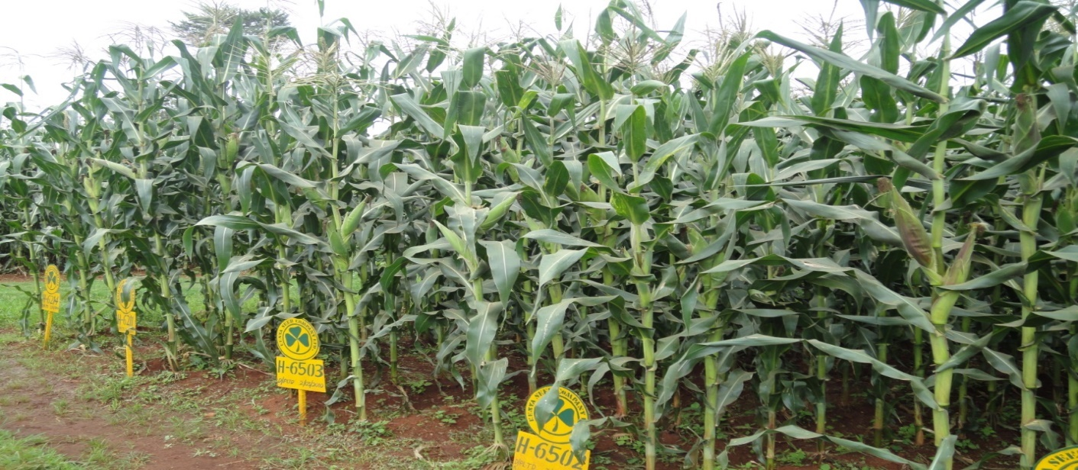-The Company has an elaborate seed distribution channel that ensures that Seed gets to our customer, promptly and in the right state. The channel starts from the Marketing stores to the Company branches, then to appointed and licensed Agents and Stockists and finally to the farmers throughout the Country.

*Seed maize varieties on a demonstration plot where farmers learn about good agronomical practices*

**Social sustainability**

1. Education

The company sponsored school activities and individual school going children through donation of cash and other material that might enhance the process of learning within schools in our business environment. Among the schools and individuals sponsored include.

* News Paper in Education **(NIE**) in three counties namely, Baringo County, Uasin Gishu and Trans-Nzoia County for the year.

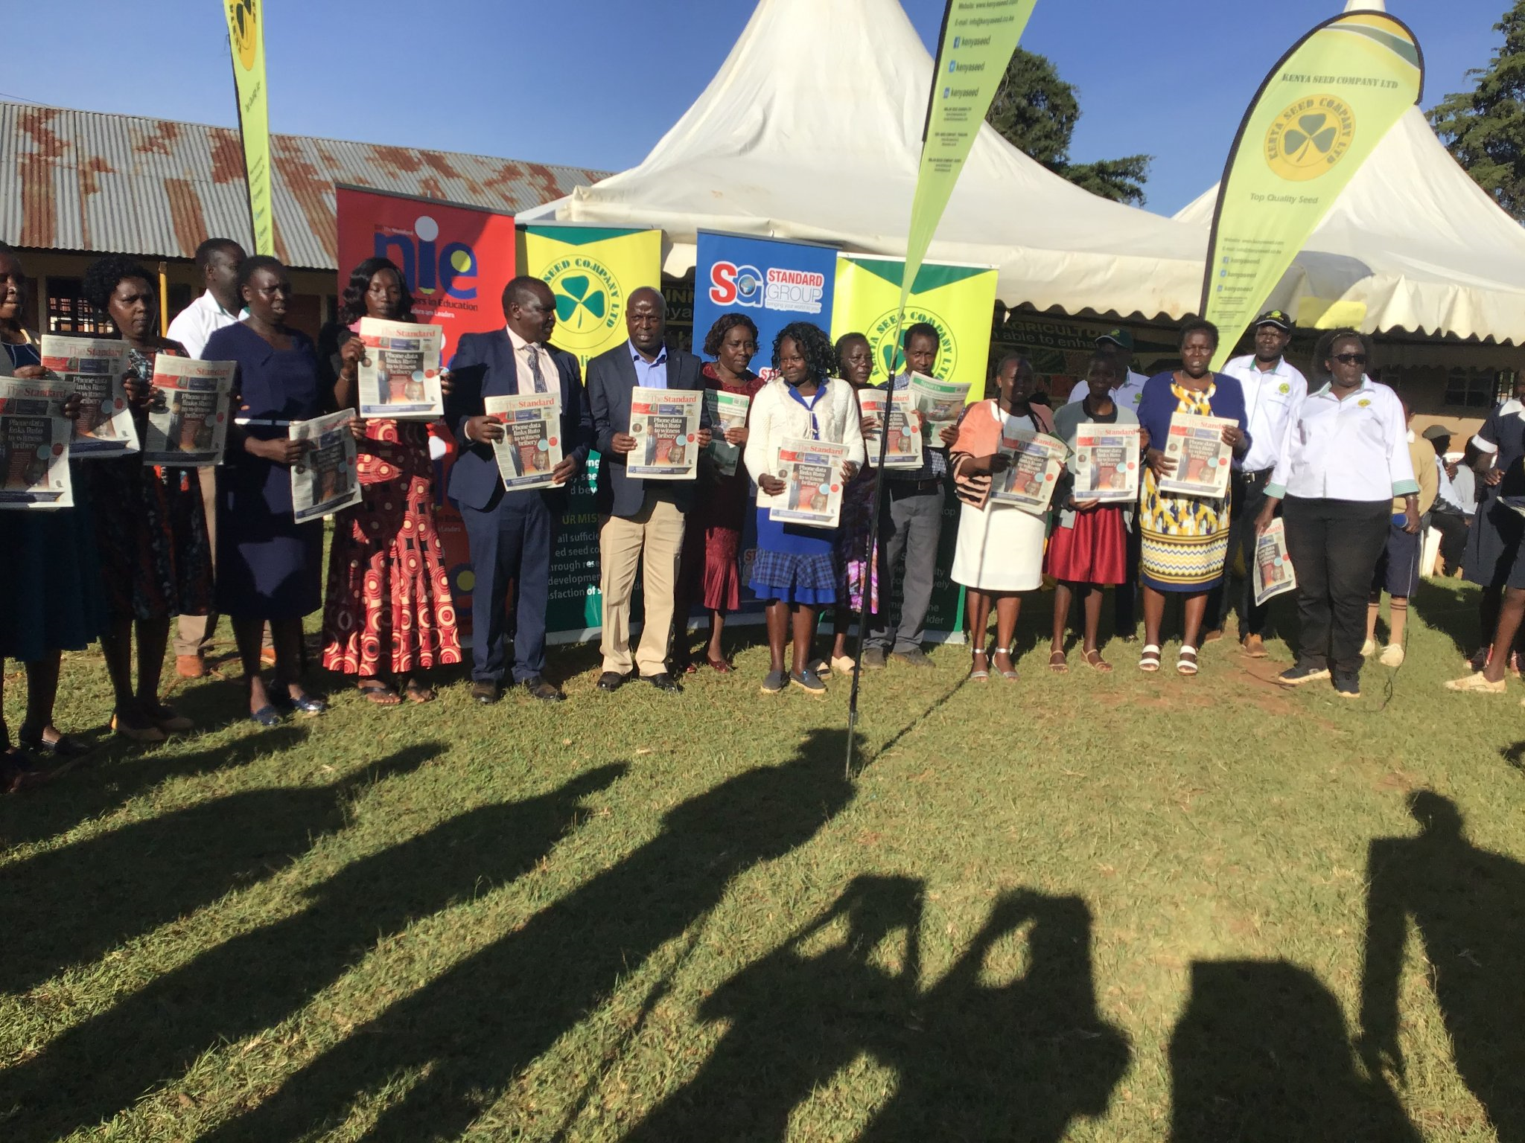

*Teachers pose during the NIE program*

1. Economic empowerment

Kenya Seed Company enables the surrounding communities to improve their livelihoods by offering jobs to the locals. The company provided casual/temporary employment to 1,600 locals in the company’s Elgon Downs Farm and the processing factories during the peak seasons of the year.

The company assists various county governments to collect county Cess from the contracted maize seed growers and remit to the respective County governments. This ensures that the county governments provide the required services to the general public.

1. Innovation and capacity development

During the year, the company collaborated with various stakeholders in breeding of new technologies which are expected to result in commercialization of new superior seed varieties. Some of the institutions involved are University of Nairobi, Kenya Agricultural Research Organization (KALRO), CIMMYT. The company established business partnership and relationship with strategic stakeholders e.g. the County Governments and the Agricultural Society of Kenya. This has ensured that there is synchronized Production, Processing and marketing demand to ensure product availability.

1. Youth Internship and industrial attachment

Recently the government of Kenya set a goal to prepare the youth for economic development. It’s with this in mind that the company has taken to commit to developing talent for the students to prepare them for the job market. The company offered industrial attachment opportunities (three months) to various students from various colleges and universities in Kenya to acquire skills and experience in the various departments within the company.

The company also has offered internship opportunities to various students who have graduated from various colleges and universities.

|  |  |  |  |
| --- | --- | --- | --- |
| **Program** | **2023** | **2022** | **2021** |
| Internship beneficiaries | 6 | 6 | 4 |
| Industrial attachments | 181 | 186 | 205 |
| **Total** | **187** | **192** | **209** |

**Sports**

Sporting activities rejuvenate people's lives and provides an opportunity for networking. Many engage in sports as a way of assisting them avoid dangerous activities or reliving themselves from strenuous work activity. The company utilizes such forum to nurture young talent and promote our products. The sports activities were postponed for the next financial year.

**Health**

Our business strategy is focus on expanding our role in health care from providing nutritional value crops to supporting members within our community by averting Malnutrition within our business environment, among other health related issues.

We have supported health by sponsoring:

* Donation of food items to St. Lilians School in Endebess

1. **Procurement**

Kenya Seed Company adheres to principles of transparency, integrity and fairness in its drive to implement best procurement practices across all its engagements with its both internal and external customers. The main objective of procurement function is to form the basis for implementation of procurement strategies through improved processes, increased value creation and delivery of shareholder’s value. Procurement plays a key role in timely procurement of quality goods, works and services as well as disposal of obsolete and unserviceable materials and equipment. The procurement process is guided by the Public Procurement and Assets Disposal Act 2015, relevant

regulations, company procedures and best business practices. Procurement is a strategic function in the company assisting in the achievement of best returns on key initiatives like cost reduction and enhanced availabilities of supplies and value addition.

The strategies in procurement target procurement planning, tendering process, contract management, inventory management and disposals. It is the company policy to consolidate procurement requirements while acquiring goods, works and services of the right quality in order to guarantee continuity of supply, external provider service responsiveness and to achieve value for money. The organization maximizes return on money spent through the procurement of goods, works and services throughout the entire procurement process. Value addition has been enhanced through the following initiatives;

* **­Procurement Planning**

The Company prepares Procurement plans on an annual basis, which guide all procurements as per approved budgets. The Procurement plan is approved by the Accounting Officer in the organization and executed by management to support company strategic objectives. The plans are implemented in accordance with the Public Procurement and Asset Disposal Act, 2015, ensuring all companies requirements are met.

* **Buy Kenya Build Kenya**

Our Company provides growth and development avenues through procurement of goods, works and services from citizens. This has continued to create wealth sustainably. The following approaches were used under this initiative:

1. **Creating Value for Special Groups**

The Public Procurement and Asset Disposal Act, 2015 provides for public procuring entities to set aside a reservation of procurement opportunities for Youth, Women and Persons living with Disabilities (YWPD). Our focus in the target group is anchored on our strong belief that local firms support employment creation, and create value for stakeholders. In the year, we awarded these special groups procurement contracts as shown below:

|  |  |  |  |
| --- | --- | --- | --- |
| **Category** | **2022/2023 (Awards in Kshs.)** | **2021/2022 (Awards in Kshs.)** |  |
| PWD | 7,850,990 | 596,700 |  |
| Women | 110,972,118 | 213,896,888 |  |
| Youth | 26,882,676 | 19,030,095 |  |
| **Total** | **145,705,785** | **202,546,156** |  |

To improve uptake of the given allocations we have to undertake the following initiatives: -

* Sensitization and awareness programs to these groups to take advantage of the scheme.
* Management of Supplier relationships
* Continuous supplier registration of the disadvantaged groups.
* Effective planning, monitoring and implementation of the allocations

1. Empowering Local Firms

Promotion of local content in procurement (Buy Kenya, Build Kenya) initiatives is continuously supported whereby 40% of the company’s procurement budget is spent on local products and services supplied by citizen contractors. The department endeavors to give opportunities to many vendors and contractors as possible to participate in its tendering processes whereby there is enhancement of local economic growth and maintenance of good trade relations with the locals. This supports growth of the local industry for sustainable development for its stakeholders. During the year, procurement of locally produced goods and services awarded to citizen contractors as shown below:

|  |  |  |  |
| --- | --- | --- | --- |
| **Period** | **2022/2023(Awards in Kshs.)** | **2021/2022(Awards in Kshs.)** |  |
| 1st Half | 503,273,685 | 288,847,164 |  |
| 2nd Half | 330,734,067 | 616,655,360 |  |
| **Total** | **834,007,752** | **905,502,524** |  |

* Process Improvement

Our procurement processes require continuous improvement to address emerging challenges and compliance with legal requirements. To achieve this there has been enhanced confidentiality of procurement information from the tendering process to award of contracts and also increased transparency and accountability of the tendering process. We have also had continuous training of various heads of user departments and procurement staff on how to handle emerging challenges and the importance of compliance in all procurement processes. The department through the use of SAP system platform enables the tracking of procurement proceedings through a single integrated system after user department raises an online request.

* Compliance to Statutory Requirements

The procurement function is guided by the Public Procurement and Asset Disposal Act (PPADA), 2015 and relevant regulations as established. All our procurements are processed with due compliance to all these statutory requirements and company procedures.

We submit statutory reports to the Public Procurement Regulatory Authority (PPRA)/The National Treasury, Ministry of Trade and Industry and Ministry of Agriculture, Livestock, Fisheries and Irrigation. The reports demonstrate commitment to compliance requirements that enhances transparency, fairness and value for money for sustainable growth. We complied and submitted the following reports;

|  |  |  |
| --- | --- | --- |
| **No.** | **Report** | **Body** |
|  | Buy Kenya Build Kenya-40% | Ministry of Trade and Industry |
|  | Implementation of procurement plans | PPRA |
|  | Approved Procurement Plan | PPRA |
|  | Quarterly reports on procurement contracts awarded to the Special Groups | PPRA |
|  | Procurement proceedings terminated before award. | PPRA |
|  | Direct Procurement contracts awarded for Value above Kenya Shillings Five Hundred Thousand | PPRA |
|  | All procurement contracts awarded for value above Kenya Shillings Five million. | PPRA |
|  | Big Four Agenda compliance report | MOALFI |
|  | Quarterly progress reports summarizing procurements allocated to target groups | PPRA |

1. Other forms of supporting the community

Kenya Company is committed to partnering with the society through different means and ways by giving back. Our initiative to give back to society is through the CSR Program; our staff participates in these programs to give back to society/community around us using their different gifted expertise. This has created a positive relationship with the society, who in turn promotes our business by buying our products. During the year, the company visited St Lilians school for the physically challenged and donated foodstuff to the children as part of giving back to the community.

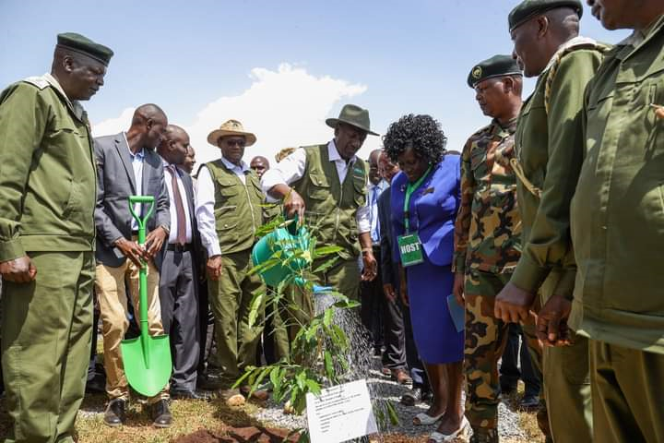

*KSC team with President William Ruto during tree plating exercise in Kaptagat forest*

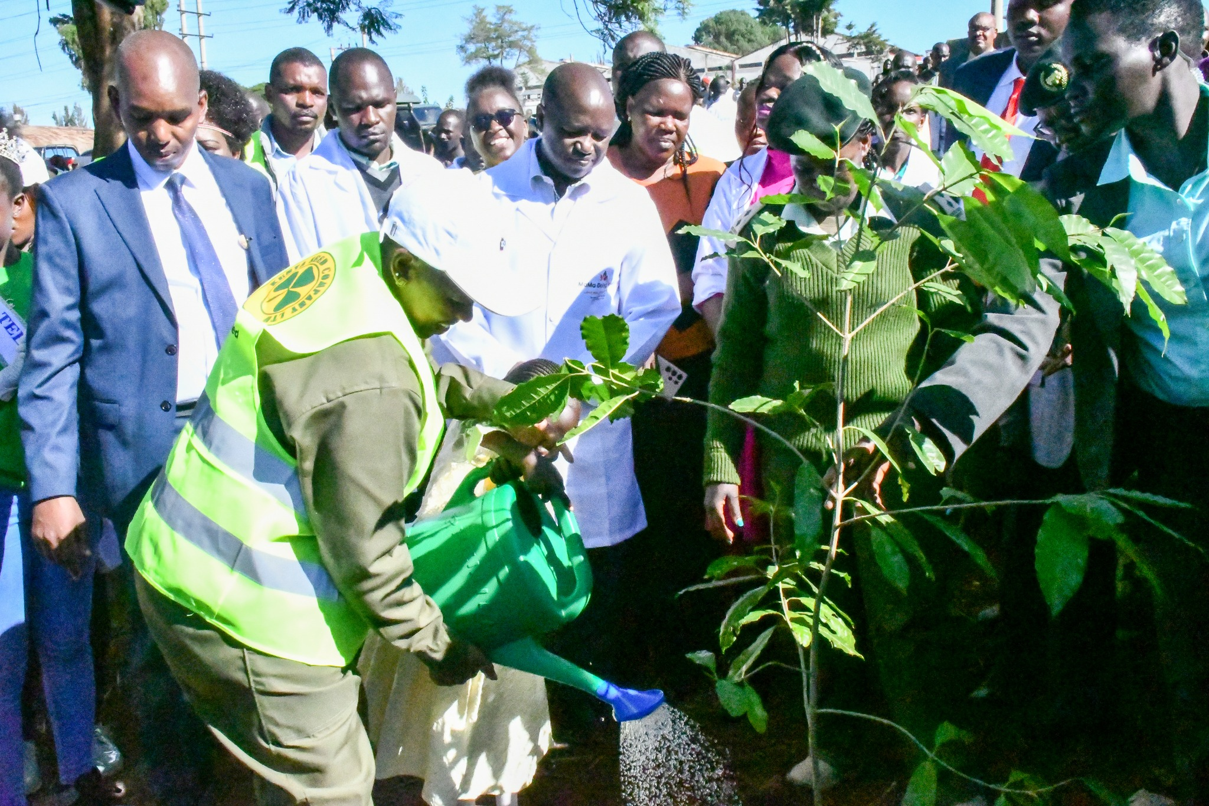

Kenya seed Company Ag. MD Sammy Chepsiror led staff in joining the first lady for a tree planting exercise in Kitale.

1. Enterprise risk management

Risk is a state of uncertainty where some of the possibilities involve a loss, catastrophe or other undesirable outcome. Mitigating risks, or lessening their adverse impacts, is at the heart of its effective management. If attention were not paid to expected risks, planned activities would end in disaster. If implemented correctly a successful risk mitigation strategy reduces any adverse variations in the financial returns or outputs.

Some of the key risks that were identified, together with corresponding mitigating measures are highlighted below:

| **Risks** | **Mitigation** |
| --- | --- |
| Effects of climate change i.e. global warming | * Use of insurance * Expansion into irrigated areas * Use of improved varieties |
| Loss of plant efficiency due to age | * Continuous plant improvement * Effective maintenance and retirement of old equipment * Adoption of new technologies |
| Loss of production area due to land subdivision, competition | * Creation of seed villages * Long term contracts with the growers * Competitive seed pricing to the Growers |
| Emerging diseases and pests | * Equipped company laboratories for pathological and entomological tests. * Technical staff training on emerging issues. * Collaboration with research and relevant institutions * Production of tolerant varieties * Develop disease/pest resistant varieties |
| Decrease in yields | * Growers training * Soil analysis * Encourage minimum/conservation tillage * Embrace emerging technologies |
| Drought | * Expansion of dam and irrigation system at the Elgon Downs Farm |
| Loss of market to competitors | * Availing customer driven seed varieties/as per eco zone. * Timely marketing planned activities * Production of drought resilient seed varieties |
| High turnover of skilled labour to competition thereby affecting department performance | * Ensuring there is knowledge sharing among workers. * Embracing knowledge management strategy |
| Terrorism | * Conduct regular staff sensitizations to create awareness |
| HIV and Aids, Cancer, drug and substance abuse and other lifestyles diseases | * Sensitization programmes * Put in place employee support programs (establish wellness unit, collaborate with relevant institutions |
| Erratic weather pattern | * Research and Development to release preferred varieties * Sensitize farmers on superior varieties once released * Produce crops in the right Agro-ecological zones |
| Fake seeds | * Frequent surveillance visits, Informers |

*Kenya Seed Company training farmers as a means of supporting investments in Agriculture as the best weapons against hunger and poverty and making lives better for billions of people globally*

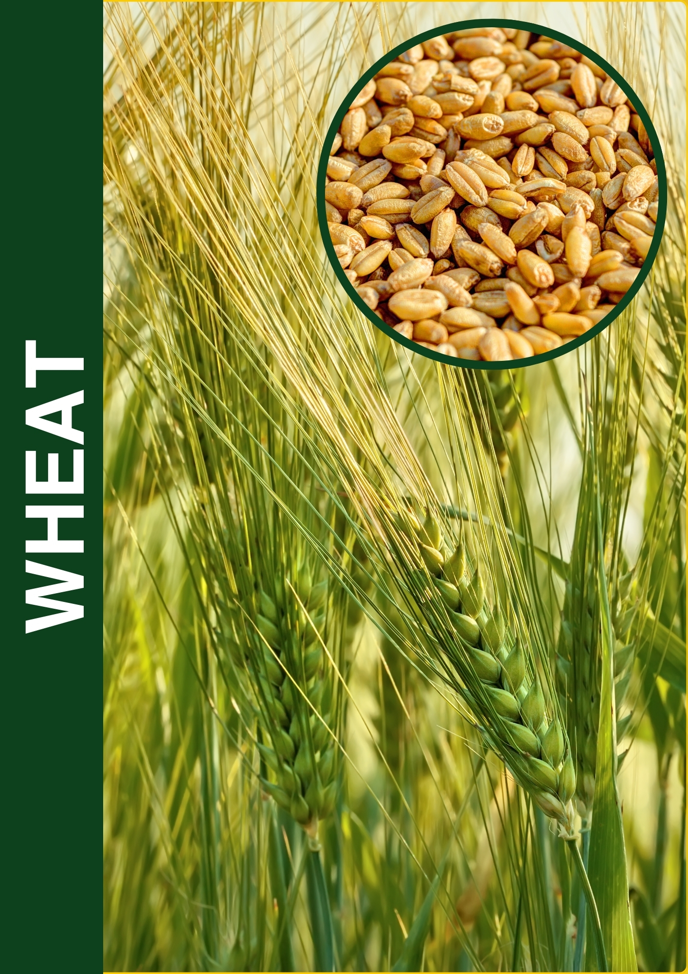

|  |
| --- |
|  |

# REPORT OF THE DIRECTORS

The Directors submit their audited consolidated financial statements for the year ended 30th June 2023 which show the state of the company and company affairs.

**Principal Activities**

The company and its subsidiaries carry on the business of seed growers and seed merchants. It operates a seed maize shelling and drying plant and a small cereal drying plant. The Company also distributes vegetable seeds under the brand name of “Simlaw Seeds”.

**Results**

The results of the company for the year ended 30th June 2023 are set out in the statement of comprehensive income on page 1.

**Dividends**

The Board of Directors approved a dividend policy where dividend paid will be the higher of Kshs 5.25 per share or 20% of the after-tax profit. Subject to the Shareholders approval, the Directors propose payment of a first and final dividend totaling Kshs 12,748,597 in respect of the year ended 30 June 2023 compared to 5,25 totalling Kshs 56,601,641 for 10,781,265 number of shares (Kshs 5.25 2022) (Kshs 5.25, 2023:) per share. The dividend is payable subject to, where applicable, deduction of withholding tax as required under the Kenyan Income Tax Act, Chapter 470, Laws of Kenya.

**Directors**

The Directors who served during the year and to the date of this report are as shown on page (xi).

**Auditors**

The Auditor General is responsible for the statutory audit of the company’s financial statements in accordance with Article 229 of the Constitution of Kenya and the Public Audit Act, 2015.

**BY ORDER OF THE BOARD**

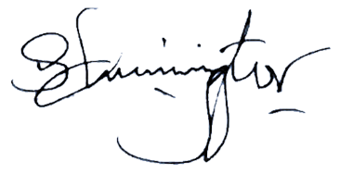

**…………………………**

Managing Director

Kitale, Kenya

**30.06.2023**

# STATEMENT OF DIRECTORS’ RESPONSIBILITIES

Section 81 of the Public Finance Management Act, 2012, and Kenyan Companies Act 2015 require the Directors to prepare financial statements in respect of the company, which give a true and fair view of the state of affairs of the company at the end of the financial year and the operating results of the company for that year. The Directors are also required to ensure that the company keeps proper accounting records which disclose with reasonable accuracy the financial position of the company. The Directors are also responsible for safeguarding the assets of the company.

The Directors are responsible for the preparation and presentation of the company’s financial statements, which give a true and fair view of the state of affairs of the company for and as at the end of the financial year ended on **June 30,** **2023**. This responsibility includes:

1. maintaining adequate financial management arrangements and ensuring that these continue to be effective throughout the reporting period;
2. maintaining proper accounting records, which disclose with reasonable accuracy at any time the financial position of the company;
3. designing, implementing and maintaining internal controls relevant to the preparation and fair presentation of the financial statements, and ensuring that they are free from material misstatements, whether due to error or fraud;
4. safeguarding the assets of the company;
5. selecting and applying appropriate accounting policies; and
6. Making accounting estimates that are reasonable in the circumstances.

The Directors accept responsibility for the company’s financial statements, which have been prepared using appropriate accounting policies supported by reasonable and prudent judgements and estimates, in conformity with International Financial Reporting Standards (IFRS), and in the manner required by the PFM Act, 2012 and the Kenya Company’s Act 2015. The Directors are of the opinion that the company’s financial statements give a true and fair view of the state of the company’s transactions during the financial year ended **June 30, 2023**, and of the company’s financial position as at that date. The Directors further confirm the completeness of the accounting records maintained for the company, which have been relied upon in the preparation of the company’s financial statements as well as the adequacy of the systems of internal financial control.

Nothing has come to the attention of the Directors to indicate that the company will not remain a going concern for at least the next twelve months from the date of this statement.

The Directors acknowledge that the independent audit of the financial statements does not relieve them of their responsibility.

**Approval of the financial statements**

The financial statements and the accompanying notes from pages 1 to 60 were approved by the Board of Directors on and were signed on its behalf by:

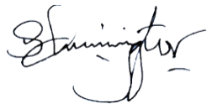

|  |  |  |
| --- | --- | --- |
|  |  |  |
| **Mr. Sammy Chepsiror** |  | **Mr. Mohammed Bulle** |
| Ag.Managing Director |  | Chairman of the Board |

# REPORT OF THE AUDITOR GENERAL ON KENYA SEED COMPANY LTD & IT’S SUBSIDIARIES

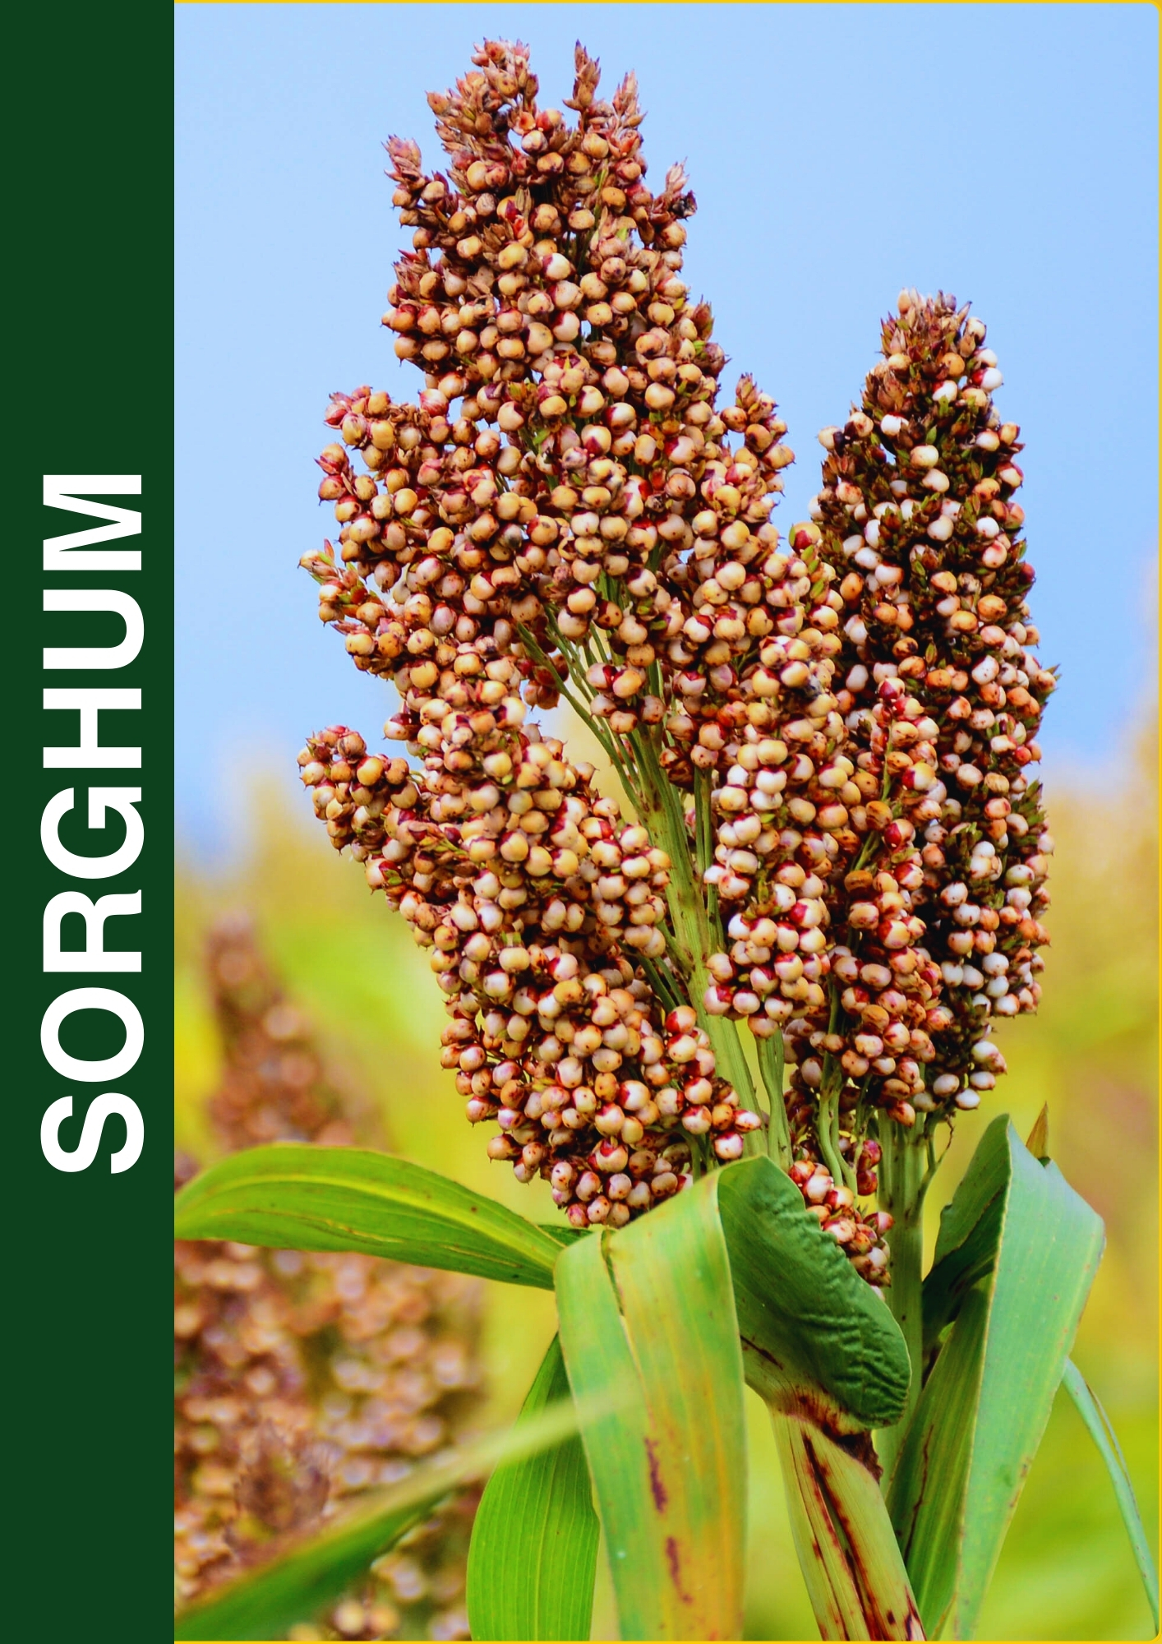

|  |
| --- |
|  |

# STATEMENT OF PROFIT OR LOSS AND OTHER COMPREHENSIVE INCOME FOR THE YEAR ENDED 30 JUNE 2023.

|  |  |  |  |  |  |  |  |  |
| --- | --- | --- | --- | --- | --- | --- | --- | --- |
|  |  | **Group** | | |  | **Company** | | |
|  |  | **2023** |  | **2022** |  | **2023** |  | **2022** |
| 2 | **Notes** | Kshs ‘000 |  | Kshs ‘000 |  | Kshs ‘000 |  | Kshs ‘000 |
|  |  |  |  |  |  |  |  |  |
| Revenue | 4 | 7,155,959 |  | 6,943,124 |  | 5,033,701 |  | 5,127,499 |
| Cost of sales | 5 | (4,426,853) |  | (4,260,029) |  | (3,123,037) |  | (3,118,079) |
| Gross profit |  | 2,729,106 |  | 2,683,095 |  | 1,910,664 |  | 2,009,421 |
| Other income | 6 | 75,234 |  | 114,455 |  | 48,152 |  | 95,733 |
|  |  | 2,804,340 |  | 2,797,550 |  | 1,958,816 |  | 2,105,154 |
| EXPENSES |  |  |  |  |  |  |  |  |
| Operating expenses | 7 | (1,160,728) |  | (1,217,685) |  | (768,791) |  | (885,459) |
| Administration expenses | 8 | (837,371) |  | (806,070) |  | (616,889) |  | (620,719) |
| Selling and distribution expenses | 9 | (361,407) |  | (338,028) |  | (226,489) |  | (228,727) |
| Research and development costs | 10 | (128,147) |  | (114,511) |  | (104,755) |  | (98,464) |
|  |  | (2,488,225) |  | (2,476,294) |  | (1,716,924) |  | 1,833,369 |
| Operating Profit | 11 | 316,116 |  | 321,256 |  | 241,892 |  | 271,785 |
| Finance Income | 12 (b) | 102,850 |  | 78,745 |  | 22,048 |  | 15,817 |
| Finance cost | 12 (a) | - |  | (40,786) |  | - |  | (39,946) |
| Profit before taxation |  | 418,966 |  | 359,215 |  | 263,940 |  | 247,656 |
| Income Tax expense | 13 (a) | (193,357) |  | (188,005) |  | (200,197) |  | (165,350) |
| **Profit for the year** |  | **225,609** |  | **171,210** |  | **63,743** |  | **82,306** |
|  |  |  |  |  |  |  |  |  |
| **Profit attributable to:** |  |  |  |  |  |  |  |  |
| Owners of the parent company |  | 225,609 |  | 171,210 |  | 63,743 |  | 82,306 |
|  |  |  |  |  |  |  |  |  |
| Earnings per share attributable to: | |  |  |  |  |  |  |  |
| Basic (Kshs per share) | 14 | 21 |  | 16 |  | 6 |  | 8 |
|  |  |  |  |  |  |  |  |  |
| **Other comprehensive income:** |  |  |  |  |  |  |  |  |
| Profit for the year |  | 225,609 |  | 171,210 |  | 63,743 |  | 82,306 |
| Exchange differences on translating foreign operations | 35 | (68,095) |  | (12,723) |  | - |  | - |
| Income tax effect | 35 | 20,428 |  | 3,817 |  | - |  | - |
| Fair value loss on Bearer Plants | 22(a) | 5,055 |  | (13,481) |  | 5,055 |  | (13,381) |
| Revaluation Surplus |  |  |  |  |  |  |  |  |
| **Total comprehensive income** |  | **182,997** |  | **148,823** |  | **68,798** |  | **68,826** |
|  |  |  |  |  |  |  |  |  |
| Attributable to: |  |  |  |  |  |  |  |  |
| **Owners of the parent** |  | **182,997** |  | **148,823** |  | **68,798** |  | **68,826** |

The notes set out from page 9 form an integral part of the financial statements.

# STATEMENT OF FINANCIAL POSITION

**AS AT 30TH JUNE 2023**

|  |  |  |  |  |  |  |  |  |
| --- | --- | --- | --- | --- | --- | --- | --- | --- |
|  |  | **Group** | | |  | **Company** | | |
|  |  | **2023** |  | **2022** |  | **2023** |  | **2022** |
|  | **Notes** | Kshs ‘000 |  | Kshs ‘000 |  | Kshs ‘000 |  | Kshs ‘000 |
| **ASSETS** |  |  |  |  |  |  |  |  |
| **Non-current assets** |  |  |  |  |  |  |  |  |
| Property, plant and equipment | 16 | 9,311,677 |  | 4,977,648 |  | 8832,953 |  | 4,606,774 |
| Intangible assets | 17 | 52,032 |  | 53,348 |  | 51,104 |  | 52,680 |
| Investment in subsidiaries | 18 | - |  | - |  | 60,074 |  | 55,699 |
| Deferred tax asset | 29(b) | 38,360 |  | 41,648 |  | - |  | - |
| Staff receivables | 21 | 2,614 |  | 2,523 |  | 2,614 |  | 2,523 |
| Bearer biological assets | 22(a) | 223,186 |  | 194,943 |  | 223,186 |  | 194,943 |
| Loan capital to subsidiaries | 23(a) |  |  |  |  | 224,186 |  | 212,681 |
|  |  | 9,627,869 |  | 5,270,110 |  | 9,394.117 |  | 5,125,300 |
| **Current assets** |  |  |  |  |  |  |  |  |
| Consumable biological assets | 22(b) | 74,427 |  | 58,998 |  | 74,258 |  | 58,903 |
| Staff receivables | 21 | 14,807 |  | 26,493 |  | 3,074 |  | 16,185 |
| Cash and Cash equivalent | 34(a+b) | 2,943,520 |  | 2,529,385 |  | 2,607,389 |  | 2,358,666 |
| Inventories | 24 | 3,110,977 |  | 3,429,739 |  | 1,755,791 |  | 2,265,475 |
| Trade and other receivables | 25 | 934,970 |  | 1,094,608 |  | 402,683 |  | 623,959 |
| Amounts due from subsidiaries | 23(b) | - |  | - |  | 1,927,003 |  | 1,675,432 |
| Due from Parastatal and other |  |  |  |  |  |  |  |  |
| Government controlled organizations | 23(c) | 1,277,892 |  | 1,250,867 |  | 1,215,420 |  | 1,219,530 |
| Tax recoverable | 13(c) | 395,241 |  | 306,305 |  | 364,581 |  | 279,314 |
|  |  | 8,751,833 |  | 8,696,395 |  | 8,351,199 |  | 8,497,464 |
| **Total assets** |  | **18,379,702** |  | **13,966,505** |  | **17,745,316** |  | **13,622,764** |
|  |  |  |  |  |  |  |  |  |
| **EQUITY AND LIABILITIES** |  |  |  |  |  |  |  |  |
| **Equity** |  |  |  |  |  |  |  |  |
| Share capital | 26 | 215,625 |  | 215,625 |  | 215,625 |  | 215,625 |
| Share premium | 26 | 281 |  | 281 |  | 281 |  | 281 |
| Revaluation surplus |  | 8,285,566 |  | 4,078,533 |  | 8,140,620 |  | 4,012,664 |
| Translation reserve | 35 | 8,029 |  | (39,638) |  | - |  | - |
| Proposed Dividends | 15 | - |  | 226,407 |  | - |  | 226,407 |
| Retained earnings |  | 8,359,385 |  | 8,176,388 |  | 8,239,036 |  | 8,170,248 |
|  |  | 16,868,886 |  | 12,657,597 |  | 16,595,563 |  | 12,625,225 |
| **Non-current liabilities** |  |  |  |  |  |  |  |  |
| Deferred tax liability | 29(c) | 609,948 |  | 422,184 |  | 609,948 |  | 422,184 |
| Amounts due to directors | 23(d) | 19,992 |  | 17,788 |  | 19,992 |  | 17,788 |
|  |  | 629,940 |  | 439,972 |  | 629,940 |  | 439,972 |

**STATEMENT OF FINANCIAL POSITION**

**AS AT 30TH JUNE 2022 (continued)**

|  |  |  |  |  |  |  |  |  |
| --- | --- | --- | --- | --- | --- | --- | --- | --- |
|  |  | **Group** | | |  | **Company** | | |
|  |  | **202** | **3** | **2022** |  | **2023** |  | **2022** |
|  | **Notes** | Kshs ‘000 |  | Kshs ‘000 |  | Kshs ‘000 |  | Kshs ‘000 |
| **Current liabilities** |  |  |  |  |  |  |  |  |
| Amounts due to directors | 23(d) | 1,350 |  | 1,350 |  | 1,350 |  | 1,350 |
| Due to subsidiaries | 19 | - |  | - |  | 63,462 |  | 124,915 |
| Due to Parastatal and other |  |  |  |  |  |  |  |  |
| government controlled organizations | 23(e) | - |  | 3,792 |  | - |  | 3,792 |
| Employee benefits obligations | 30 | 65,038 |  | 68,699 |  | 57,374 |  | 61,009 |
| Trade and other payables | 31 | 805,285 |  | 785,893 |  | 388,424 |  | 357,298 |
| Unclaimed dividends | 32 | 9,203 |  | 9,203 |  | 9,203 |  | 9,203 |
|  |  | 880,876 |  | 868,936 |  | 519,812 |  | 557,567 |
| **Total equity and liabilities** |  | **18,379,702** |  | **13,966,505** |  | **17,745,316** |  | **13,622,764** |

The financial statements and the notes set out from page 1 were approved by the Board of Directors on 30.06.2023 and signed on its behalf by:

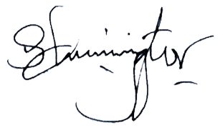

**………………………… **

**Mr. Sammy Chepsiror CPA. Patrick Thuo Mr. Mohammed Bulle.**

**Ag. Managing Director Head of Finance Chairman of the Board**

**ICPAK M/NO: 4045**

# STATEMENT OF CHANGES IN EQUITY FOR THE YEAR ENDED 30 JUNE 2023.

|  |  |  |  |  |  |  |  |
| --- | --- | --- | --- | --- | --- | --- | --- |
| GROUP | Share capital | Share premium | Revaluation reserve | Translation Reserve | Retained earnings | Proposed Dividend | Total |
|  | Kshs ‘000 | Kshs ‘000 | Kshs ‘000 | Kshs ‘000 | Kshs ‘000 | Kshs ‘000 | Kshs ‘000 |
| Year ended 30 June 2021 |  |  |  |  |  |  |  |
| As at 1 July 2021 | 215,625 | 281 | 4,153,982 | (48,544) | 7,952,115 | 226,407 | 12,499,867 |
| Prior year adjustment | - | - | - | - | - | - | - |
| Total comprehensive income for the year | - | - | - | - | 171,211 | - | 171,211 |
| Fair value Gain of Bio Assets | - | - | - | - | (13,481) | - | (13,481 |
| Proposed Dividends | - | - | - | - | (226,407) | 226,407 | - |
| Transfer of excess depreciation |  |  | (107,784) |  | 107,784 | - | - |
| Deferred tax on excess depreciation | - | - | 32,335 | - | (32,335) | - | - |
| Translation Reserves | - | - | - | 8,906 | (8,906) | - | - |
| As at 30 June 2022 | **215,625** | **281** | **4,078,533** | **(39,638)** | **8,176,388** | **226,407** | **12,657,597** |
| Year ended 30 June 2023 |  |  |  |  |  |  |  |
| As at 1 July 2022 | **215,625** | **281** | **4,078,533** | **(39,638)** | **8,176,388** | **226,407** | **12,657,597** |
| Prior year adjustment |  |  |  |  |  |  |  |
| Transfer of excess depreciation |  |  |  |  |  |  |  |
| Deferred tax on excess depreciation | - | - |  |  |  |  |  |
| Total comprehensive income for the year | - | - |  |  | 225,609 |  | 225,609 |
| Fair value Gain of Bio Assets | - | - |  |  | 5,055 |  | 5,055 |
| Translation reserves |  |  |  | 47,666 | (47,666) |  | - |
| Revaluation of assets |  |  | 4,207,032 |  |  |  | 4,207,032 |
| Proposed Dividends | - | - |  |  |  | (226,407) | (226,407) |
| Translation Reserves | - | - | - |  |  | - | - |
| As at 30 June 2023 | **215,625** | **281** | **8,285,566** | **8,029** | **8,359,385** | **-** | **16,868,886** |

|  |  |  |  |  |  |  |  |
| --- | --- | --- | --- | --- | --- | --- | --- |
| COMPANY | Share capital | Share premium | Revaluation reserve | Translation Reserve | Retained earnings | Proposed Dividend | Total |
|  | Kshs ‘000 | Kshs ‘000 | Kshs ‘000 | Kshs ‘000 | Kshs ‘000 | Kshs ‘000 | Kshs ‘000 |
| Year ended 30 June 2022 |  |  |  |  |  |  |  |
| As at 1 July 2021 | 215,625 | 281 | 4,088,113 | - | 8,025,972 | 226,407 | 12,556,399 |
| Prior year adjustment | - | - | - | - | - | - | - |
| Total comprehensive income for the year | - | - | - | - | 82,306 | - | 82,306 |
| Fair value Gain of Bio Assets | - | - | - | - | (13,481) | - | (13,481) |
| Deferred tax on excess depreciation | **-** | **-** | 32,335 | - | (32,335) | **-** | **-** |
| Transfer of excess depreciation | - | - | (107,784) | - | 107,784 | - | - |
| As at 30 June 2022 | **215,625** | **281** | **4,012,664** | **-** | **8,170,247** | **226,407** | **12,625,225** |
| Year ended 30 June 2023 |  |  |  |  |  |  |  |
| As at 1 July 2022 | **215,625** | **281** | **4,012,664** | **-** | **8,170,247** | **226,407** | **12,625,225** |
| Prior year adjustment |  |  |  |  | (9) |  | (9) |
| Total comprehensive income for the year | - | - | - | - | 63,743 | - | 63,743 |
| Fair value Gain of Bio Assets | - | - | - | - | 5.055 | - | 5.055 |
| Revaluation of assets | - | - | 4,127,956 | - | - | - | 4,127,956 |
| Dividend payout in the year | - | - | - | - | - | (226,407) | (226,407) |
| Transfer of excess depreciation | - | - | - | - | - | - | - |
| Deferred tax on excess depreciation | **-** | **-** | - | - | - | **-** | **-** |
| As at 30 June 2023 | **215,625** | **281** | **8,140,620** | **-** | **8,239,036** | **-** | **16,595,563** |

The notes set out from page 9 form an integral part of the financial statements.

# STATEMENT OF CASH FLOWS FOR THE YEAR ENDED 30 JUNE 2023.

|  |  |  |  |  |  |  |  |  |  |
| --- | --- | --- | --- | --- | --- | --- | --- | --- | --- |
|  |  | | **Group** | | |  | **Company** | | |
|  |  | | **2023** |  | **2022** |  | **2023** |  | **2022** | |
|  | **Notes** | | Kshs ‘000 |  | Kshs ‘000 |  | Kshs ‘000 |  | Kshs ‘000 | |
| **OPERATING ACTIVITIES:** |  | |  |  |  |  |  |  |  | |
| **Cash generated from operations** | 39 (a) | | 1,112,261 |  | 361,485 |  | 1,002,621 |  | 352,694 | |
| Finance income |  | | - |  | (40,786) |  | - |  | (24,129) | |
| Finance costs |  | | 102,850 |  | - |  | 22,048 |  | - | |
| Tax paid | 13(c) | | (100,850) |  | (496,041) |  | (97,700) |  | (476,187) | |
| Net Cash flows used in operating activities |  | | 1,114,261 |  | (175,342) |  | 926,970 |  | 147,622 | |
| **Investing activities: -** |  | |  |  |  |  |  |  |  | |
| Purchase of Property, plant and equipment |  | | (495,450) |  | (122,580) |  | (456,211) |  | (80,929) | |
| Purchase of intangible assets |  | | (16,329) |  | (1,042) |  | (15,110) |  | - | |
| Disposal proceeds from sale of assets |  | | 15,401 |  | 6,200 |  | 15,401 |  | 6,200 | |
| **Net Cash flows from investing activities** |  | | (496,378) |  | (117,422) |  | (455,920) |  | (74,729) | |
| **Financing activities**  Dividends paid |  | | (226,407) |  | - |  | (226,407) |  | - | |
| Loan repayment. |  | | - |  | (10,035) |  | - |  | - | |
| **Net cash flows from financing activities** | | | **(226,407)** |  | **(10,035)** |  | **(226,407)** |  | **-** | |
|  | |  |  |  |  |  |  |  |  |
| **Cash and cash equivalents:** | | |  |  |  |  |  |  |  |
| Movement during the year | | | **391,476** |  | **(302,799)** |  | **244,643** |  | **(222,351)** |
| Effect of movements in exchange rates on cash held | | | 22,653 |  | 19,119 |  | 4,081 |  | 4 |
| As at 1 July 2022 | | | 2,529,390 |  | 2,813,071 |  | 2,358,666 |  | 2,581,017 |
| **As at 30 June 2023** | | **34** | **2,943,520** |  | **2,529,390** |  | **2,607,389** |  | **2,358,666** |

The notes set out from page 9 form an integral part of the financial statements.

# STATEMENT OF COMPARISON OF BUDGET AND ACTUAL AMOUNTS FOR THE YEAR ENDED 30 JUNE 2023

|  |  |  |  |  |
| --- | --- | --- | --- | --- |
| **Budget Line** | **Original & Final Budget** | **Actual on Comparable basis** | **Performance Difference** | **% Change** |
|  | **2022-2023** | **2022-2023** | **2022-2023** |  |
| **Revenue:** |  |  |  |  |
| Maize Seeds (note 1) | 5,824,000,000 | 4,589,967,696 | 1,234,032,304 | 21% |
| Wheat Seeds (note 2) | 129,310,345 | 110,664,272 | 18,646,072 | 14% |
| Pasture Seeds (note 3) | 110,537,500 | 94,617,844 | 15,919,656 | 14% |
| Sunflower seeds (note 4) | 27,978,657 | 14,162,262 | 13,816,396 | 49% |
| Sorghum seeds (note 5) | 26,180,948 | 19,809,515 | 6,371,433 | 24% |
| Vegetable Seeds (note 6) | 180,000,000 | 198,890,958 | (18,890,958) | (10%) |
| Millet Seeds (note 7) | 2,917,327 | 1,109,160 | 1,808,167 | 62% |
| Beans & Pulses seeds | 36,579,952 | 45,297,196 | (8,717,244) | (24%) |
| Farm produce | 254,663,500 | 3,205,559 | 251,457,941 | 99% |
| Rice seeds | 6,683,445 | 280,130 | 6,403,315 | 96% |
| Other seeds | 74,224,882 | 80,850 | 74,144,032 | 100% |
| **Total Revenue** | **6,673,076,556** | **5,078,085,443** | **1,594,991,113** | **24%** |
| Cost of Sales | (3,851,321,380) | (3,123,036,779) | (728,284,601) | 19% |
| **Gross Profit** | **2,821,755,176** | **1,955,048,664** | **866,706,512** |  |
| Other income (note 8) | 154,820,148 | 70,199,965 | 84,620,183 | 55% |
| Losses on Bio assets/Finance costs (12) | **-** | (39,329,769) | 39,329,769 |  |
| **Total Income** | **2,976,575,325** | **1,985,918,880** | **990,656,444** |  |
| Operating expense (note 9) | 1,021,957,733 | 768,790,582 | 253,167,151 | 25% |
| Administration expense (note 10) | 534,182,187 | 616,888,632 | (82,706,445) | (15%) |
| Selling & Distribution expense | 308,741,601 | 226,488,642 | 82,252,959 | 27% |
| Research & Development expense (note11) | 107,422,374 | 104,755,471 | 2,666,904 | 2% |
| **Total Expenses** | **1,972,303,894** | **1,716,923,326** | **255,380,569** | **13%** |
| **Profit Before Taxes** | **1,004,271,430** | **268,995,555** | **735,275,875** | 73% |
| Tax Charges |  | (200,197,428) | 200,197,428 |  |
| **Surplus for the Period** | **1,004,271,430** | **68,798,127** | **535,078,448** | 53% |

**Budget Notes for the variances of more than 10%:**

1. **Maize seeds sales**

The decrease in maize seed sales is due to delayed rains and coupled with the factors like unavailability of fertilizers to the farmers, and the available one was very costly to the farmer.

1. **Wheat Seed sales**

The decrease in wheat sales is due to diversification to farming other crops like maize in the rift valley region due to expected price increase in commercial maize.

1. **Pasture Seed sales**

The decrease in pasture sales is attributable to lack of enough pasture seed in the year arising from lack of land for pasture seed growing, as Most dairy farmers have also now established their own pasture fields for own livestock consumption.

1. **Sunflower seed sales**

The delayed rains which affected the maize planting season led to delay in harvesting of the crop and most farmers therefore had no fields to grow sunflower, hence drop in sunflower revenue.

1. **Sorghum seed sales**

Sorghum planting season was also affected by delayed long rains in the year in South Nyanza Region and hence led to the drop in its revenue.

1. **Vegetable seed sales**

There was decrease in demand for vegetable seeds during the year after the maize season was over, due to delay in planting season that brought about by delay in harvesting the maize crop.

1. **Millet seed sales**

Most farmers have resorted to using farm saved seed for millet production due to its slow consumption adoption in the market.

1. **Other Income.**

Other incomes increased by 70 % compared to the budgeted amount of Kshs 65million.

1. **Operating expenses**

The operating expenses Increased by 13% due to increase in employment costs and transport costs due to high fuel prices. Also, the company’s depreciation expense portion used for product costing, was not considered while costing, so as to align to the requirements of Kenya Revenue Authority.

1. **Administration expenses**

These expenses increase is as result of VAT disallowed by KRA and time barred invoices which reduced in the year from Kshs 194M in 2022 to Kshs 122 M in 2023.

1. **Research and development expenses**

Expenses relating to testing and inspection at the research plots and laboratory decreased to 98 million from 106 million the previous.

1. **Fair value losses on Biological assets and finance costs.**

Fair value loss was attributed to loss in (Consumable and bearer) biological assets, during the year as compared to the previous reporting period where it was a gain. Finance costs is attributed to valuation of foreign currencies in Rwanda and Dollar accounts.

**NOTES TO THE FINANCIAL STATEMENTS**

**1. SIGNIFICANT ACCOUNTING POLICIES**

The principal accounting policies applied in the preparation of these financial statements are set out below. These policies have been consistently applied to all years presented, unless otherwise stated.

**a) General Information**

Kenya Seed Company Limited is a private liability company incorporated in Kenya under the Kenyan Companies Act and is domiciled in Kenya. The company has a number of subsidiaries in Kenya, Uganda and Tanzania. The registered office is as shown on page **xi**.

**b) Statement of Compliance and Basis of Preparation**

The financial statements have been prepared in accordance with, and comply with International Financial Reporting Standards (IFRS) issued by the International Accounting Standard Board (IASB), and the manner required by the Kenyan Companies Act.

The measurement basis applied is the historical cost basis, except where otherwise stated in the accounting policies below. The financial statements are presented in Kenya Shillings (Kshs), rounded to the nearest thousand, which is also the functional currency.

The preparation of financial statements in conformity with IFRS requires the use of certain critical accounting estimates as detailed in note 1(d) below. It also requires management to exercise its judgment in the process of applying the company’s accounting policies. These accounting policies are consistent with the previous period.

**c) Critical judgments and sources of estimation uncertainty**

In preparing the financial statements conformity with International Financial Reporting Standards, management (representing directors) is required to make certain critical accounting estimates and assumptions that affect the amounts represented in the financial statements and related disclosures. It also requires directors to exercise their judgment in the process of applying the Company’s accounting policies.

Use of available information and the application of judgment is inherent in the formation of estimates. Although these estimates are based on directors’ best knowledge of current events and actions they may undertake in the future, actual results in the future could differ from these estimates which may be material to the financial statements. In particular, critical judgments applied include:

* Trade receivables, held to maturity investments and loans and other receivables;
* Available for sale assets;
* Taxation;
* Valuation of biological assets – detailed in Note 22;
  + Estimation of useful lives of property, plant and equipment, land and intangible assets; Notes 1(e); 1(f); and 1(g).
  + Determination of revalued amounts of property, plant and equipment; Notes 1(e) and 16.

Where applicable, the directors consulted experts to determine accounting estimates that require special or technical knowledge and experience.

**SIGNIFICANT ACCOUNTING POLICIES (CONTINUED)**

**Trade receivables, held to maturity investments and loans and other receivables**

The Company assesses its trade receivables for impairment at each statement of financial position date. In determining whether an impairment loss should be recorded in the income statement, the Company makes judgments as to whether there is observable data indicating a measurable decrease in the estimated future cash flows of a financial asset.

The impairment for trade receivables, held to maturity investments and loans and receivables is calculated on a portfolio basis, based on historical loss ratios, adjusted for national and industry specific economic conditions and other indicators present at the reporting date that correlate with defaults on the portfolio. These annual loss ratios are applied to loan balances in the portfolio and scaled to the estimated loss emergence period.

**Available for sale assets**

The company follows the guidance of IAS 39 to determine when an available for sale financial asset is impaired. This determination requires significant judgment.

In making this judgment, the company evaluates, among other factors, the duration and extent to which the fair value of an investment is less than its cost and the financial health of and near term business outlook for the investee, including factors such as industry and sector performance, changes in technology and operational and financial cash flow.

**d) Revenue recognition**

1. Revenue is recognized to the extent that it is probable that the economic benefits will flow to the Company and the revenue can be reliably measured, regardless of when the payment is being made.

Revenue is measured at the fair value of the consideration received or receivable and represents the value of goods invoiced to customers during the year less discounts allowed to customers, sales returns and Value Added Tax.

* Revenue from sale of goods is recognized when the company has transferred to the buyers the significant risks and rewards incidental to the ownership of the goods; and
* Interest income is recognized on time basis, using the effective interest method. Effective interest rate is the rate that exactly discounts the estimated future cash receipts through the expected useful life of the financial asset to that asset’s net carrying amount.
  + ii) Other income is recognized on an accrual basis. It mainly relates interest on growers’ advances, sale of chemicals, fertilizers, rental income and gain on disposal on assets.

**e) Property, plant and equipment**

Property, plant and equipment are stated initially at cost and subsequently revalued amounts less accumulated depreciation and any impairment losses. Increases in the carrying amounts of property, plant and equipment resulting from revaluations are credited to the revaluation surplus, except to the extent that they represent a reversal of a decrease in the value of an asset previously recognized as an expense, in which case the increase is credited to the income statement to the extent the decrease was previously charged. Decreases in carrying amounts of property, plant and equipment are charged to income statement to the extent they exceed the balances, if any, held in the revaluation surplus relating to previous revaluation of the relevant assets. On subsequent disposal of revalued assets, the attributable revaluation surplus remaining in the revaluation surplus is transferred directly to the retained earnings.

**SIGNIFICANT ACCOUNTING POLICIES (CONTINUED)**

Properties in the course of construction for administrative or other purposes are held in the books of account as work in progress at historical cost less any accumulated impairment losses. The cost of such assets includes professional fees and costs directly attributable to the asset. Such assets are not depreciated until they are ready for the intended use.

Gains or losses arising on disposal of an asset are determined as the difference between the net sales proceeds and the carrying amount of the asset at the time of sale and are recognized in the profit or loss in the year in which the sale occurred.

Depreciation is charged so as to write off the cost or valuation of the property, plant and equipment using straight line method over their estimated useful lives at the following annual rates:

|  |  |
| --- | --- |
| • Industrial and residential buildings | 5% |
| • Farm works | 5% |
| • Plant and machinery | 10% |
| • Tractors, trailers and forklifts | 10% |
| • Furniture and equipment | 20% |
| • Motor vehicles | 25% |
| • Computers | 33.33% |

Freehold land is not depreciated.

The useful life of property, plant and equipment and the pattern of utilization of economic benefits arising from the use of the assets are reviewed at each reporting date to take into account any changes in the market, economic and industry trends.

* 1. **Leases**

Leases are classified as finance leases whenever the terms of the lease transfer substantially all risks and rewards of ownership to the lessee.

All other leases are classified as operating leases.

Payments to acquire leasehold interest in land are treated as prepaid operating lease rentals and stated at historical cost less accumulated amortization and any accumulated impairment losses. Annual amortization is charged on a straight-line basis over the remaining period of the lease. Rentals payable under operating leases are charged to the profit or loss on a straight-line basis over the term of the relevant lease.

Assets held under finance leases are recognized as assets of the Company at the lower of the fair value of the leased asset and the present value of the minimum lease payments determined as the inception of the lease. The corresponding liability to the lessor is included in the statement of financial position as finance lease obligation. Lease payments are apportioned between finance charges and reduction of the lease liability to income statement over the lease term so as to produce constant annual rate of charge on the remaining balance of the obligations for each accounting year.

**SIGNIFICANT ACCOUNTING POLICIES (CONTINUED)**

**g) Intangible assets**

Intangible assets represent computer software and are stated at their historical cost less accumulated amortization and any accumulated impairment losses.

Amortization is calculated to write off the cost of computer software on a straight-line basis over its estimated useful life of three years. The useful life of intangible assets and the pattern of utilization of economic benefits arising from the use of the intangible assets are reviewed at each reporting date to take into account any changes in the market, economic and industry trends.

*Research and development costs*

Research costs are expensed as incurred. Development expenditures, on an individual project, are recognized as an intangible asset when the Company can demonstrate:

* The technical feasibility of completing the intangible asset so that it will be available for use or sale;
* Its intention to complete and its ability to use or sell the asset;
* How the asset will generate future economic benefits;
* The availability of resources to complete the asset; and
* The ability to measure reliably the expenditure during development.

Following initial recognition of the development expenditure as an asset, the cost model is applied requiring the asset to be carried at cost less any accumulated amortization and accumulated impairment losses. Amortization of the asset begins when development is complete and the asset is available for use. It is amortized over the period of expected future benefit. Amortization is recorded in cost of sales. During the period of development, the asset is tested for impairment annually.

**h) Investment in subsidiaries**

The investments in subsidiaries are stated at their acquisition cost less any accumulated impairment losses in the separate (company) annual financial statements.

**i) Biological assets**

Living plants and animals with probable future economic benefits which are owned and controlled by the Company are accounted for as biological assets. Biological assets are measured on initial recognition and at the end of each reporting period at its fair value less costs to sell. They are subsequently measured at lower of cost and net realizable value in accordance with IAS 2 once harvested.

The fair value of the biological assets and agricultural produce that have an active market is determined using the quoted price in the market. The fair value of the biological assets that do not have an active market is determined at the present value of the expected net cash flows discounted at the current market determined pretax borrowing rate.

The fair value of the Company’s newly planted crops is estimated by reference to costs incurred on the crops up to the reporting date.

Point of sale costs include commissions to brokers and dealers, levies by regulatory agencies and transfer taxes and duties but exclude transport and other costs necessary to get the assets to the market.

**SIGNIFICANT ACCOUNTING POLICIES (CONTINUED)**

For financial reporting purposes, the Company classifies its biological assets as follows:

i) Consumable biological assets

Consumable biological assets are those that are to be harvested as agricultural produce or to be sold as biological assets. These are seasonal crops grown by the Company i.e. maize, wheat, sunflower, pasture, millet, oats and vegetables.

ii) Bearer biological assets

Other biological assets are classified as bearer biological assets.

Gains or losses arising on initial recognition of biological assets and agricultural produce and from changes in fair value less point of sale costs is recognized in the income statement for the year.

**j) Inventories**

Inventories are stated at the lower of cost and net realizable value. Cost comprises expenditure directly incurred in purchasing, field inspection and monitoring costs and processing the inventory, together with appropriate allocation of processing overheads. Cost is calculated using the weighted average method. Net realizable value represents the estimated selling price less all estimated costs of completion and the estimated costs necessary to make the sale.

* 1. **Impairment of non-financial assets**

At each reporting date, the Company reviews the carrying amounts of its tangible and intangible assets, to determine whether there is any indication that those assets have suffered an impairment loss. If any such indication exists, the relevant asset’s recoverable amount is estimated in order to determine the extent of the impairment loss. Whenever the carrying amount of an asset exceeds its recoverable amount, an impairment loss is recognized in the income statement unless the relevant asset is carried at a revalued amount, in which case the impairment loss is treated as a decrease in revaluation. Impairment gains that represent reversal of losses previously recognized in relation to certain assets are captured as income unless the relevant asset is carried at a revalued amount, in which case the reversal of the impairment loss is treated as an increase in revaluation. Where the asset does not generate cash flows that are independent from other assets, the Company estimates the recoverable amount of the cash generating unit to which the asset belongs. Recoverable amount is the higher of fair value less selling costs, and value in use. In assessing value in use, the estimated future cash flows are discounted to their present value using a pretax discount rate that reflects the market reassessments of the time value of money and the risks specific to the asset for which the estimates of future cash flows have not been adjusted.

**l) Financial instruments– under IAS 39 –up to 31 December 2017**

***(i) Classification***

The Company classifies its financial assets in the following categories; at fair value through profit or loss, loans and receivables and available for-sale. The classification depends on the purpose for which the financial assets were acquired. Management determines the classification of its financial assets at initial recognition.

*Loans and receivables*

Loans and receivables are non-derivative financial assets with fixed or determinable payments that are not quoted in an active market. They are included in current assets, except for maturities greater than 12 months after the reporting date. These are classified as non-current assets. The Company’s loans and receivables comprise ‘trade and other receivables’ and ’other receivables’ in the statement of financial position.

***(ii) Recognition and measurement***

Regular purchases and sales of financial assets are recognised on the trade date, which is the date on which the Company commits to purchase or sell the asset. Financial assets are derecognised when the rights to receive cash flows from the investments have expired or have been transferred and the Company has transferred substantially all risks and rewards of ownership. Loans and receivables are carried at amortised cost using the effective interest method.

**SIGNIFICANT ACCOUNTING POLICIES (CONTINUED)**

***(iii) Offsetting financial instruments***

Financial assets and liabilities are offset and the net amount reported in the statement of financial position when there is a legally enforceable right to offset the recognized amounts and there is an intention to settle on a net basis or realise the asset and settle the liability simultaneously.

***(iv) Impairment of financial assets***

The Company assesses at the end of each reporting period whether there is objective evidence that a financial asset or group of financial assets is impaired. A financial asset or a group of financial assets is impaired and impairment losses are incurred only if there is objective evidence of impairment as a result of one or more events that occurred after the initial recognition of the asset (a ‘loss event’) and that loss event (or events) has an impact on the estimated future cash flows of the financial asset or group of financial assets that can be reliably estimated. Evidence of impairment may include indications that the debtors or a group of debtors is experiencing significant financial difficulty, default or delinquency in interest or principal payments, the probability that they will enter bankruptcy or other financial reorganisation, and where observable data indicate that there is a measurable decrease in the estimated future cash flows, such as changes in arrears or economic conditions that correlate with defaults.

For loans and receivables category, the amount of the loss is measured as the difference between the asset’s carrying amount and the present value of estimated future cash flows (excluding future credit losses that have not been incurred) discounted at the financial asset’s original effective interest rate. The carrying amount of the asset is reduced and the amount of the loss is recognised in profit or loss. If a loan or held-to-maturity investment has a variable interest rate, the discount rate for measuring any impairment loss is the current effective interest rate determined under the contract. As a practical expedient, the Company may measure impairment on the basis of an instrument’s fair value using an observable market price. If, in a subsequent period, the amount of the impairment loss decreases and the decrease can be related objectively to an event occurring after the impairment was recognised (such as an improvement in the debtor’s credit rating), the reversal of the previously recognised impairment loss is recognised in profit or loss.

**Financial instruments – under IFRS 9 – Effective 1 January 2018**

***(i) Recognition and initial measurement***

Financial assets and financial liabilities are recognised in the Company’s statement of financial position when the Company becomes a party to the contractual provisions of the instrument. Financial assets and financial liabilities are initially measured at fair value. Transaction costs that are directly attributable to the acquisition or issue of financial assets and financial liabilities (other than financial assets and financial liabilities at fair value through profit or loss) are added to or deducted from the fair value of the financial assets or financial liabilities, as appropriate, on initial recognition. Transaction costs directly attributable to the acquisition of financial assets or financial liabilities at fair value through profit or loss are recognized immediately in profit or loss.

***(ii) Classification and subsequent measurement***

The Company classifies its financial assets in the following categories; amortised cost, fair value through profit or loss (FVTPL) and fair value through other comprehensive income (FVOCI). The classification depends on the purpose for which the financial assets were acquired. Management determines the classification of its financial assets at initial recognition. The classification of financial assets and their subsequent accounting will be determined by the application of dual tests examining the contractual cash flow characteristics of the financial instruments and the Company’s business model for managing the assets. Financial assets may be held at amortised cost only where both the asset is held in a business model whose objective is to hold financial assets in order to collect contractual cash flows; and the contractual terms of the financial asset give rise on specified dates to cash flows that consist solely of principal and interest on the outstanding principal.

Under IAS 39, all financial liabilities were initially recognised at fair value and subsequently measured at amortised cost using the effective interest rate (EIR) model, unless the option to fair value liabilities was taken. This accounting is the essentially the same under IFRS 9.

**SIGNIFICANT ACCOUNTING POLICIES (CONTINUED)**

**(l) Financial instruments – under IFRS 9 – Effective 1 January 2018 (Continued)**

***(iii) Offsetting financial instruments***

Financial assets and liabilities are offset and the net amount reported in the statement of financial position when there is a legally enforceable right to offset the recognized amounts and there is an intention to settle on a net basis or realize the asset and settle the liability simultaneously.

***(iv) Impairment of financial assets***

The Company recognizes a loss allowance for expected credit losses on investments in debt instruments that are measured at amortized cost or at FVOCI, trade receivables and contract assets, as well as on financial guarantee contracts. The amount of expected credit losses is updated at each reporting date to reflect changes in credit risk since initial recognition of the respective financial instrument. The “incurred loss” model is replaced by the “expected credit loss” model in IFRS 9. This applies to all financial assets not held at fair value through profit and loss (FVTPL) – certain investments, loans, trade receivables and other receivables.

For financial assets carried at amortized cost (including loans and other receivables such as trade debtors), impairment losses should be recognized under the “expected loss model”, building up a debtors’ provision / allowance account against credit losses over the life of the financial asset (including an estimate of initial credit risk), rather than the “incurred loss model” used under IAS 39, where a loss was recognized only if there was a specific event (such as default) triggering an impairment review. Under the impairment approach in IFRS 9 it is no longer necessary for a credit event to have occurred before credit losses are recognized. Instead, the Company will account for expected credit losses, and changes in those expected credit losses. The amount of expected credit losses is updated at each reporting date to reflect changes in credit risk since initial recognition and, consequently, more timely information is provided about expected credit losses.

***(v) Derecognition of financial assets***

The Company derecognizes a financial asset only when the contractual rights to the cash flows from the asset expire, or when it transfers the financial asset and substantially all the risks and rewards of ownership of the asset to another entity. If the Company neither transfers nor retains substantially all the risks and rewards of ownership and continues to control the transferred asset, the Company recognizes its retained interest in the asset and an associated liability for amounts it may have to pay. If the Company retains substantially all the risks and rewards of ownership of a transferred financial asset, the Company continues to recognize the financial asset and also recognises a collateralized borrowing for the proceeds received.

**m) Foreign currency transactions**

Transactions in foreign currencies are initially recorded by the Company entities at their respective functional currency rates prevailing at the date of the transaction. Monetary assets and liabilities denominated in foreign currencies are retranslated at the functional currency spot rate of exchange ruling at the reporting date. All differences are taken to the profit or loss with the exception of all monetary items that provide an effective hedge for a net investment in a foreign operation. These are recognized in other comprehensive income until the disposal of the net investment, at which time they are recognized in the profit or loss. Tax charges and credits attributable to exchange differences on those monetary items are also recorded in other comprehensive income.

Non-monetary items that are measured in terms of historical cost in a foreign currency are translated using the exchange rates as at the dates of the initial transactions. Non-monetary items measured at fair value in a foreign currency are translated using the exchange rates at the date when the fair value is determined.

**SIGNIFICANT ACCOUNTING POLICIES (CONTINUED)**

**n) Foreign operations**

The subsidiary companies operating in Tanzania and Uganda are classified as foreign entities since their operations are carried out with significant level of autonomy. In translating the financial statements of the subsidiary companies;

1. The assets and liabilities, both monetary and non-monetary are translated at the closing rate;
2. Transactions of the subsidiaries for the year are translated at the average exchange rates ruling in the year;
3. All the resulting exchange differences are recognized in other comprehensive income and accumulated in the translation reserve in equity until the disposal of the net investment. On disposal of a foreign operation, the component of other comprehensive income relating to that particular foreign operation is recognized in the profit or loss.

**o) Provisions**

Provisions for liabilities are recognized when there is a present obligation (legal or constructive) resulting from a past event, it is probable that an outflow of economic resources will be required to settle the obligation and a reliable estimate can be made of the monetary value of the obligation.

**p) Provisions for debtors**

Debts are considered for provision when; the debt has remained for twelve months and there is documented evidence that all collection avenues have been exhausted without success; when there is lack of supporting evidence for the debt; when the company has lost court case and will not be able to collect the debt; when the debtor is declared bankrupt; and when the debtor dies and debt cannot be recovered from any other means possible.

**q) Provisions for obsolete stocks**

The company declares provisions for obsolete stocks based on KEPHIS and the company’s Quality Assurance Department results and Board approval. The amount declared has been certified by KEPHIS as low germ and are not meant for sale. These seeds are yet to be destroyed thus provided for as per the schedule.

* 1. **Loan capital to subsidiaries**

The loan capital relates to amounts advanced to the subsidiaries to help start operations. The directors resolved that the loans should be treated as loan capital as they will be used to increase the share capital of the parent company in the subsidiaries.

**s) Dividends**

Dividends payable on ordinary shares are charged to retained earnings in the period in which they are declared. Proposed dividends are not accrued for until ratified in an Annual General Meeting.

**t) Employee benefits**

*(i) Defined benefits scheme*

The Company operates a defined benefits pension scheme for its employees. The scheme was administered independently by Aon Minet Insurance Brokers Limited and was funded by contributions from both the Company companies and employees at rates which were determined every three years by certified actuaries. The employer contributed 15% while the employee contributed 10% of the employee’s basic pay to the scheme. The scheme’s funds were managed by Old Mutual Asset Managers (Kenya) Limited.

**SIGNIFICANT ACCOUNTING POLICIES (CONTINUED)**

The scheme is subjected to valuations by independent actuaries once every three years to fulfill the requirements under the scheme rules and the requirements of the Income Tax (Retirement Benefits) Rules 1994 and the Retirement Benefits Act, 1997. The actuarial valuation method adopted entailed the comparison of the value of the scheme’s assets at the valuation date with its liabilities and an assessment of the ability of the scheme to meet its obligations to members.

The company’s obligations to all staff retirement benefits schemes are charged to the profit or loss as they fall due. Gains and losses on the actuarial valuation were dealt with in the statement of comprehensive income.

*(ii) Defined contribution scheme*

The Company also contributes to the statutory National Social Security Funds (NSSF) in Kenya, Uganda and Tanzania. Contributions to the NSSF are determined by local statutes.

The Company’s contributions to the retirement benefit schemes are charged to the profit or loss in the year to which they relate.

*(iii) Accrued leave pay*

Employee entitlements to annual leave are recognized when they accrue to employees. A provision is made for the estimated liability for outstanding annual leave entitlement as a result of services rendered by employees up to the reporting date.

*(iv) Gratuity*

Entitlements to gratuity are recognized when they accrue to qualifying employees. A provision is made for the estimated annual gratuity as a result of services rendered by employees up to the reporting date.

**u) Contingent liabilities**

Contingent liabilities arise if there is a possible obligation; or present obligations that may, but probably will not, require an outflow of economic resources; or there is a present obligation, but there is no reliable method to estimate the monetary value of the obligation.

**v) Income Taxes**

*Current Tax*

Current tax assets and liabilities for the current and prior periods are measured at the amount expected to be recovered from or paid to the taxation authorities. The tax rates and tax laws used to compute the amount are those that are enacted or substantively enacted by the reporting date. Current tax relating to items recognized directly in other comprehensive income or equity is recognized in other comprehensive income or equity and not in the income statement.

*Deferred tax*

Deferred tax is provided for using the liability method, for all temporary differences arising between the tax bases of assets and liabilities and their carrying values for financial reporting purposes. Deferred tax assets and liabilities are measured at the tax rates that are expected to apply to the year when the asset is realized or the liability is settled, based on tax rates (and tax laws) that have been enacted or substantively enacted at the reporting date. Deferred income tax relating to items recognized directly in other comprehensive income or equity is recognized in equity and not in the profit or loss.

**SIGNIFICANT ACCOUNTING POLICIES (CONTINUED)**

Deferred tax liabilities are recognized for all taxable temporary differences, except:

* Where the deferred tax liability arises from the initial recognition of goodwill or of an asset or liability in a transaction that is not a business combination and, at the time of the transaction, affects neither the accounting profit nor taxable profit or loss; and,
* In respect of taxable temporary differences associated with investments in subsidiaries, associates and interests in joint ventures, where the timing of the reversal of the temporary differences can be controlled and it is probable that the temporary differences will not reverse in the foreseeable future.

Deferred income tax assets are recognized for all deductible temporary differences, carry forward of unused tax credits and unused tax losses, to the extent that it is probable that taxable profit will be available against which the deductible temporary differences, and the carry forward of unused tax credits and unused tax losses can be utilized except:

* + Where the deferred tax asset relating to the deductible temporary difference arises from the initial recognition of an asset or liability in a transaction that is not a business combination and, at the time of the transaction, affects neither the accounting profit nor taxable profit or loss;
  + In respect of deductible temporary differences associated with investments in subsidiaries, associates and interests in joint ventures, deferred tax assets are recognized only to the extent that it is probable that the temporary differences will.
  + reverse in the foreseeable future and taxable associates and interests in joint Ventures, deferred tax assets are recognized only to the extent e profit will be available against which the temporary differences can be utilized;
  + The carrying amount of deferred tax assets is reviewed at each reporting date and reduced to the extent that it is no longer probable that sufficient taxable profit will be available to allow all or part of the deferred tax asset to be utilized. Unrecognized deferred tax assets are reassessed at each reporting date and are recognized to the extent that it has become probable that future taxable profit will allow the deferred tax asset to be recovered; and,
  + Deferred tax assets and deferred income tax liabilities are offset, if a legally enforceable right exists to set off current tax assets against current tax liabilities and the deferred taxes relate to the same taxable entity and the same taxation authority.

1. **APPLICATION OF NEW AND REVISED INTERNATIONAL FINANCIAL REPORTING STANDARDS (IFRS)**
2. **Relevant new standards and amendments to published standards effective for the year ended 30 June 2023**

***IFRS 16: Leases***

The new standard, effective for annual periods beginning on or after 1st January 2019, introduces a new lessee accounting model, which requires a lessee to recognise assets and liabilities for all leases with a term of more than 12 months, unless the underlying asset is of low value. A lessee is required to recognise a right-of-use asset representing its right to use the underlying leased asset and a lease liability representing its obligation to make lease payments. Application of IFRS 16 requires right-of-use assets and lease liabilities to be recognised in respect of most operating leases where the Company is the lessee.

***IFRIC 23: Uncertainty Over income tax treatments***

The interpretation addresses the determination of taxable profit (tax loss), tax bases, unused tax losses, unused tax credits and tax rates, when there is uncertainty over income tax treatments under IAS 12. It specifically considers:

* Whether tax treatments should be considered collectively
* Assumptions for taxation authorities' examinations
* The determination of taxable profit (tax loss), tax bases, unused tax losses, unused tax credits and tax rates
* The effect of changes in facts and circumstances

***Amendments to IFRS 9 titled Prepayment Features with Negative Compensation (issued in October 2017***)

The amendments, applicable to annual periods beginning on or after 1 January 2019, allow entities to measure prepayable financial assets with negative compensation at amortised cost or fair value through other comprehensive income if a specified condition is met.

***Amendments to IAS 28 titled Long-term Interests in Associates and Joint Ventures (issued in October 2017)***

The amendments, applicable to annual periods beginning on or after 1st January 2019, clarify that an entity applies IFRS 9, rather than IAS 28, in accounting for long-term interests in associates and joint ventures.

***Amendments to IFRS 3 - Annual Improvements to IFRSs 2015–2017 Cycle, issued in December 2017.***

The amendments, applicable to annual periods beginning on or after 1st January 2019, provide additional guidance on applying the acquisition method to particular types of business combination.

***Amendments to IFRS 11 - Annual Improvements to IFRSs 2015–2017 Cycle, issued in December 2017***

The amendments, applicable to annual periods beginning on or after 1st January 2019, clarify that when an entity obtains joint control of a business that is a joint operation, it does not re-measure its previously held interests

***Amendments to IAS 12 - Annual Improvements to IFRSs 2015–2017 Cycle, issued in December 2017***

The amendments, applicable to annual periods beginning on or after 1st January 2019, clarify that all income tax consequences of dividends should be recognised when a liability to pay a dividend is recognised, and that these income tax consequences should be recognised in profit or loss, other comprehensive income or equity according to where the entity originally recognised the transactions to which they are linked.

1. **Relevant new standards and amendments to published standards effective for the year ended 30 June 2020**

***Amendments to IAS 23 - Annual Improvements to IFRSs 2015–2017 Cycle, issued in December 2017***

The amendments, applicable to annual periods beginning on or after 1st January 2019, clarify that the costs of borrowings made specifically for the purpose of obtaining a qualifying asset that is substantially completed can be included in the determination of the weighted average of borrowing costs for other qualifying assets.

***Amendments to IAS 19 titled Plan Amendment, Curtailment or Settlement (issued in February 2018)***

The amendments, applicable to plan amendments, curtailments or settlements occurring on or after the beginning of the first annual reporting period that begins on or after 1st January 2019, requires an entity to use updated actuarial assumptions to determine current service cost and net interest for the remainder of the annual reporting period after the plan amendment, curtailment or settlement when the entity re-measures its net defined benefit liability (asset) in the manner specified in the amended standard.

***Amendments to IAS 1 and IAS 8 Definition of Material***

The amendments are intended to make the definition of material in IAS 1 easier to understand and are not intended to alter the underlying concept of materiality in IFRS Standards. The concept of ‘obscuring’ material information with immaterial information has been included as part of the new definition. The threshold for materiality influencing users has been changed from ‘could influence’ to ‘could reasonably be expected to influence’. The definition of material in IAS 8 has been replaced by a reference to the definition of material in IAS 1. In addition, the IASB amended other Standards and the Conceptual Framework that contain a definition of material or refer to the term ‘material’ to ensure consistency. The amendments are applied prospectively for annual periods beginning on or after 1 January 2020, with earlier application permitted.

1. **New and amended standards and interpretations in issue but not yet effective in the year ended 30 June 2023**

| **Title** | | **Description** | **Effective Date** |
| --- | --- | --- | --- |
| IAS 39-Financial Instruments:  Recognition and Measurement | | IAS 39 "Financial Instruments: Recognition and Measurement" outlines the requirements for the recognition and measurement of financial assets, financial liabilities, and some contracts to buy or sell non-financial items. Financial instruments are initially recognized when an entity becomes a party to the contractual provisions of the instrument and are classified into various categories depending upon the type of instrument, which then determines the subsequent measurement of the instrument (typically amortized cost or fair value). Special rules apply to embedded derivatives and hedging instruments. | The amendments are effective for annual periods beginning on or after January 1, 2020. Earlier application is permitted. |
| IFRS 4- Insurance Contracts (Superseded) | | IFRS 4 "Insurance Contracts" applies, with limited exceptions, to all insurance contracts (including reinsurance contracts) that an entity issues and to reinsurance contracts that it holds. In light of the IASB's comprehensive project on insurance contracts, the standard provides a temporary exemption from the requirements of some other IFRSs, including the requirement to consider IAS 8 "Accounting Policies, Changes in Accounting Estimates and Errors" when selecting accounting policies for insurance contracts. | The amendments are effective for annual periods beginning on or after January 1, 2020. Earlier application is permitted. |
| IFRS 7- Financial Instrument Disclosures | | IFRS 7 "Financial Instruments: Disclosures" requires disclosure of information about the significance of financial instruments to an entity, and the nature and extent of risks arising from those financial instruments, both in qualitative and quantitative terms. Specific disclosures are required in relation to transferred financial assets and a number of other matters. | The amendments are effective for annual periods beginning on or after January 1, 2020. Earlier application is permitted. |
| IFRS 16- Leases | | IFRS 16 specifies how to recognize, measure, present and disclose leases. The standard provides a single lessee accounting model, requiring the recognition of assets and liabilities for all leases, unless the lease term is 12 months or less or the underlying asset has a low value. Lessor accounting however remains largely unchanged from IAS 17 and the distinction between operating and finance leases is retained. | The amendments are effective for annual periods beginning on or after January 1, 2020. Earlier application is permitted. |
| IAS 1 — Presentation of Financial Statements | IAS 1 "Presentation of Financial Statements" sets out the overall requirements for financial statements, including how they should be structured, the minimum requirements for their content and overriding concepts such as going concern, the accrual basis of accounting and the current/non-current distinction. The standard requires a complete set of financial statements to comprise a statement of financial position, a statement of profit or loss and other comprehensive income, a statement of changes in equity and a statement of cash flows. | | The amendments are effective for annual periods beginning on or after January 1, 2023. Earlier application is permitted. |
| IAS 12 — Income Taxes | IAS 12, "Income Taxes" implements a so-called 'comprehensive balance sheet method' of accounting for income taxes which recognizes both the current tax consequences of transactions and events and the future tax consequences of the future recovery or settlement of the carrying amount of an entity's assets and liabilities. Differences between the carrying amount and tax base of assets and liabilities, and carried forward tax losses and credits, are recognized, with limited exceptions, as deferred tax liabilities or deferred tax assets, with the latter also being subject to a 'probable profits' test. | | Earlier application is permitted. The amendments are effective for annual reporting periods beginning on or after January 1, 2023. Early adoption is permitted. |
| IAS 16 — Property, Plant and Equipment | IAS 16 "Property, Plant and Equipment" outlines the accounting treatment for most types of property, plant and equipment. Property, plant and equipment is initially measured at its cost, subsequently measured either using a cost or revaluation model, and depreciated so that its depreciable amount is allocated on a systematic basis over its useful life. | | The amendments are effective for annual periods beginning on or after January 1, 2022. Early application is permitted. |
| IAS 37 — Provisions, Contingent Liabilities and Contingent Assets | IAS 37 "Provisions, Contingent Liabilities and Contingent Assets" outlines the accounting for provisions (liabilities of uncertain timing or amount), together with contingent assets (possible assets) and contingent liabilities (possible obligations and present obligations that are not probable or not reliably measurable). | | The amendments are effective for annual periods beginning on or after January 1, 2022. Early application is permitted. |
| IAS 41 — Agriculture | IAS 41 "Agriculture" sets out the accounting for agricultural activity – the transformation of biological assets (living plants and animals) into agricultural produce (harvested product of the entity's biological assets). The standard generally requires biological assets to be measured at fair value less costs to sell. | | The amendments are effective for annual periods beginning on or after January 1, 2022. Early application is permitted. |
| IFRS 1 — First-time Adoption of International Financial Reporting Standards | IFRS 1 "First-time Adoption of International Financial Reporting Standards" sets out the procedures that an entity must follow when it adopts IFRS for the first time as the basis for preparing its general-purpose financial statements. The IFRS grants limited exemptions from the general requirement to comply with each IFRS effective at the end of its first IFRS reporting period. | | The amendments are effective for annual periods beginning on or after January 1, 2022. Early application is permitted. |
| IFRS 3 — Business Combinations | IFRS 3 "Business Combinations" outlines the accounting when an acquirer obtains control of a business (e.g. an acquisition or merger). Such business combinations are accounted for using the 'acquisition method', which generally requires assets acquired and liabilities assumed to be measured at their fair values at the acquisition date. | | The amendments are effective for annual periods beginning on or after January 1, 2022. Early application is permitted if an entity also applies all other updated references (published together with the updated Conceptual Framework) at the same time or earlier. |
| IFRS 17 — Insurance Contracts | IFRS 17 establishes the principles for the recognition, measurement, presentation and disclosure of insurance contracts within the scope of the standard. The objective of IFRS 17 is to ensure that an entity provides relevant information that faithfully represents those contracts. This information gives a basis for users of financial statements to assess the effect that insurance contracts have on the entity's financial position, financial performance and cash flows. | | The IASB tentatively decided to defer the effective date of IFRS 17, Insurance Contracts to annual periods beginning on or after January 1, 2022. The IASB has also published 'Extension of the Temporary Exemption from Applying IFRS 9 (Amendments to IFRS 4)' to defer the fixed expiry date of the amendment also to annual periods beginning on or after January 1, 2023. |

The Directors do not plan to apply any of the above until they become effective. Based on their assessment of the potential impact of application of the above, they do not expect that there will be a significant impact on the company’s financial statements.

**iii) Early adoption of standards**

The entity did not early – adopt any new or amended standards in year ending 30th June 2023.

1. **OWNERSHIP OF KENYA SEED COMPANY LIMITED**

Kenya Seed Company Limited was incorporated as a limited company under the Kenyan Companies Act, Chapter 486 of the Laws of Kenya on 2 July 1956 and its subscribers were private individuals. In 1960, it was converted to a public limited liability company. Until the year 2002, the Company was a 52.88% subsidiary of Agricultural Development Corporation (ADC), which is wholly owned by the Government of Kenya.

During the year 2002, the Company increased the authorized share capital from 11 million to 20 million ordinary shares of Kshs 20 each. Subsequently, the Company issued 3,370,000 shares following a board resolution. By December 2003, the company had issued 14,151,265 shares, resulting in a dilution of ADC shareholding to 40%.

Following this, Agricultural Development Corporation (ADC) filed a suit in the High Court of Kenya (Case reference number 575 of 2005) seeking various declarations to stop the issue of 3,370,000 ordinary shares and to restore the Company’s original memorandum and articles of association. This case has not yet been decided.

In addition, by Kenya Gazette Notices No. 976/2003 and 3/2005, the Minister for Agriculture invoked his powers under section 6(1) of the Kenya State Corporations Act and appointed a new management team to take over from the existing management and declared the 3,370,000 shares issued as void. The former company management and some seed growers, moved to court on 31 December 2003 seeking judicial review for orders of Certiorari, mandamus and prohibition.

The court ruling was delivered on 6 April 2006 in which the application by the former management and seed growers was dismissed with costs. Subsequently, the former management and seed growers filed a case at the Court of Appeal on 30 June 2006 requesting the court to quash the High Court ruling. The case was ruled upon on 10 December 2010 and the net result of the decision was that the appeal must fail. The court of appeal ordered that it be dismissed and the ex parte appellants bear two thirds of the costs in the court of appeal and in the courts above.

**The 2001 Share Issue**

Discussion on the 2001 share issue was carried out between various stakeholders under the chairmanship of the Principal Secretary, State Department of Agriculture in the ministry of Agriculture, Livestock and Fisheries. As a result of this meeting, the Principal Secretary pursuant to the AGs advisory to settle the 2001 share issue out of court, appointed a Verification Committee consisting of officers from the ministry of Agriculture, Attorney General’s office, Treasury, Capital Markets Authority, Agricultural Development Corporation (ADC), Kenya Seed Company and representatives of the private shareholders. The committee was tasked with the responsibility of verifying the names of individuals who bought the 2001 shares, amounts paid and scrutinize the Share Certificates issued. The committee also verified the bank statements to establish that all the money paid was banked in the Company’s bank account. Upon completion of the exercise the committee presented a report to the Principal Secretary for onward submission to the AG for further guidance. The AG has since given his advisory that a Deed of Settlement between Kenya Seed Company and ADC is prepared for his review before it is registered in court to facilitate withdrawal of Nairobi HCCC No. 575 of 2004. This process is now ongoing and once it is completed the 2001 share issue will be settled.

|  |  |  |  |  |  |  |  |  |  |  |  |  |  |  |  |
| --- | --- | --- | --- | --- | --- | --- | --- | --- | --- | --- | --- | --- | --- | --- | --- |
|  | **Notes to the Financial statements** | **Group** | | | | | | |  | **Company** | | | | | |
|  |  | **2023** | |  | | **2022** | | |  | **2023** | |  | **2022** | | |
| **4.** | **REVENUE** | **Kshs ‘000** | |  | | **Kshs ‘000** | | |  | **Kshs ‘000** | |  | **Kshs ‘000** | | |
|  | Income from Certified Maize Seeds | 5,238,302 | |  | | 5,164,800 | | |  | 4,545,964 | |  | 4,642,939 | | |
|  | Income from Basic Maize Seeds | 46,939 | |  | | 53,549 | | |  | 44,004 | |  | 50,802 | | |
|  | Income from Vegetable Seeds | 1,499,279 | |  | | 1,439,779 | | |  | 244,188 | |  | 281,575 | | |
|  | Income from Wheat Seeds | 110,910 | |  | | 144,206 | | |  | 110,664 | |  | 143,161 | | |
|  | Income from Pasture Seeds | 164,335 | |  | | 124,887 | | |  | 94,618 | |  | 71,007 | | |
|  | Income from Other Seeds | 137,374 | |  | | 99,433 | | |  | 35,442 | |  | 21,546 | | |
|  | Income from sale of milk | 3,206 | |  | | 2,667 | | |  | 3,206 | |  | 2,667 | | |
|  | Fair value gain/loss on biological assets | (44,385) | |  | | (86,197) | | |  | (44,385) | |  | (86,197) | | |
|  |  | **7,155,959** | |  | | **6,943,124** | | |  | **5,033,701** | |  | **5,127,499** | | |
|  |  | | | | | | | | | | | | | | |
|  |  | **Group** | | | | |  |  |  | | **Company** | | |  |  |
|  |  | **2023** |  | | **2022** | | | |  | | **2023** |  | **2022** | | |
| **5.** | **a) COST OF SALES** | **Kshs ‘000** |  | | **Kshs ‘000** | | | |  | | **Kshs ‘000** |  | **Kshs ‘000** | | |
|  | Opening stock | 3,429,739 |  | | 3,364,899 | | | |  | | 2,265,575 |  | 2,242,365 | | |
|  | Purchases | 4,545,724 |  | | 4,579,365 | | | |  | | 2,235,349 |  | 2,745,894 | | |
|  | Factory overheads | 440,723 |  | | 456,911 | | | |  | | 378,003 |  | 395,295 | | |
|  | **Less:** |  |  | |  | | | |  | |  |  |  | | |
|  | Closing stock | (3,111,422) |  | | (3,429,739) | | | |  | | (1,755,791) |  | (2,265,365) | | |
|  | Intra-Group purchases | (577,559) |  | | (891,399) | | | |  | |  |  |  | | |
|  | **Total Cost of goods sold** | **4,426,853** |  | | **4,260,029** | | | |  | | **3,123,037** |  | **3,118,079** | | |

|  |  |  |  |  |  |  |  |  |
| --- | --- | --- | --- | --- | --- | --- | --- | --- |
| **5.** | **b) COST OF SALES** |  |  |  |  |  |  |  |
|  | Cost for Certified Maize Seeds | 3,049,445 |  | 2,906,258 |  | 2,657,741 |  | 2,621,361 |
|  | Cost for Basic Maize Seeds | 43,485 |  | 50,889 |  | 43,756 |  | 50,624 |
|  | Cost for Vegetable Seeds | 1,055,903 |  | 1,023,267 |  | 223,090 |  | 246,157 |
|  | Cost for Wheat Seeds | 96,071 |  | 126,748 |  | 100,762 |  | 132,785 |
|  | Cost for Pasture Seeds | 129,856 |  | 82,838 |  | 76,464 |  | 53,930 |
|  | Cost for Other Seeds | 46,767 |  | 68,011 |  | 21,224 |  | 12,062 |
|  | Cost for by products | - |  | 1,159 |  | - |  | 1,159 |
|  | Cost for seedlings | 5,326 |  | 858 |  | - |  | - |
|  | **Total Cost of goods sold** | **4,426,853** |  | **4,260,029** |  | **3,127,037** |  | **3,118,079** |
|  | The above is a presentation of the cost of sale by Product sold | | | | | | | |

|  |  |  |  |  |  |  |  |  |  |  |  |  |  |  |  |  |
| --- | --- | --- | --- | --- | --- | --- | --- | --- | --- | --- | --- | --- | --- | --- | --- | --- |
|  |  | |  | | | **Group** | | | **Company** | | | | | | | |
| **6.** | | **OTHER INCOME** | | | **2023** | |  | **2022** | |  | **2023** |  | | **2022** | |
|  | |  | | | **Kshs ‘000** | |  | **Kshs ‘000** | |  | **Kshs ‘000** |  | | **Kshs ‘000** | |
|  | | Bad debts recovered - trade debtors | | | 67,685 | |  | 27,577 | |  | 66,997 |  | | 27,577 | |
|  | | Gain on disposal of property | | | - | |  | 7,974 | |  | - |  | | 6,200 | |
|  | | Rental income | | | 1,895 | |  | 1,696 | |  | 1,895 |  | | 1,696 | |
|  | | Interest on subsidiary loan | | | 1,505 | |  | 1,398 | |  | 1,505 |  | | 1,398 | |
|  | | Interest on growers advances and car loans | | | 25,854 | |  | 10,134 | |  | 25,854 |  | | 10,134 | |
|  | | By-products | | | (77,242) | |  | 6,975 | |  | (77,242) |  | | 6,975 | |
|  | | Coffee sales | | | 8,778 | |  | 28,624 | |  | 8,778 |  | | 28,624 | |
|  | | Sale of chemicals and fertilizer | | | 27,204 | |  | 8,442 | |  | 11,375 |  | | 3,195 | |
|  | | Sale of gunnies & sundry items | | | 5,238 | |  | 9,524 | |  | 5,238 |  | | 9,524 | |
|  | | Miscellaneous | | | 14,234 | |  | 12,112 | |  | 3,752 |  | | 410 | |
|  | |  | | | **75,234** | |  | **114,455** | |  | **48,152** |  | | **95,733** | |
|  | |  | | **Group** | | | | | |  | **Company** | | | |
| **7.** | | **OPERATING EXPENSES** | | **2023** | | |  | **2022** | |  | **2023** |  | **2022** | |
|  | |  | | **Kshs ‘000** | | |  | **Kshs ‘000** | |  | **Kshs ‘000** |  | **Kshs ‘000** | |
| **(a)** | | **EMPLOYMENT COSTS** | |  | | |  |  | |  |  |  |  | |
|  | | Salaries and allowances | | 444,288 | | |  | 440,623 | |  | 254,511 |  | 264,152 | |
|  | | Wages | | 139,298 | | |  | 146,933 | |  | 118,779 |  | 131,130 | |
|  | | Staff welfare | | 160,735 | | |  | 136,149 | |  | 102,947 |  | 88,458 | |
|  | | Leave pay accrual | | 7,493 | | |  | 4,729 | |  | 3,101 |  | 3,168 | |
|  | | Pension scheme contributions | | 17,873 | | |  | 19,101 | |  | 11,681 |  | 11,944 | |
|  | | Staff gratuity accrual | | 42,975 | | |  | 46,587 | |  | 26,577 |  | 28,093 | |
|  | | National Social Security Fund (NSSF) | | 13,337 | | |  | 5,197 | |  | 8,717 |  | 2,907 | |
|  | |  | | **825,999** | | |  | **799,320** | |  | **526,313** |  | **529,852** | |
|  | |  | | |  | |  |  | |  |  |  |  | |

**Employment costs for subsidiaries categorized under Admin expenses**

|  |  |  |  |  |  |  |  |  |  |  |  |  |  |  |  |  |  |  |  |  |  |  |  |  |  |  |  |  |  |  |  |  |  |  |  |
| --- | --- | --- | --- | --- | --- | --- | --- | --- | --- | --- | --- | --- | --- | --- | --- | --- | --- | --- | --- | --- | --- | --- | --- | --- | --- | --- | --- | --- | --- | --- | --- | --- | --- | --- | --- |
| |  |  |  |  |  | | --- | --- | --- | --- | --- | | **The average number of employees at the end of the year was:** | | | | | |  | **Group** | | **Company** | | |  | **2023** | **2022** | **2023** | **2022** | | Permanent employees- Management |  | 160 | 123 | 105 | | Permanent employees- Unionisable |  | 79 | 36 | 48 | | Temporary and contracted employees |  | 428 | 186 | 196 | | **Total** |  | **667** | **345** | **349** | |
|
|
|
|

|  |  |  |  |  |
| --- | --- | --- | --- | --- |
|  | **Group** | | **Company** | |
| **Gender distribution in numbers** | **2023** | **2022** | **2023** | **2022** |
| Female |  | 278 | 132 | 127 |
| Male |  | 389 | 213 | 222 |

|  |  |  |  |  |  |  |  |  |  |  |  |
| --- | --- | --- | --- | --- | --- | --- | --- | --- | --- | --- | --- |
|  |  | |  |  |  |  |  |  |  | | |
|  |  | | **Group** | | |  | **Company** | | | | |
|  |  | | **2023** |  | **2022** |  | **2023** |  | **2022** | | |
| (b) | **ESTABLISHMENT COSTS** | | **Kshs ‘000** |  | **Kshs ‘000** |  | **Kshs ‘000** |  | **Kshs ‘000** | | |
|  | Depreciation | | 107,078 |  | 135,299 |  | 82,270 |  | 127,442 | | |
|  | Amortization (Note 18) | | 4,465 |  | 14,228 |  | 4,180 |  | 13,960 | | |
|  | Rent and rates | | 54,444 |  | 56,423 |  | 33,723 |  | 35,941 | | |
|  | Power and light | | 15,152 |  | 11,985 |  | 11,591 |  | 9,336 | | |
|  | Repairs and maintenance | | 21,358 |  | 12,242 |  | 15,823 |  | 10,742 | | |
|  | Water supply | | 1,306 |  | 1,190 |  | 673 |  | 523 | | |
|  |  | | **203,803** |  | **231,367** |  | **148,261** |  | **197,945** | | |
| (c) | **MACHINERY COSTS** | |  |  |  |  |  |  |  | | |
|  | Depreciation | | 40,272 |  | 97,438 |  | 35,552 |  | 93,644 | | |
|  | Fuel and oil costs | | 45,364 |  | 48,616 |  | 30,507 |  | 38,171 | | |
|  | General repairs | | 43,164 |  | 39,190 |  | 26,029 |  | 24,092 | | |
|  | Weighbridge costs | | 13 |  | - |  | 13 |  | - | | |
|  | Other workshop costs | | 2,132 |  | 1,755 |  | 2,113 |  | 1,755 | | |
|  |  | | **130,926** |  | **186,998** |  | **94,215** |  | **157,662** | | |
|  | **TOTAL OPERATING EXPENSES** | | **1,160,728** |  | **1,217,685** |  | **768,789** |  | **885,459** | | |
|  |  | | **Group** | | |  | **Company** | | | |
| **8.** | **ADMINISTRATION EXPENSES** | | **2023** |  | **2022** |  | **2023** |  | | **2022** |
|  |  | | **Kshs ‘000** |  | **Kshs ‘000** |  | **Kshs ‘000** |  | | **Kshs ‘000** |
|  | Bad Debts W/o Trade receivables | | 96,247 |  | 109,221 |  | 10,537 |  | | 90,788 |
|  | Obsolete stocks W/o | | 145,438 |  | 126,025 |  | 122,219 |  | | 115,467 |
|  | Directors' remuneration - fees | | 3,554 |  | 3,455 |  | 1,350 |  | | 1,350 |
|  | * other expenses | | 8,986 |  | 11,576 |  | 7,390 |  | | 6,059 |
|  | Legal and professional fees | | 25,670 |  | 33,734 |  | 15,703 |  | | 24,856 |
|  | Insurance | | 34,959 |  | 27,934 |  | 23,627 |  | | 20,286 |
|  | Training expenses | | 29,375 |  | 53,432 |  | 28,137 |  | | 50,754 |
|  | Postage and telecommunications | | 16,147 |  | 16,008 |  | 12,181 |  | | 12,573 |
|  | Bank charges | | 6,433 |  | 4,973 |  | 2,706 |  | | 2,420 |
|  | Mpesa charges | | 165 |  | 26 |  | 165 |  | | 226 |
|  | Printing and stationery | | 17,433 |  | 10,333 |  | 9,089 |  | | 4,009 |
|  | | Auditors’ remuneration | 9,604 |  | 13,648 |  | 4,200 |  | | 3,939 |
|  | | Office equipment | 2,122 |  | 1,399 |  | - |  | | 65 |
|  | | Licenses and trade subscriptions | 21,684 |  | 41,021 |  | 7,219 |  | | 12,281 |
|  | | AMS/SAP Maintenance | 23,092 |  | 14,958 |  | 19,485 |  | | 12,819 |
|  | | VAT disallowed expenses | 122,574 |  | 194,778 |  | 122,574 |  | | 194,778 |
|  | | Statutory levies | 22,880 |  | 23,668 |  | 22,880 |  | | 23,668 |
|  | | Security Services | 36,543 |  | 32,505 |  | 28,011 |  | | 25,476 |
|  | | Fixed Asset loss on revaluation | - |  | 8,142 |  | - |  | | 8,142 |
|  | | ISO/Corruption prevention | 1,170 |  | 1,481 |  | 1,170 |  | | 1,481 |
|  | | Fumigation & hygiene maintenance | 1,192 |  | 906 |  | 718 |  | | 674 |
|  | | Tender expenses | 962 |  | 1,201 |  | 945 |  | | 1,201 |
|  | | Withholding tax Rwanda | 12,603 |  | 32,143 |  | - |  | | 580 |
|  | | Miscellaneous expenses | 21,715 |  | 16,156 |  | 361 |  | | 50 |
|  | | Corporate social responsibility | 2,124 |  | 5,344 |  | 1,520 |  | | 5,265 |
|  | | Loss on sale of fixed assets | 6,771 |  | - |  | 6,771 |  | | - |
|  | | Intangible Assets loss on retirement | - |  | - |  | 24,417 |  | | - |
|  | | Loss on sale of by products | 136,983 |  | - |  | 136,983 |  | | - |
|  | | Lab & analyses sample-Simlaw Kenya | - |  | - |  | - |  | |  |
|  | | Farm expenses | 6,532 |  | 1,512 |  | 6,532 |  | | 1,512 |
|  | |  | **837,371** |  | **806,070** |  | **616,890** |  | | **620,719** |
|  | |  | | | | | | | | |
|  | |  | **Group** | | |  | **Company** | | | |
|  | |  | **2023** |  | **2022** |  | **2023** |  | | **2022** |
| **9.** | | **SELLING & DISTRIBUTION EXPENSE** | **Kshs ‘000** |  | **Kshs ‘000** |  | **Kshs ‘000** |  | | **Kshs ‘000** |
|  | | Transport and travelling | 274,976 |  | 260,567 |  | 171,802 |  | | 178,555 |
|  | | Publicity | 68,803 |  | 59,797 |  | 40,117 |  | | 36,222 |
|  | | Entertainment | 92 |  | 141 |  | - |  | | - |
|  | | Demonstrations | 7,373 |  | 8,324 |  | 3,835 |  | | 4,752 |
|  | | Sampling and testing seed products | 10,734 |  | 9,199 |  | 10,734 |  | | 9,199 |
|  | |  | **361,978** |  | **338,028** |  | **226,488** |  | | **228,727** |

|  |  |  |  |  |  |  |  |  |  |  |  |  |  |  |  |
| --- | --- | --- | --- | --- | --- | --- | --- | --- | --- | --- | --- | --- | --- | --- | --- |
| **10.** | **RESEARCH AND DEVELOPMENT EXPENSES** | | |  | |  | |  | |  | |  | |  | |
|  | Research and development | 70,307 | |  | | 68,316 | |  | | 52,315 | |  | | 55,062 | |
|  | Laboratory and analysis of sample | 57,840 | |  | | 46,196 | |  | | 52,440 | |  | | 43,402 | |
|  |  | **128,147** | |  | | **114,511** | |  | | **104,755** | |  | | **98,464** | |
| **11.** | **OPERATING PROFIT** | | **Group** | | | | | |  | | **Company** | | | | |
|  |  | | **2023** | |  | | **2022** | |  | | **2023** |  | **2022** | | |
|  |  | | **Kshs ‘000** | |  | | **Kshs ‘000** | |  | | **Kshs ‘000** |  | **Kshs ‘000** | | |
|  | The operating profit is arrived at after charging: | |  | |  | |  | |  | |  |  |  | | |
|  | Obsolete inventories W/O | | 145,438 | |  | | 126,025 | |  | | 122,219 |  | 115,467 | | |
|  | Bad and doubtful debts W/O | | 96,247 | |  | | 109,221 | |  | | 10,537 |  | 90,788 | | |
|  | Depreciation | | 286,326 | |  | | 286,326 | |  | | 118 |  | 226,046 | | |
|  | Amortization of intangible assets | | 5,146 | |  | | 16,377 | |  | | 4,180 |  | 13,960 | | |
|  | Employment costs (note 7(a) | | 825,999 | |  | | 799,320 | |  | | 526,313 |  | 529,852 | | |
|  | Directors’ emoluments - fees | | 1,350 | |  | | 3,455 | |  | | 1,350 |  | 1,350 | | |
|  | - other expenses | | 8,986 | |  | | 3,455 | |  | | 7,390 |  | 6,059 | | |
|  | Auditors’ remuneration | | 9,604 | |  | | 13,648 | |  | | 4,200 |  | 3,939 | | |
|  | Effects of discounting of staff receivables | | 9,700 | |  | | 1,736 | |  | | 9,700 |  | 1,736 | | |
|  | Gain on disposal of property, plant and equipment | | (6,771) | |  | | 6,200 | |  | | (6,771) |  | 6,200 | | |
|  | Operating rentals receivable | | (1,895) | |  | | (1,696) | |  | | 1,895 |  | (1,696) | | |
|  | Bad debts recovered | | 66,997 | |  | | (27,577) | |  | | 66,997 |  | (27,577) | | |
| **12.** | **a) FINANCE COSTS** | |  | |  | |  | |  | |  |  |  | | |
|  | Bank Loan interest | | - | |  | | 839 | |  | | - |  | - | | |
|  | Loan negotiation fees | | - | |  | | - | |  | | - |  | - | | |
|  | Foreign exchange loss | | - | |  | | 39,946 | |  | | - |  | 39,966 | | |
|  |  | | **-** | |  | | **40,786** | |  | | **-** |  | **39,946** | | |
|  | **b) FINANCE INCOME** | |  | |  | |  | |  | |  |  |  | | |
|  | Interest on FDR | | (22,048) | |  | | (15,817) | |  | | (22,048) |  | (15,817) | | |
|  | Interest on treasury bills | |  | |  | |  | |  | | - |  | - | | |
|  | Foreign exchange gain | | (80,802) | |  | | (62,928) | |  | | - |  | - | | |
|  |  | | **(102,850)** | |  | | **(78,745)** | |  | | **(22,048)** |  | **(15,817)** | | |
| **13.** | **TAXATION** | |  | |  | |  | |  | |  |  |  | | |
| - | Statement of comprehensive income: - | | | |  | |  | |  | |  |  |  | | |
| (a) | Taxation charge | |  | |  | |  | |  | |  |  |  | | |
|  | Charge for the year | | 53,262 | |  | | 241,780 | |  | | 12,433 |  | 210,219 | | |
|  | Deferred tax credit | | 187,762 | |  | | (44,869) | |  | | 187,761 |  | (44,869) | | |
|  | Under provision in previous years | | - | |  | | - | |  | |  |  |  | | |
|  | Foreign exchange translations | | (47,666) | |  | | (8,906) | |  | | 3 |  | - | | |
|  |  | | **193,357** | |  | | **188,005** | |  | | **200,197** |  | **165,350** | | |
| (b) | Reconciliation of tax based on accounting profit to tax expense: - | | | | | | | |  | |  |  |  | | |
|  |  | |  | |  | |  | |  | |  |  | | |  |
|  | **Accounting profit before tax** | | **452,991** | |  | | **359,214** | |  | | **265,425** |  | | | **247,656** |
|  | Tax at the applicable rate of 30% | | 135,897 | |  | | 107,764 | |  | | 79,627 |  | | | 74,297 |
|  | Tax effect of expenses not deductible | | 144,535 | |  | | 98,541 | |  | | 144,535 |  | | | 91,053 |
|  | Tax effect of revenues that are not taxable | | (39,408) | |  | | (9,395) | |  | | (23,968) |  | | | - |
|  | Prior year current tax adjustments | | - | |  | | - | |  | |  |  | | | - |
|  | Foreign exchange translations | | (47,666) | |  | | (8,906) | |  | | 3 |  | | | - |
|  |  | | **19,358** | |  | | **188,005** | |  | | **200,197** |  | | | **165,350** |

|  |  |  |  |  |  |  |  |  |
| --- | --- | --- | --- | --- | --- | --- | --- | --- |
|  |  | **Group** | | |  | **Company** | | |
|  |  | **2023** |  | **2022** |  | **2023** |  | **2022** |
| **13.** | **TAXATION (Continued)** | **Kshs ‘000** |  | **Kshs ‘000** |  | **Kshs ‘000** |  | **Kshs ‘000** |
|  | Statement of financial position: - | |  |  |  |  |  |  |
| (c) | Tax (payable)/recoverable | |  |  |  |  |  |  |
|  | As at 1 July | 306,304 |  | 47,181 |  | 279,314 |  | 13,346 |
|  | Exchange rate differences | 33,210 |  | 3,740 |  | - |  | - |
|  | Taxation charge | (45,123) |  | (240,657) |  | (12,433) |  | (210,219) |
|  | Tax paid | 100,850 |  | 496,041 |  | 97,700 |  | 476,187 |
|  | Prior years understatement | - |  | - |  | - |  | - |
|  | As at 30 June | 395,241 |  | 306,305 |  | 364,581 |  | 279,314 |
|  |  |  |  |  |  |  |  |  |
| **14.** | **EARNINGS PER SHARE** |  |  |  |  |  |  |  |
|  | Earnings per share have been calculated on the after-tax profit (loss) for the year of Kshs -- million and Kshs 289 million for the Group and Company respectively (2022: Kshs (226 million) and Kshs 63 million for the Group and Company respectively), and the 10,781,265 shares in issue at the respective reporting dates.  There were no potentially dilutive shares in issue on either 30 June 2023 or 30 June 2022. Therefore, the diluted earnings per share are the same as the basic earnings per share. | | | | | | | |

|  |  |  |  |  |  |  |  |
| --- | --- | --- | --- | --- | --- | --- | --- |
| **15.** | **PROPOSED DIVIDEND** |  |  |  |  |  |  |

|  |  |  |  |  |  |  |  |  |  |  |  |  |  |  |  |  |  |  |  |  |  |  |  |  |  |  |  |  |  |  |  |  |  |  |  |  |  |  |  |  |  |  |  |  |  |  |  |
| --- | --- | --- | --- | --- | --- | --- | --- | --- | --- | --- | --- | --- | --- | --- | --- | --- | --- | --- | --- | --- | --- | --- | --- | --- | --- | --- | --- | --- | --- | --- | --- | --- | --- | --- | --- | --- | --- | --- | --- | --- | --- | --- | --- | --- | --- | --- | --- |
|  | |  |  |  |  | | --- | --- | --- | --- | | In respect of the current year, the directors propose that a dividend of (2023: Kshs 5.25) per share amounting to Kshs 56,601,641 be paid to shareholders (being the higher of 20% of the Profit after Tax, compared to Kshs 5.25 per share). This dividend is subject to approval by shareholders at the Annual General Meeting and has not been included as a liability in these financial statements. | | | | | The following proposed dividends are subject to approval when the respective annual general meetings are held. The unpaid proposed dividends have been recognized as liabilities in the financial statements, having it coming from retained earnings. | | | | | **Financial year** | | **Proposed Dividend** | **Declared Dividend in AGM, Audited accounts received 30.06.2023** | **Total Unpaid proposed dividend, both Audited and non-audited accounts dividend** | | Kshs ‘000 | Kshs ‘000 | Kshs ‘000 | | 2018/2019 | | 56,602 | 56,602 | 56,602 | | 2019/2020 | | 93,018 | 93,018 | 93,018 | | 2020/2021 | | 115,717 | 115,717 | 115,717 | | 2021/2022 | | 56,602 | **-** | 56,602 | | 2022/2023 | | 56,602 | - | 56,602 | | **Totals** | | **378,540** | **265,337** | **378,540** |   The dividends are payable subject to, where applicable, deduction of withholding tax as required under the Kenya Income Tax Act, Chapter 470 Laws of Kenya. |

**16. PROPERTY PLANT AND EQUIPMENT**

**a) Group –Year ended 30 June 2023**

|  |  |  |  |  |  |  |  |  |  |  |  |  |
| --- | --- | --- | --- | --- | --- | --- | --- | --- | --- | --- | --- | --- |
|  |  | Industrial, residential  buildings | Farm  works | Plant and  machinery |  | Furniture and  Equipment | Motor  vehicles |  | Work-in-  progress |  | Coffee bushes  Bearer |  |
|  | Free hold Land | Tractors, trailers and Forklifts | Computers | Motor Cycles | Total |
|  |  | Kshs ’000 | Kshs ’000 | Kshs ’000 | Kshs ’000 | Kshs ’000 | Kshs ’000 | Kshs ’000 | Kshs ’000 |  | Kshs ’000 | Kshs ’000 |
| **Cost or Valuation** |  |  |  |  |  |  |  |  |  |  |  |  |
| At 1 July 2022 | 2,845,592 | 2,302,375 | 347,020 | 997,787 | 110,683 | 265,171 | 383,807 | 116,107 | 49,421 | 272 | 96,255 | 7,514,490 |
| Additions | 179,928 | 12,567 | 3,026 | 3,564 | 18,306 | 13,889 | 94,200 | 14,516 | 154,638 | 815 | - | 495,450 |
| Revaluation | 2,023,570 | 1,308,983 | 120,318 | 441,518 | 32,578 | 51,613 | 158,193 | 58,492 | - | - | - | 4,195,264 |
| Asset retirement | - | - | - | - | - | - | (3,771) | (179) | (2,830) | - | - | 6,781 |
| Capitalization |  | - | - | - | - | - | - | - | - | - | - | - |
| Transfer from WIP | - | - | - | - | - | - | - | - | (201,071) | - | - | (201,071) |
| Disposals | - | - | - | - | (11,439) | - | (101,836) | - | - | - | - | (113,275) |
| **At 30 June 2023** | **5,049,091** | **3.623,925** | **470,364** | **1.442.870** | **150.127** | **330,673** | **530,593** | **188,935** | **158** | **1,087** | **96,255** | **11,884,078** |
| **Accumulated depreciation** | | |  |  |  |  |  |  |  |  |  |  |
| At 1 July 2022 | 1,691 | 831,301 | 123,578 | 850,098 | 49,934 | 232,459 | 322,414 | 100,041 | - | - | 25,330 | 2,536,847 |
| Charge for the year | 742 | 64.908 | 15,235 | 12,815 | 2.227 | 12,426 | (1,745) | 6,789 | - | 260 | 5,066 | 118,723 |
| Eliminated on disposal | - | - | - | - | (8,235) | - | (85,391) | - | - | - | - | (93,776) |
| Adjustments | 3,749 | 1,222 | 15,951 | 27,584 | - | (44,711) | 9,602 | 2,715 | - | - | - | 10,607 |
| **At 30 June 2023** | **6,182** | **894,987** | **154,764** | **890,497** | **43,926** | **197,114** | **244,730** | **109,544** | **-** | **260-** | **30,396** | **2,572,401** |
|  | | |  |  |  |  |  |  |  |  |  |  |
| **At 30 June 2023** | **5,042,908** | **2,728,939** | **315,600** | **552,373** | **106,201** | **133,559** | **285,863** | **79,391** | **158** | **827** | **65,859** | **9,311,677** |

**16. PROPERTY PLANT AND EQUIPMENT**

**b) Company –Year ended 30 June 2022**

|  |  |  |  |  |  |  |  |  |  |  |  |  |  |  |  |  |  |  |  |  |  |  |  |  |  |  |  |  |  |
| --- | --- | --- | --- | --- | --- | --- | --- | --- | --- | --- | --- | --- | --- | --- | --- | --- | --- | --- | --- | --- | --- | --- | --- | --- | --- | --- | --- | --- | --- |
|  |  | |  | |  | | |  | |  | |  | |  | |  | |  | |  | |  | |  | |  | |  | |
|  | |  | | | |  | Industrial, residential  buildings | | Farm  works | | Plant and  machinery | |  | | Furniture and  Equipment | | Motor  vehicles | |  | | Work-in-  progress | |  | | Coffee bushes  Bearer | |  | |
|  | |  | | | | Land | Tractors, trailers and Forklifts | | Computers | | Motor Cycles | | Total | |
|  | |  | | | |  | Kshs ’000 | | Kshs ’000 | | Kshs ’000 | | Kshs ’000 | | Kshs ’000 | | Kshs ’000 | | Kshs ’000 | | Kshs ’000 | | Kshs ’000 | | Kshs ’000 | | Kshs ’000 | |
|  | | **Cost or Valuation** | | | |  |  | |  | |  | |  | |  | |  | |  | |  | |  | |  | |  | |
|  | | At 1 July 2021 | | | | 2,675,100 | 2,147,783 | | 340,070 | | 884,848 | | 107,048 | | 194,405 | | 258,205 | | 76,430 | | 21,301 | | - | | 96,255 | | 6,801,445 | |
|  | | Additions | | | | - | - | | 6,950 | | - | | 3,635 | | 16,641 | | 21,231 | | 4,080 | | 28,120 | | 272 | | - | | 80.929 | |
|  | | Adjustment on Revaluation | | | |  | - | | - | | - | | - | | - | | - | | - | | - | | - | | - | |  | |
|  | | Capitalization | | | |  | - | | - | | - | | - | |  | |  | |  | |  | |  | |  | |  | |
|  | | Disposals | | | | - | - | | - | | - | | - | | - | | -9000 | | - | | - | | - | | - | | -9,000 | |
|  | | At 30 June 2022 | | | | **2,675,100** | **2,147,783** | | **347,020** | | **884,848** | | **110,683** | | **211,046** | | **270,436** | | **80,510** | | **49,421** | | **272** | | **96,255** | | **6,873,374** | |
|  | |  | | **Accumulated depreciation** | | | | |  | |  | |  | |  | |  | |  | |  | |  | |  | |  | |
|  | | At 1 July 2021 | | | | - | 707,451 | | 107,778 | | 715,259 | | 40,521 | | 179,622 | | 216,656 | | 66,963 | | - | | - | | 20,264 | | 2,054,514 | |
|  | | Charge for the year | | | | - | 106,559 | | 15,818 | | 49,682 | | 9,413 | | 9,066 | | 19,973 | | 5,504 | | - | | 6 | | 5,066 | | 221,086 | |
|  | | Eliminated on disposal | | | | - | - | | - | | - | | - | | - | | -9,000 | | - | | - | | - | | - | | -9,000 | |
|  | | At 30 June 2022 | | | | **-** | **814,010** | | **123,596** | | **764,941** | | **49,934** | | **188,687** | | **227,629** | | **72,467** | | **-** | | **6** | | **25,330** | | **2,266,600** | |
|  | |  | |  | | | | |  | |  | |  | |  | |  | |  | |  | |  | |  | |  | |
|  | | At 30 June 2022 | | | | **2,675,100** | **1,333,773** | | **223,424** | | **119,907** | | **60,748** | | **22,359** | | **42,807** | | **8,043** | | **49,421** | | **266** | | **70,925** | | **4,606,774** | |

|  |  |  |  |  |  |  |  |  |  |  |  |  |  |  |  |  |  |  |  |  |  |  |  |  |
| --- | --- | --- | --- | --- | --- | --- | --- | --- | --- | --- | --- | --- | --- | --- | --- | --- | --- | --- | --- | --- | --- | --- | --- | --- |
|  |  |  | | |  | |  | |  | |  | |  | |  | |  | |  | |  | |  | |
|  | | |  |  | |  | |  | |  | |  | |  | |  | |  | |  | |  | |

**16. PROPERTY PLANT AND EQUIPMENT**

**c) Group –Year ended 30 June 2022**

|  |  |  |  |  |  |  |  |  |  |  |  |  |
| --- | --- | --- | --- | --- | --- | --- | --- | --- | --- | --- | --- | --- |
|  |  | Industrial, residential  buildings | Farm  works | Plant and  machinery |  | Furniture and  Equipment | Motor  vehicles |  | Work-in-  progress |  | Coffee bushes  Bearer |  |
|  | Free hold Land | Tractors, trailers and Forklifts | Computers | Motor Cycles | Total |
|  |  | Kshs ’000 | Kshs ’000 | Kshs ’000 | Kshs ’000 | Kshs ’000 | Kshs ’000 | Kshs ’000 | Kshs ’000 |  | Kshs ’000 | Kshs ’000 |
| **Cost or Valuation** |  |  |  |  |  |  |  |  |  |  |  |  |
| At 1 July 2021 | 2,844,643 | 2,291,180 | 340,070 | 996,664 | 107,048 | 249,724 | 351,201 | 105,479 | 21,301 | - | 96,255 | 7,403,567 |
| Additions | - | 10,621 | 6,950 | 969 | 3,635 | 18,994 | 46,012 | 7,007 | 28,120 | 272 | - | 122,580 |
| Capitalization | 949 | 574 | - | 170 | - | -3,419 | 181 | 3,708 | - | - | - | 2,163 |
| Disposals | - | - | - | -16 | - | -128 | -13,587 | -87 |  | - | - | -13,818 |
| At 30 June 2022 | 2,845,592 | 2,302,375 | 347,020 | 997,787 | 110,683 | 265,171 | 383,807 | 116,107 | 49,421 | 272 | 96,255 | 7,514,490 |
| **Accumulated depreciation** | | |  |  |  |  |  |  |  |  |  |  |
| At 1 July 2021 | 496 | 722,517 | 107,778 | 800,474 | 40,521 | 222,225 | 296,236 | 96,061 | - | - | 20,264 | 2,306,572 |
| Charge for the year | 559 | 108,612 | 15,818 | 50,465 | 9,413 | 13,113 | 20,958 | 3,888 | - | - | 5,066 | 227,892 |
| Eliminated on disposal | - | - | - | 16 | - | 128 | -4,413 | 87 | - | - | - | -4,182 |
| Adjustments | 636 | 172 | -17 | -857 |  | -3,007 | 9,633 | - | - | - |  | 6,560 |
| **At 30 June 2022** | **1,691** | **831,301** | **123,579** | **850,098** | **49,934** | **232,459** | **322,414** | **100,036** | **-** | **-** | **25,330** | **2,536,842** |
| **Net carrying amount** | | |  |  |  |  |  |  |  |  |  |  |
| **At 30 June 2022** | **2,843,901** | **1,471,074** | **223,442** | **147,689** | **60,748** | **22,359** | **61,393** | **16,071** | **49,421** | **272** | **70,925** | **4,977,648** |

|  |  |  |  |  |  |  |  |  |  |  |  |  |
| --- | --- | --- | --- | --- | --- | --- | --- | --- | --- | --- | --- | --- |
|  |  |  |  |  |  |  |  |  |  |  |  |  |
|  |  |  |  |  |  |  |  |  |  |  |  |  |
|  |  |  |  |  |  |  |  |  |  |  |  |  |
|  |  |  |  |  |  |  |  |  |  |  |  |  |
|  |  |  |  |  |  |  |  |  |  |  |  |  |
|  |  |  |  |  |  |  |  |  |  |  |  |  |
|  |  |  |  |  |  |  |  |  |  |  |  |  |
|  |  |  |  |  |  |  |  |  |  |  |  |  |
|  |  |  |  |  |  |  |  |  |  |  |  |  |
|  |  |  |  |  |  |  |  |  |  |  |  |  |
|  |  |  |  |  |  |  |  |  |  |  |  |  |
|  |  |  |  |  |  |  |  |  |  |  |  |  |
|  |  |  |  |  |  |  |  |  |  |  |  |  |
|  |  |  |  |  |  |  |  |  |  |  |  |  |
|  |  |  |  |  |  |  |  |  |  |  |  |  |
|  |  |  |  |  |  |  |  |  |  |  |  |  |
|  |  |  |  |  |  |  |  |  |  |  |  |  |

**16. PROPERTY PLANT AND EQUIPMENT**

1. **Company year-ended 30th June, 2023**

|  |  |  |  |  |  |  |  |  |  |  |  |  |  |  |  |  |  |  |  |  |  |  |  |  |  |  |  |  |  |
| --- | --- | --- | --- | --- | --- | --- | --- | --- | --- | --- | --- | --- | --- | --- | --- | --- | --- | --- | --- | --- | --- | --- | --- | --- | --- | --- | --- | --- | --- |
|  |  | |  | |  | | |  | |  | |  | |  | |  | |  | |  | |  | |  | |  | |  | |
|  | |  | | | |  | Industrial, residential  buildings | | Farm  works | | Plant and  machinery | |  | | Furniture and  Equipment | | Motor  vehicles | |  | | Work-in-  progress | |  | | Coffee bushes  Bearer | |  | |
|  | |  | | | | Land | Tractors, trailers and Forklifts | | Computers | | Motor Cycles | | Total | |
|  | |  | | | |  | Kshs ’000 | | Kshs ’000 | | Kshs ’000 | | Kshs ’000 | | Kshs ’000 | | Kshs ’000 | | Kshs ’000 | | Kshs ’000 | | Kshs ’000 | | Kshs ’000 | | Kshs ’000 | |
|  | | **Cost or Valuation** | | | |  |  | |  | |  | |  | |  | |  | |  | |  | |  | |  | |  | |
|  | | At 1 July 2022 | | | | 2,675,100 | 2,147,783 | | 347,020 | | 884,848 | | 110,683 | | 211,046 | | 270,436 | | 80,510 | | 49,421 | | 272 | | 96,255 | | 6,873,374 | |
|  | | Additions | | | | 179,928 | - | | 3,026 | | 1,231 | | 18,306 | | 11,176 | | 75,164 | | 11,926 | | 154,638 | | 815 | | - | | 456,211 | |
|  | | Adjustment on Revaluation | | | | 2,012,070 | 1,295,675 | | 120,318 | | 429,710 | | 32,578 | | 38,016 | | 130,816 | | 55,415 | | - | | - | |  | | 4,114,597 | |
|  | | Retirements through transfer | | | | - | - | | - | | - | | - | | - | | (3,771) | | (179) | | - | | - | | - | | (3,951) | |
|  | | Disposals | | | | - | - | |  | |  | | (11,439) | | - | | (99,468) | | - | | (203,902) | | - | | - | | (314,808) | |
|  | | At 30 June 2023 | | | | 4,867,098 | 3,443,458 | | 470,364 | | 1,315,789 | | 150,127 | | 260,239 | | 373,177 | | 147,671 | | 158 | | 1,087 | | 96,255 | | 11,125,423 | |
|  | |  | | **Accumulated depreciation** | | | | |  | |  | |  | |  | |  | |  | |  | |  | |  | |  | |
|  | | At 1 July 2022 | | | | - | 814,010 | | 123,596 | | 764,941 | | 49,934 | | 188,687 | | 227,629 | | 72,467 | | - | | 6 | | 25,330 | | 2,266,600 | |
|  | | Charge for the year | | | | - | 61,969 | | 15,235 | | 31,996 | | 2,227 | | 9,134 | | 20,167 | | 11,408 | | - | | 260 | | 5,066 | | 157,462 | |
|  | | Accumulated Depr charge on revaluation | | | | - | - | | 15,951 | | 9,584 | | - | | (48,091) | | (17,176) | | - | | - | | - | | - | | (39,732) | |
|  | | Eliminated on disposal | | | | - | - | | - | | - | | (8,235) | | - | | (83,634) | | - | | - | | - | | - | | (91,869) | |
|  | | At 30 June 2023 | | | | - | 875,979 | | 154,782 | | 806,521 | | 43,926 | | 149,730 | | 146,987 | | 83,875 | | 158 | | 266 | | 30,396 | | 2,292,461 | |
|  | |  | |  | | | | |  | |  | |  | |  | |  | |  | |  | |  | |  | |  | |
|  | | At 30 June 2023 | | | | **4,867,098** | **2,567,479** | | **315,582** | | **509,268** | | **106,201** | | **110,508** | | **226,190** | | **63,797** | | **158** | | **821** | | **65,859** | | **8,832,962** | |

**16. PROPERTY PLANT AND EQUIPMENT**

The Fixed Assets include assets that are fully depreciated as shown below:

|  |  |  |
| --- | --- | --- |
| **Non-Current Assets** | **COST/VALUATION** | **ACCUMULATED DEPN as at 30.06.2023** |
| Industrial Building | 18,113,750.00 | (18,113,750.00) |
| Plant & Machinery | 62,105,982.03 | (62,105,982.03) |
| Office Equipment & Tools | 125,378,149.91 | (125,378,149.91) |
| Furniture and Fittings | 13,135,413.42 | (13,135,413.42) |
| Motor Vehicles | 7,050,664.60 | (7,050,664.60) |
| Fork Lifts | 2,700,000.00 | (2,700,000.00) |
| TR/TRAILERS | 6,00,000.00 | (6,00,000.00) |
| Computer Hardware | 45,025,219.00 | (45,025,219.00) |
| Software asset/Intangible Asset | 33,767,791.35 | (33,767,791.35) |
| Farm works | 49,945,800 | (49,945,800) |
| **TOTAL** | **357,822,770.31** | **(357,822,770.31)** |

|  |  |  |
| --- | --- | --- |
| The Fixed Assets include assets that are fully depreciated as shown below: | | |
| **Non-Current Assets** | **COST/VALUATION** | **ACCUMULATED DEPN as at 30.06.2022** |
| Industrial Building | 1,634,000.00 | (1,634,000.00) |
| Plant & Machinery | 9,789,678.88 | (9,789,678.88) |
| Office Equipment & Tools | 153,973,620.03 | (153,973,620.03) |
| Furniture and Fittings | 22,440,713.35 | (22,440,713.35) |
| Motor Vehicles | 196,793,723.26 | (196,793,723.26) |
| Fork Lifts | 2,000,000.00 | (2,000,000.00) |
| TR/TRAILERS | 3,956,960.00 | (3,956,960.00) |
| Computer Hardware | 61,248,011.57 | (61,248,011.57) |
| Software asset/Intangible Asset | 36,538,154.67 | (36,538,154.67) |
| **TOTAL** | **488,374,861.76** | **(488,374,861.76)** |

The Additions in 2019 relate to three parcels of Land which were revalued in the year but had not been revalued in 2015 due to lack of documentation

|  |  |  |  |  |  |  |  |  |  |  |  |  |
| --- | --- | --- | --- | --- | --- | --- | --- | --- | --- | --- | --- | --- |
|  | **17. INTANGIBLE ASSETS** | **Group** | | |  |  |  | **Company** | | |  |  |
|  |  | **2023** |  | **2022** | | |  | **2023** |  | **2022** | | |
|  |  | Kshs ‘000 |  | Kshs ‘000 | | |  | Kshs ‘000 |  | Kshs ‘000 | | |
|  | **Cost** |  |  |  | | |  |  |  |  | | |
|  | As at 1 July | 199,039 |  | 197,997 | | |  | 175,673 |  | 175,673 | | | |
|  | Additions | 16,329 |  | 1,042 | | |  | 15,110 |  | - | | | |
|  | Adjustment | 13,389 |  | - | | |  | 13,389 |  |  | | | |
|  | Retirement of obsolete software | (44,868) |  | - | | |  | (44,868) |  |  | | | |
|  | As at 30 June | 183,890 |  | 199,039 | | |  | 159,304 |  | 175,673 | | | |
|  |  |  |  |  | | |  |  |  |  | | | |
|  | **Amortization** |  |  |  | | |  |  |  |  | | | |
|  | As at 1 July | 145,692 |  | 130,233 | | |  | 122,992 |  | 109,033 | | | |
|  | Charge for the year | 5,746 |  | 15,459 | | |  | 4,180 |  | 13,960 | | | |
|  | Prior year adjustment | 3 | - | - | | |  | 3 |  |  | | | |
|  | Software retirement | (18,975) |  | - | | |  | (18,975) |  |  | | | |
|  | Exchange rate difference | 608 |  | - | | |  | - |  |  | | | |
|  | As at 30 June | 131,857 |  | 145,692 | | |  | 108,200 |  | 122,992 | | | |
|  | **Net carrying amount** |  |  |  | | |  |  |  |  | | | |
|  | **As at 30 June** | **52,032** |  | **53,348** | | |  | **51,104** |  | **52,680** | | | |

The intangible assets consist of SAP and AMS systems, C4 Evo Premium tracking system, Anti-counterfeit software, Google Apps suite email service, Mobile retail POS software and Teammate audit software and accounting systems used by the subsidiaries.

|  |  |  |  |  |  |  |  |  |  |
| --- | --- | --- | --- | --- | --- | --- | --- | --- | --- |
|  |  | | |  |  | | | | |
|  |  | | |  | **2023** | | |  | **2022** |
|  | **18. INVESTMENT IN SUBSIDIARIES** | | |  | Kshs ‘000 | | |  | Kshs ‘000 |
|  |  | | |  |  | | |  |  |
|  | Unquoted investments at historical cost in wholly owned subsidiaries are as follows: | | | | | | | | |
|  | Simlaw Seeds Company Uganda Limited (5,000 shares of Ushs 25,000 each) | | | 4 | 4,496 | | |  | 4,496 |
|  | Simlaw Seeds Company Uganda Limited (Unalloted share capital) | | | 4 | 50,000 | | |  | 50,000 |
|  | Kibo Seed Company Limited (10,000 shares of Tshs 500,000 each) | | | | 1,000 | | |  | 1,000 |
|  | Simlaw Seeds Company Limited (5,000 shares of Kshs 40 each) | | | | 200 | | |  | 200 |
|  | Unquoted investments | | |  | 3 | | |  | 3 |
|  | Kenya Seed Company Rwanda (5000 shares of Rwf 7000each) | | |  | 4,375 | | |  | - |
|  |  | | |  | 60,074 | | |  | 55,699 |
|  |  | | |  |  | | |  |  |
|  | The principal activities of the subsidiaries are importing and selling various types of plant seeds. The details of the above subsidiary companies are as follows: | | | | | | | | |
|  | **Company** |  | **Percentage**  **Holding** | | |  | **Country of**  **Incorporation** | | |
|  |  |  |  | | |  |  | | |
|  | Kibo Seed Company Limited |  | 99.96% | | |  | Tanzania | | |
|  | Simlaw Seeds Company Limited |  | 99.96% | | |  | Kenya | | |
|  | Mt Elgon Seed Company Limited |  | 99.96% | | |  | Uganda | | |
|  | Simlaw Seed Uganda Limited |  | 99.96% | | |  | Uganda | | |
|  | Simlaw Seed Company (TZ) Limited |  | 99.96% | | |  | Tanzania | | |
|  | Kenya Seed Rwanda Limited |  | 99.96% | | |  | Rwanda | | |

|  |  |  |  |  |  |
| --- | --- | --- | --- | --- | --- |
|  |  |  | **Company** | | |
|  |  |  | **2023** |  | **2022** |
| **19**. | **DUE TO RELATED PARTIES & SUBSIDIARIES** |  | Kshs ‘000 |  | Kshs ‘000 |
|  |  |  |  |  |  |
|  | Simlaw Seeds Kenya Limited |  | 57,521 |  | 124,915 |
|  | National Cereals and produce Board |  | 1,273 |  | - |
|  | Kenya Farmers association Ltd |  | 1,793 |  | - |
|  | Kibo seed company |  | 2,875 |  | - |
|  |  |  | **63,462** |  | **124,915** |
|  | The Overpaid amount to Kenya National Trading Corporation has been reclassified under the Domestic customers. | | | | |

**20**. **AVAILABLE FOR SALE INVESTMENTS-UNQUOTED 2023 2022**

Kshs000’ Kshs 000’

Mt Elgon Hospital-Equity shares 200 200

Kenya Farmers Association-Equity shares 2 2

Less: Accumulated impairment losses ( 202) (202)

|  |  |  |  |  |  |  |  |  |  |
| --- | --- | --- | --- | --- | --- | --- | --- | --- | --- |
|  |  |  | **Group** | | |  | **Company** | | |
|  |  |  | **2023** |  | **2022** |  | **2023** |  | **2021** |
| **21.** | **STAFF RECEIVABLES** |  | Kshs ‘000 |  | Kshs ‘000 |  | Kshs ‘000 |  | Kshs ‘000 |
|  |  |  |  |  |  |  |  |  |  |
|  | Gross staff receivables |  | 133,634 |  | 134,288 |  | 120,164 |  | 122,275 |
|  | Provision for bad and doubtful debts | | (116,182) |  | (105,272) |  | (114,477) |  | (103,567) |
|  | Net receivables |  | 17,452 |  | 29,016 |  | 5,687 |  | 18,708 |
|  | Within one year (note 25) |  | (14,839) |  | (26,493) |  | (3,074) |  | (16,185) |
|  | Amounts receivable after one year | | 2,613 |  | 2,523 |  | 2,613 |  | 2,523 |

The balances represent staff car loans and other advances. Terms and conditions applicable are that the staff car loans and staff laptop loans are for a period of four years and two years respectively and are charged interest at the rate of 6% p.a. (2022: 6% p.a.) while other advances are given for varying periods and are interest free.

The company Staff receivables at the end of the year are made up of the following:

|  |  |  |  |
| --- | --- | --- | --- |
|  |  | **2023** | **2022** |
|  |  | **Kshs ‘000** | **Kshs ‘000** |
|  | Advances | 49,408 | 49,226 |
|  | Car Loan | 4,563 | 2,758 |
|  | Imprest | 17,567 | 17,588 |
|  | Others | 47,260 | 48,859 |
|  | Impairment | (114,477) | (103,567) |
|  | Net receivable | 4,321 | 14,864 |

|  |  |  |  |  |  |
| --- | --- | --- | --- | --- | --- |
|  |  |  | **Group and Company** | | |
|  |  |  | **2023** |  | **2022** |
| **22.** | **BIOLOGICAL ASSETS** |  | Kshs ‘000 |  | Kshs ‘000 |
|  |  |  |  |  |  |
| **(a)** | **Bearer biological assets** |  |  |  |  |
|  | Coffee |  | 59,835 |  | 54,780 |
|  | Livestock |  | 73,623 |  | 59,207 |
|  | Trees |  | 89,728 |  | 80,956 |
|  |  |  | 223,186 |  | 194,943 |
| **i** | **Coffee:** |  |  |  |  |
|  | Fair value as at 1 July |  | 54,780 |  | 68,260 |
|  | Increase in fair value (note 22(c)) |  | 5,055 |  | (13,481) |
|  | Transferred to note 16 (PPE) |  | - |  | - |
|  | Fair value as at 30 June |  | 59,835 |  | 54,780 |

In the year ended 30th June 2017, Coffee was transferred to PPE in line with IFRS changes (IAS 16 and IAS 41).

The comparative in a above are for the company alone.

|  |  |
| --- | --- |
| **22.** | **BIOLOGICAL ASSETS (continued)** |

In the estimation of the fair value of the coffee plants, the following significant assumptions were made in 2022/2023:

1. The coffee bushes will remain productive for the next 13years after year end;
2. The biological transformation will remain at 100%;
3. The pretax incremental borrowing rate will remain at 13.21%;
4. The prevailing weather and climatic conditions will not change; and,
5. The sales and cost of sales are expected to escalate at an average of 8.77% p.a.

In the estimation of the fair value of the coffee plants, the following significant assumptions were made in 2021/2022:

1. The coffee bushes will remain productive for the next 14years after year end;
2. The biological transformation will remain at 100%;
3. The pretax incremental borrowing rate will remain at 12.27%;
4. The prevailing weather and climatic conditions will not change; and,
5. The sales and cost of sales are expected to escalate at an average of 6,29% p.a.

|  |  |  |  |  |  |  |  |
| --- | --- | --- | --- | --- | --- | --- | --- |
|  | Cattle |  | Sheep |  | Goats |  | Total |
| ***Livestock*** | Kshs’000 |  | Kshs’000 |  | Kshs’000 |  | Kshs’000 |
| **Year ended 30 June 2022** |  |  |  |  |  |  |  |
| Fair value as at 1 July 2021 | 55,901 |  | 1,636 |  | 1,670 |  | 59,207 |
| Decreases due to sales | (11,691) |  | (634) |  | (250) |  | (12,575) |
| Additional Costs/Expenses | 4,378 |  | 2,359 |  | 1,973 |  | 8,710 |
| As at 30 June 2023 | **48,588** |  | **3,361** |  | **3,392** |  | **55,342** |
|  |  |  |  |  |  |  |  |
| Gains arising from physical changes | 16,774 |  | 932 |  | 288 |  | 17,994 |
| Increases due to newborns | 233 |  | 30 |  | 23 |  | 287 |
| Fair value (loss)/gain on livestock (note 22 (c)) | **17,007** |  | **962** |  | **311** |  | **18,280** |
| Fair value as at 30 June 2023 | **65,595** |  | **4,323** |  | **3,704** |  | **73,622** |
|  |  |  |  |  |  |  |  |
| **Year ended 30 June 2022** |  |  |  |  |  |  |  |
| Fair value as at 1 July 2021 | 63,108 |  | 1,135 |  | 654 |  | 64,898 |
| Decreases due to sales | (9,884) |  | (977) |  | (132) |  | (10,493) |
| Additional Costs/Expenses | 1,991 |  | 819 |  | 894 |  | 3,704 |
| As at 30 June 2022 | **55,715** |  | **977** |  | **1,417** |  | **58,109** |
|  |  |  |  |  |  |  |  |
| Gains arising from physical changes | (31) |  | 637 |  | 236 |  | 842 |
| Increases due to newborns | 217 |  | 22 |  | 17 |  | 256 |
| Fair value (loss)/gain on livestock (note 22 (c)) | 186 |  | 659 |  | 253 |  | **1,098** |
| Fair value as at 30 June 2022 | **55,901** |  | **1,636** |  | **1,670** |  | **59,207** |

|  |  |  |  |  |
| --- | --- | --- | --- | --- |
| Significant assumptions made in the estimation of the fair value of the livestock in 2022/2023 include: | | | | |
| 1. The market conditions will remain constant; 2. The prevailing climatic conditions will not change; 3. The sales and cost prices are expected to escalate at an average rate of 8.77% p.a.; 4. The level of biological transformation for each category of livestock are follows: - 5. The livestock will attain their full maturity at the age of 36 months. | | | | |
|  |  |  |  |  |
| **Category** |  | **Age** |  | **Percentage** |
|  |  |  |  |  |
| Calves I |  | 0 - 6 months |  | 21% |
| Calves II |  | 6 months - 1 year |  | 18% |
| Weaners I |  | 1 & half years - 2 years |  | 13% |
| Weaners II |  | 2 & half years - 3 years |  | 22% |
| Mature |  | over 3 years |  | 26% |
|  |  |  |  | 100% |
| For purposes of valuation, the livestock have been Grouped as above. | | | | |
|  | | | | |
|  | | | | |
|  | | | | |
| During the year, the livestock yielded 56,465.68 litres of milk (2021 – 83,014 litres). | | | | |
| Significant assumptions made in the estimation of the fair value of the livestock in 2021/2022 include: | | | | |
| 1. The market conditions will remain constant; 2. The prevailing climatic conditions will not change; 3. The sales and cost prices are expected to escalate at an average rate of 6.29% p.a.; 4. The level of biological transformation for each category of livestock are follows: - 5. The livestock will attain their full maturity at the age of 36 months. | | | | |
|  |  |  |  |  |
| **Category** |  | **Age** |  | **Percentage** |
|  |  |  |  |  |
| Calves I |  | 0 - 6 months |  | 23% |
| Calves II |  | 6 months - 1 year |  | 11% |
| Weaners I |  | 1 & half years - 2 years |  | 15% |
| Weaners II |  | 2 & half years - 3 years |  | 18% |
| Mature |  | over 3 years |  | 33% |
|  |  |  |  | 100% |
| For purposes of valuation, the livestock have been Grouped as above. | | | | |
|  | | | | |

|  |  |  |  |  |
| --- | --- | --- | --- | --- |
| 1. The livestock count at the end of the year is as summarized as below: | | | | |
|  |  |  | | |
|  |  | **2023** |  | **2022** |
|  |  | no. |  | no. |
| Cattle |  | 657 |  | 630 |
| Goats |  | 296 |  | 283 |
| Sheep |  | 354 |  | 259 |
|  |  | 1,307 |  | 1,172 |
|  |  |  |  |  |
| The company intends to keep the livestock for milk and meat production. Accordingly, the livestock are classified as bearer biological assets. | | | | |

|  |  |
| --- | --- |
| **22.** | **BIOLOGICAL ASSETS (continued)** |

During the year, the livestock yielded 68,950, litres of milk (2022 – 56,465.68litres).

|  |  |
| --- | --- |
| **22.** | **BIOLOGICAL ASSETS (continued)** |

|  |  |  |  |  |  |  |  |  |  |  |
| --- | --- | --- | --- | --- | --- | --- | --- | --- | --- | --- |
| ***iii*** | ***Trees*** |  |  |  | |  | | |  |  |
|  |  |  |  |  | |  | | |  |  |
|  | Significant assumptions made in the estimation of the fair value of the trees in 2023 include: | | | | | | | | | |
|  | 1. The sales and cost prices are expected to escalate at an average rate of 8.77% p.a.; 2. Since the trees are not fully mature, their transformation is based on the current age of tree species; 3. Prevailing market lending interest rate of 13.21% has been used as the discounting factor; 4. Cash inflows and outflows accrue evenly throughout the useful life; and 5. 20% of the trees planted will not attain maturity due to natural factors. | | | | | | | | | |
|  | The maturity for the trees | | | | | | | | | |
|  | Trees are categorized as follows: | | | | | | | | | |
|  |  |  |  | |  | | **Number** |  | | **Value** |
|  | **Category** |  | **Maturity** | |  | | **of trees** |  | | **Kshs ‘000** |
|  | Eucalyptus Grandis |  | 20 years | |  | | 24,135 |  | | 41,586 |
|  | Ordinary Blue Gum |  | 20 years | |  | | 18,249 |  | | 31,446 |
|  | Cupressus Lusitanica |  | 20 years | |  | | 6,785 |  | | 16,696 |
|  |  |  |  | |  | | 49,169 |  | | 89,728 |
|  |  |  |  | |  | |  |  | |  |
|  | The 49,966 trees cover 136 acres of land. | | | | | | |  | |  |

|  |  |  |  |  |  |  |
| --- | --- | --- | --- | --- | --- | --- |
| Significant assumptions made in the estimation of the fair value of the trees in 2022 include: | | | | | | |
| 1. The sales and cost prices are expected to escalate at an average rate of 6.29% p.a.; 2. Since the trees are not fully mature, their transformation is based on the current age of tree species; 3. Prevailing market lending interest rate of 12.27% has been used as the discounting factor; 4. Cash inflows and outflows accrue evenly throughout the useful life; and 5. 20% of the trees planted will not attain maturity due to natural factors. | | | | | | |
|  | | | | | | |
| Trees are categorized as follows: | | | | | | |
|  |  |  |  | **Number** |  | **Value** |
| **Category** |  | **Maturity** |  | **of trees** |  | **Kshs ‘000** |
| Eucalyptus Grandis |  | 20 years |  | 24,315 |  | 37,570 |
| Ordinary Blue Gum |  | 20 years |  | 18,256 |  | 28,172 |
| Cupressus Lusitanica |  | 20 years |  | 6,850 |  | 15,214 |
|  |  |  |  | 49,421 |  | 80,956 |
|  |  |  |  |  |  |  |
| The 46,298 trees cover 144 acres of land. | | | | |  |  |
|  | | |  |  | | |
|  | | |  | 2022 |  | 2022 |
| Trees | | |  | Kshs ‘000 |  | Kshs ‘000 |
|  | | |  |  |  |  |
| Fair value as at 1 July | | |  | 80,956 |  | 77,891 |
| Decrease in fair value (note 22(c)) | | |  | 8,772 |  | 3,066 |
| Fair value as at 30 June | | |  | **89,728** |  | **80,956** |

|  |  |  |  |  |  |  |  |  |  |  |
| --- | --- | --- | --- | --- | --- | --- | --- | --- | --- | --- |
| **22. BIOLOGICAL ASSETS** | | | |  |  |  |  |  |  |  |
|  | Maize | Wheat | pasture | Sunflower | Sorghum | Oats | Millet | Beans | Vegetables | Total |
| **(b) Consumable biological assets** | Kshs ‘000 | Kshs ‘000 | Kshs ‘000 | Kshs ‘000 | Kshs ‘000 | Kshs ‘000 | Kshs ‘000 | Kshs ‘000 | Kshs ‘000 | Kshs ‘000 |
| 1. **Group** |  |  |  |  |  |  |  |  |  |  |
| Fair value at 1 July 2022 | 41,784 | 2,412 | 13,277 | 436 | 315 | 156 | 1 | 523 |  | 58,903 |
| Additional costs for old crop | 19,269 | 15,454 | 2,631 | 2,000 | 131 | 841 | - | 1,494 |  | 41,820 |
| Gains in fair values due to physical changes - 2021/2022 crop | 22,567 | 5,015 | (13,935) | (585) | (363) | 1,493 | (1) | (2,016) |  | 12,174 |
| Decrease in fair value due to harvesting | (83,620) | (22,881) | (1,972) | (1,850) | (84) | (2,490) | - | - |  | (112,897) |
| Increase in fair value due to new planting | 96,462 | 30,097 | 7,446 | 7,101 | 1,999 | 6,758 | - | 1,070 |  | 150,934 |
| Gain/(loss) in fair value due to physical changes – 2022/2023 crop | (38,153) | (26,103) | (3,342) | (1,239) | (1,845) | (5,307) | - | (688) |  | (76,676) |
| **Fair value at 30June 2023** | **58,309** | **3,994** | **4,105** | **5,863** | **153** | **1,451** | **-** | **383** |  | **74,258** |
|  |  |  |  |  |  |  |  |  |  |  |
| 1. **Company** |  |  |  |  |  |  |  |  |  |  |
| Fair value at 1 July 2022 | 41,784 | 2,412 | 13,277 | 436 | 315 | 156 | 1 | 523 |  | 58,903 |
| Additional costs for old crop | 19,269 | 15,454 | 2,631 | 2,000 | 131 | 841 | - | 1,494 |  | 41,820 |
| Gains in fair values due to physical changes - 2021/2022 crop | 22,567 | 5,015 | (13,935) | (585) | (363) | 1,493 | (1) | (2,016) |  | 12,174 |
| Decrease in fair value due to harvesting | (83,620) | (22,881) | (1,972) | (1,850) | (84) | (2,490) | - | - |  | (112,897) |
| Increase in fair value due to new planting | 96,462 | 30,097 | 7,446 | 7,101 | 1,999 | 6,758 | - | 1,070 |  | 150,934 |
| Gain/(loss) in fair value due to physical changes - 2022/2023 crop | (38,153) | (26,103) | (3,342) | (1,239) | (1,845) | (5,307) | - | (688) |  | (76,676) |
| **Fair value at 30June 2023** | **58,309** | **3,994** | **4,105** | **5,863** | **153** | **1,451** | **-** | **383** |  | **74,258** |

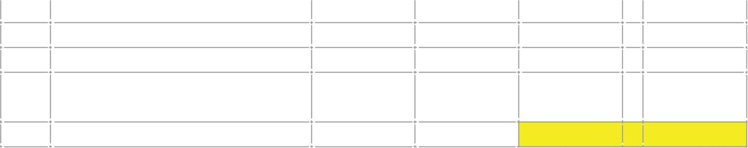

|  |  |  |  |  |  |  |  |  |  |  |
| --- | --- | --- | --- | --- | --- | --- | --- | --- | --- | --- |
| **22. BIOLOGICAL ASSETS** | | | |  |  |  |  |  |  |  |
|  | Maize | Wheat | pasture | Sunflower | Sorghum | Oats | Millet | Beans | Vegetables | Total |
| **(b) Consumable biological assets** | Kshs ‘000 | Kshs ‘000 | Kshs ‘000 | Kshs ‘000 | Kshs ‘000 | Kshs ‘000 | Kshs ‘000 | Kshs ‘000 | Kshs ‘000 | Kshs ‘000 |
| 1. **Group** |  |  |  |  |  |  |  |  |  |  |
| Fair value at 1 July 2021 | 87,984 | 4,691 | 11,383 | 883 | 444 | 92 | 7 | 570 | - | 106,054 |
| Additional costs for old crop | 18,742 | 4,728 | 316 | 249 | 25 | 112 | 17 | 173 | - | 24,363 |
| Gains in fair values due to physical changes - 2020/2021 crop | (65,819) | 7,742 | (9,293) | (565) | (464) | (200) | (11) | (483) | - | (69,092) |
| Decrease in fair value due to harvesting | (40,907) | (17,162) | (2,406) | (567) | (5) | (4) | (13) | (260) | - | (61,324) |
| Increase in fair value due to new planting | 76,310 | 3,747 | 120 | 849 | (9) | 23 | 16 | (39) | - | 81,017 |
| Gain/(loss) in fair value due to physical changes - 2021/2022 crop | (34,527) | (1,335) | 13,157 | (413) | 324 | 133 | (14) | 562 | 95 | (22,019) |
| **Fair value at 30June 2022** | **41,783** | **2,411** | **13,277** | **436** | **315** | **156** | **1** | **523** | **95** | **58,998** |
|  |  |  |  |  |  |  |  |  |  |  |
| 1. **Company** |  |  |  |  |  |  |  |  |  |  |
| Fair value at 1 July 2021 | 87,984 | 4,691 | 11,383 | 883 | 444 | 92 | 7 | 570 | - | 106,054 |
| Additional costs for old crop | 18,742 | 4,728 | 316 | 249 | 25 | 112 | 17 | 173 | - | 24,363 |
| Gains in fair values due to physical changes - 2021/2022 crop | (65,819) | 7,742 | (9,293) | (565) | (464) | (200) | (11) | (483) | - | (69,092) |
| Decrease in fair value due to harvesting | (40,907) | (17,162) | (2,406) | (567) | (5) | (4) | (13) | (260) | - | (61,324) |
| Increase in fair value due to new planting | 76,310 | 3,747 | 129 | 849 | (9) | 23 | 16 | (39) | - | 81,017 |
| Gain/(loss) in fair value due to physical changes - 2021/2022 crop | (34,527) | (1,335) | 13,157 | (413) | 324 | 133 | (14) | 562 | - | (22,113) |
| **Fair value at 30June 2022** | **41,783** | **2,411** | **13,277** | **436** | **315** | **156** | **1** | **523** | **-** | **58,903** |

|  |  |
| --- | --- |
| **22.** | **BIOLOGICAL ASSETS (continued)** |

The seed output from the company’s biological assets were as follows:

|  |  |  |  |  |
| --- | --- | --- | --- | --- |
|  | | | | |
|  |  | **Group and Company** | | |
|  |  | **2023** |  | **2022** |
|  |  | Kgs ‘000 |  | Kgs ‘000 |
|  |  |  |  |  |
| Maize |  | 1,220.56 |  | 424.50 |
| Wheat |  | 632.17 |  | 391.99 |
| Sunflower |  | 30.56 |  | 7.62 |
| Pasture |  | 25.72 |  | 17.36 |
| Sorghum |  | 17.58 |  | 1.60 |
| Millet |  | - |  | 0.52 |
| Oats |  | 34.60 |  | 1.29 |
|  |  | 1,961.20 |  | 844.88 |
|  |  |  |  |  |

|  |
| --- |
| In valuation of crops, the following key assumptions have been made: |
| 1. That the crops mature after within four to nine months and biological transformation takes place uniformly over the life cycle of the crops; 2. That the market conditions will remain unchanged; and, 3. That climatic and weather condition will not change. |
| The financial risk management strategies formulated by the company to reduce various financial risk exposures relating to its biological assets are disclosed in note 37. |

|  |  |  |  |  |  |  |  |
| --- | --- | --- | --- | --- | --- | --- | --- |
| **22. (c)** | **Group** | | | **Company** | | | |
|  | **2023** |  | **2022** |  | **2023** |  | **2022** |
| Fair value gains/(losses) | Kshs’000 |  | Kshs’000 |  | Kshs’000 |  | Kshs’000 |
|  |  |  |  |  |  |  |  |
| Coffee (IAS 16-Bearer Plants) | 5,055 |  | (13,481) |  | 5,055 |  | (13,481) |
|  |  |  |  |  |  |  |  |
| Livestock | 18,280 |  | 1,098 |  | 18,280 |  | 1,098 |
| Trees | 8,772 |  | 3,066 |  | 8,772 |  | 3,066 |
| Consumable biological assets | (71,437) |  | (90,361) |  | (71,437) |  | (90,361) |
| Total as per IAS 41 | 5,055 |  | (13,481) |  | 5,055 |  | (13,481) |

|  |  |  |  |  |  |
| --- | --- | --- | --- | --- | --- |
| **23.** | **RELATED PARTIES TRANSACTIONS AND BALANCES** | | | | |
|  | In the normal course of business, trading occurs among the related parties at terms and conditions similar to those offered to other clients.  The Government of Kenya through Agricultural Development Corporation (ADC) is the principal shareholder of the Kenya Seed Company, holding 52.88% of the company’s equity interest.  Other related parties include:   1. The Parent Ministry 2. County Governments 3. Other Government of Kenya Parastatals 4. The subsidiary companies 5. Shareholders 6. Key management 7. Board of directors | | | | |
|  | Details of related party balances and transactions are as follows: - | | | | |
|  |  |  | **Company** | | |
|  |  |  | **2023** |  | **2022** |
| ***(a)*** | ***Loans capital to subsidiary companies*** |  | Kshs ‘000 |  | Kshs ‘000 |
|  |  |  |  |  |  |
|  | Simlaw Seeds Company Limited |  | 144,298 |  | 144,298 |
|  | Mt Elgon Seed Company Limited |  | 50,078 |  | 50,078 |
|  | Kibo Seed Company Limited |  | 21,452 |  | 21,452 |
|  | Simlaw Seeds Company Tanzania Limited |  | 28,816 |  | 28,816 |
|  | Simlaw Seed Company Uganda Limited |  | 29,619 |  | 18,114 |
|  |  |  | 274,264 |  | 262,759 |
|  | Less provisions for Mt. Elgon Seed Company Limited |  | (50,078) |  | (50,078) |
|  |  |  | 224,186 |  | 212,681 |
|  |  | | | | |
|  | The loan capital relates to amounts advanced to the subsidiaries to help start operations. | | | | |
|  | The directors resolved that the loans should be treated as loan capital as they will be used to increase the share capital of the parent Company in the subsidiaries in future. There are no fixed repayment terms. | | | | |
|  |  |  |  | | |
|  |  |  | **Company** | | |
|  |  |  | **2023** |  | **2022** |
| ***(b)*** | ***Amounts due from subsidiaries (Sales+sundry)*** |  | Kshs ‘000 |  | Kshs ‘000 |
|  |  |  |  |  |  |
|  | Simlaw Seeds Company Limited |  | 1,032,204 |  | 943,469 |
|  | Kibo Seed Company Limited |  | 518,907 |  | 514,445 |
|  | Mt Elgon Seed Company Limited |  | 112,381 |  | 112,381 |
|  | Simlaw Seed Company Uganda Limited |  | 178,616 |  | 217,517 |
|  | Kenya Seed Company Rwanda |  | 197,276 |  |  |
|  |  |  | 2,039,384 |  | 1,787,813 |
|  | Less provisions for Mt. Elgon Seed Company Limited |  | (112,381) |  | (112,381) |
|  |  |  | 1,927,003 |  | 1,675,432 |

|  |  |  |  |  |  |  |  |  |  |  |  |  |  |  |  |  |  |  |  |  |  |  |  |  |  |  |  |  |  |  |  |  |  |  |  |  |  |  |  |  |  |  |  |  |  |  |  |  |  |  |  |  |  |  |  |  |  |  |  |  |  |  |  |  |  |  |  |  |  |  |  |  |  |  |  |  |  |  |  |  |  |  |  |  |  |  |  |  |  |  |  |
| --- | --- | --- | --- | --- | --- | --- | --- | --- | --- | --- | --- | --- | --- | --- | --- | --- | --- | --- | --- | --- | --- | --- | --- | --- | --- | --- | --- | --- | --- | --- | --- | --- | --- | --- | --- | --- | --- | --- | --- | --- | --- | --- | --- | --- | --- | --- | --- | --- | --- | --- | --- | --- | --- | --- | --- | --- | --- | --- | --- | --- | --- | --- | --- | --- | --- | --- | --- | --- | --- | --- | --- | --- | --- | --- | --- | --- | --- | --- | --- | --- | --- | --- | --- | --- | --- | --- | --- | --- | --- | --- | --- |
| |  |  |  |  |  |  |  |  |  |  |  |  |  |  |  |  |  |  |  |  |  |  |  |  |  |  |  |  |  |  |  |  |  |  |  |  |  |  |  |  |  |  |  |  |  |  |  |  |  |  |  |  |  |  |  |  |  |  |  |  |  |  |  |  |  |  |  |  |  |  |  |  |  |  |  |  |  |  |  |  |  |  |  |  |  |  |  |  |  |  |  | | --- | --- | --- | --- | --- | --- | --- | --- | --- | --- | --- | --- | --- | --- | --- | --- | --- | --- | --- | --- | --- | --- | --- | --- | --- | --- | --- | --- | --- | --- | --- | --- | --- | --- | --- | --- | --- | --- | --- | --- | --- | --- | --- | --- | --- | --- | --- | --- | --- | --- | --- | --- | --- | --- | --- | --- | --- | --- | --- | --- | --- | --- | --- | --- | --- | --- | --- | --- | --- | --- | --- | --- | --- | --- | --- | --- | --- | --- | --- | --- | --- | --- | --- | --- | --- | --- | --- | --- | --- | --- | --- | | This relates to purchases by the subsidiaries from the parent company that has accumulated over time. The current credit period is 30 days. This category of receivables is non-interest bearing.   |  |  |  |  |  |  |  |  |  |  | | --- | --- | --- | --- | --- | --- | --- | --- | --- | --- | |  | **Aging Analysis for Amount Due from Subsidiaries (Sales)**: | | | | | | | | | |  | **Just not Due** | **0-30** | **31-60** | **61-90** | **91-120** | **120-180** | **180-365** | **over 365** | **Total** | | Kibo | - | - | - | - | 2,105 | - | (17,313) | 534,115 | 518,907 | | Mt. Elgon | - | - | - | - | - | - | - | 112,381 | 112,381 | | Simlaw Kenya | 3,194 | 7,028 | 7,859 | 35,78 | 136,056 | 28,991 | 188,156 | 624,941 | 1,032,203 | | Simlaw Uganda | - | - | - | - | 36,082 | - | 1,800 | 140,734 | 178,616 | | Kenya seed Rwanda |  |  |  |  | (449) | 17,820 | - | 179,905 | 197,276 | | **Total**  **Less Mt Elgon Prov**  **Sundry** **Accounts** | **3,194** | **7,028** | **7,859** | **35,978** | **173,794** | **46,811** | **172,643** | **1,592,077** | **2,039,384**  **-112,381** | |  | **3,194** | **7,028** | **7,859** | **35,978** | **173,794** | **46,811** | **172,643** | **1,592,077** | **1,927,003** | | |

|  |  |
| --- | --- |
| ***(c)*** | ***Amounts due from Parastatal and other government-controlled organizations*** |

|  |  |  |  |  |  |  |  |
| --- | --- | --- | --- | --- | --- | --- | --- |
|  | **Group** | | |  | **Company** | | |
|  | **2023** |  | **2022** |  | **2023** |  | **2022** |
|  | Kshs’000 |  | Kshs’000 |  | Kshs’000 |  | Kshs’000 |
| Ministry of Agriculture | 924,873 |  | 865,184 |  | 862,402 |  | 862,402 |
| Various County Governments | 338,601 |  | 335,467 |  | 338,601 |  | 310,349 |
| Kenya Farmers Association (KFA) – net | 9,553 |  | 45,239 |  | 9,553 |  | 41,892 |
| National Cereals and Produce Board | 4,865 |  | 4,887 |  | 4,865 |  | 4,887 |
|  | **1,277,892** |  | **1,250,867** |  | **1,215,421** |  | **1,219,530** |

|  |  |  |  |  |  |  |  |
| --- | --- | --- | --- | --- | --- | --- | --- |
|  | **2023** |  | **2022** |  | **2023** |  | **2022** |
|  | Kshs’000 |  | Kshs’000 |  | Kshs’000 |  | Kshs’000 |
| Kenya Farmers Association (KFA) – net |  |  |  |  |  |  |  |
| Gross receivable amount | 22,150 |  | 54,489 |  | 9,553 |  | 41,892 |
| Provision for bad and doubtful debts | - |  | (9,160) |  | - |  | - |
| Net receivable amount | **22,150** |  | **45,329** |  | **9,553** |  | **41,892** |

|  |  |  |  |  |  |  |  |  |  |  |
| --- | --- | --- | --- | --- | --- | --- | --- | --- | --- | --- |
|  |  | **Aging Analysis for Government controlled organizations for the Company:** | | | | | | | | |
|  | Not due |  | 0-30 | 31-60 | 61-90 | 91-120 | 120-180 | 180-365 | over 365 | Total |
| Ministry of Agriculture | - |  | - | - | - | - | - | 51,018 | 811,384 | 862,402 |
| County Governments | (1.13) |  | - | - | 245 | 28,750 | 28,194 | (19,305) | 300,717 | 338,601 |
| Kenya Farmers Ass | 5.48 |  | (794) | 930 | 3,259 | 95 | - | 454 | 5,605 | 9,553 |
| ADC | - |  | - | - | - | - | - | - | - | - |
| NCPB | - |  | - | - | - | - | - | - | 4,865 | 4,865 |
| KARI | - |  | - | - | - | - | - | - | - | - |
| **Total** | **4** |  | **(794)** | **930** | **3,504** | **28,845** | **28,194** | **32,167** | **1,122,571** | **1,215,421** |

|  |  |  |  |  |  |
| --- | --- | --- | --- | --- | --- |
|  |  |  | **2023** |  | **2022** |
|  |  |  | Kshs’000 |  | Kshs’000 |
|  | **Kenya Farmers Association (KFA) – net** |  |  |  |  |
|  | Gross receivable amount |  | 9,553 |  | 41,892 |
|  | Provision for bad and doubtful debts |  | - |  | - |
|  | Net receivable amount |  | 9,553 |  | 41,892 |

|  |  |  |  |  |  |
| --- | --- | --- | --- | --- | --- |
|  |  |  | **Group and Company** | | |
|  |  |  | **2023** |  | **2022** |
| ***(d)*** | ***Amounts due to Managing director*** |  | Kshs ‘000 |  | Kshs ‘000 |
|  |  |  |  |  |  |
|  | Provision for accrued fees, gratuity, leave |  | 21,342 |  | 19,138 |
|  | Due after one year |  | (19,992) |  | (17,788) |
|  | Due within one year |  | 1,350 |  | 1,350 |
|  |  | | | | |

|  |  |  |  |  |  |  |  |  |  |
| --- | --- | --- | --- | --- | --- | --- | --- | --- | --- |
| ***(e)*** | ***Amounts due to Parastatal and other government-controlled organizations*** | | | | | | | | |
|  | | **Group** | | |  | **Company** | | |
|  | | **2023** |  | **2022** |  | **2023** |  | **2022** |
|  | | Kshs’000 |  | Kshs’000 |  | Kshs’000 |  | Kshs’000 |
| Kenya Plant Health Inspectorate (KEPHIS) | | - |  | 3,792 |  | - |  | 3,792 |
|  | | - |  | 3,792 |  | - |  | 3,792 |

|  |  |  |  |  |  |
| --- | --- | --- | --- | --- | --- |
|  |  |  |  | | |
|  |  |  | **Group and Company** | | |
|  |  |  | **2023** |  | **2022** |
| **(f)** | **Transactions within the Group** |  | Kshs ‘000 |  | Kshs ‘000 |
|  | *Kenya Seed Company Limited sales to:* |  |  |  |  |
|  | Simlaw Seeds Uganda |  | 37,882 |  | 43,860 |
|  | Simlaw Seeds Company Limited |  | 507,634 |  | 826,522 |
|  | Kibo Seed Company Limited |  | 7,083 |  | 4,044 |
|  | Ksc Rwanda |  | 26,319 |  | - |
|  |  |  | 578,918 |  | 874,426 |
|  |  | | | | |
|  | *Simlaw Seed Company Limited sales to:* |  |  |  |  |
|  | Kenya Seed Company Limited |  | 260,998 |  | 241,459 |
|  | Simlaw Uganda |  | - |  | 2,690 |
|  | Kibo Seed Company Limited |  | - |  | 9,650 |
|  |  |  | 260,998 |  | 253,799 |
|  |  | | | | |
|  | *Payments made by Kenya Seed Company Limited on behalf of:* | |  |  |  |
|  | Simlaw Seeds Company Limited |  | 1,160 |  | 21,576 |
|  | Mt Elgon Seed Company Limited |  | - |  | 11,510 |
|  | Simlaw Seeds Uganda Limited |  | - |  | 11,508 |
|  | Kibo Seed Company Limited |  | 454 |  | 12,453 |
|  |  |  | 1,614 |  | 57,047 |

|  |  |  |  |  |  |  |  |  |  |
| --- | --- | --- | --- | --- | --- | --- | --- | --- | --- |
| **(f)** | **Transactions within the Group** | | | | | | | | |
|  |  | | | | **Group and Company** | | | | |
|  |  | | | | **2023** | |  | | **2022** |
|  | *Payments made on behalf of Kenya Seed Company Limited:* |  | | | Kshs ‘000 | |  | | Kshs ‘000 |
|  | Simlaw Seeds Company Limited |  | | | 1,097 | |  | | - |
|  | Kibo Seed Company Limited |  | | | - | |  | | - |
|  |  |  | | | 1,097 | |  | | - |
|  |  | | | | | | | | |
| **(g)** | **Transactions with Parastatal organizations** |  | | |  | |  | |  |
|  |  |  | | | **Group and Company** | | | | |
|  | *Sales to:* |  | | | **2023** | |  | | **2022** |
|  | National Cereals and Produce Board |  | | | 47,665 | |  | | 4,869 |
|  | Kenya Farmers Association |  | | | 171,535 | |  | | 41,890 |
|  | Agricultural Development Corporation |  | | | - | |  | |  |
|  |  |  | | | 219,200 | |  | | 46,759 |
|  | Purchases from: | |  | |  | | |  |  |
|  | Agricultural Development Corporation | |  | | 9,133 | | |  |  |
|  | The Kenya Power & Lighting Company Limited | |  | | 46,999 | | |  |  |
|  | Kenya Farmers Association | |  | | 3,202 | | |  |  |
|  | Telkom Kenya | |  | | 279 | | |  |  |
|  | Kenya Agricultural Research Institute | |  | | - | | |  |  |
|  | Agricultural Society of Kenya | |  | | - | | |  |  |
|  | National Cereals and Produce Board | |  | | 9,139 | | |  |  |
|  | KNTC | |  | | 20,160 | | |  |  |
|  |  | |  | | 88,912 | | |  |  |
|  |  | |  | |  | | |  |  |
| **(h)** | **Transactions with directors** | |  | |  | | |  |  |
|  | Directors Fees | |  | | 1,350 | | |  | 1,350 |
|  | Managing Director’s salary and gratuity provision | |  | | 13,798 | | |  | 8,787 |
|  | Board Salaries and allowances | |  | |  | | |  | 6,059 |
|  |  | |  | | 15,148 | | |  | 16,196 |
|  |  | |  | |  | | |  |  |
| **(i)** | **Key management compensation** | |  | |  | | |  |  |
|  |  | |  | |  | | |  |  |
|  | Salaries and allowances | |  | | 74,970 | | |  | 99,907 |
|  |  | |  | |  | | |  |  |
| **(j)** | **Transactions with the staff retirement benefit scheme** | | | |  | | |  |  |
|  |  | | |  | |  | |  |  |
|  | Contributions collected on behalf of the scheme | | |  | | 31,021 | |  | 36,577 |

|  |  |  |  |  |  |  |  |  |  |  |  |
| --- | --- | --- | --- | --- | --- | --- | --- | --- | --- | --- | --- |
|  |  | **Group** | | |  | | **Company** | | | | |
|  |  | **2023** |  | **2022** |  | | **2023** | | |  | **2022** |
| **24** | **INVENTORIES** | **Kshs ‘000** |  | **Kshs ‘000** |  | | **Kshs ‘000** | | |  | **Kshs ‘000** |
|  | Certified Maize Seeds | 994,311 |  | 1,271,861 |  | | 610,551 | | |  | 1,103,958 |
|  | Basic Maize Seeds | 176,564 |  | 337,126 |  | | 171,492 | | |  | 332,681 |
|  | Wheat Seeds | 108,482 |  | 129,120 |  | | 108,517 | | |  | 129,154 |
|  | Pastures | 93,177 |  | 71,457 |  | | 73,540 | | |  | 63,186 |
|  | Sorghum | 12,400 |  | 68,793 |  | | 13,154 | | |  | 69,546 |
|  | Finger millet | 2,396 |  | 38,892 |  | | 2,396 | | |  | 38,892 |
|  | Rice | 9,677 |  | 33,051 |  | | 9,677 | | |  | 33,051 |
|  | Vegetables | 927,511 |  | 1,052,439 |  | | 68,312 | | |  | 61,108 |
|  | Beans & pulses | 13,998 |  | 16,628 |  | | 13,990 | | |  | 16,621 |
|  | Sunflower | 58,919 |  | 206,974 |  | | 57,191 | | |  | 205,038 |
|  | Chemicals | 319,423 |  | 300,702 |  | | 294,836 | | |  | 294,437 |
|  | Fertilizers | 71,077 |  | 51,915 |  | | 70,013 | | |  | 50,139 |
|  | Packaging materials | 445,553 |  | 239,951 |  | | 321,261 | | |  | 221,901 |
|  | Fuel and other inventories | 51,049 |  | 40,642 |  | | 33,944 | | |  | 27,701 |
|  | Miscellaneous & Welfare items | 25,815 |  | 34,014 |  | | 19,865 | | |  | 19,564 |
|  | Cleanings and rejects | 24,763 |  | 29,871 |  | | 22,261 | | |  | 29,308 |
|  | Provision for Obsolete stocks | (224,140) |  | (493,697) |  | | (135,208) | | |  | (430,811) |
|  |  | **3,110,977** |  | **3,429,739** |  | | **1,755,791** | | |  | **2,265,475** |
| **25.** | **TRADE AND OTHER RECEIVABLES** | |  |  | |  | |  |  | |  |
|  |  | **Group** | | | |  | | **Company** | | | |
|  |  | **2023** |  | **2022** | |  | | **2023** |  | | **2022** |
|  |  | **Kshs ‘000’** |  | **Kshs ‘000’** | |  | | **Kshs ‘000’** |  | | **Kshs ‘000’** |
|  | Trade receivables | 1,772,486 |  | 1,937,437 | |  | | 1,118,725 |  | | 1,398,132 |
|  | Other receivables | 59,590 |  | 53,736 | |  | | 9,636 |  | | 8,290 |
|  | Provision for bad & doubtful debts | (897,138) |  | (896,566) | |  | | (724,678) |  | | (782,464) |
|  | **Trade & Other Receivables** | **934,938** |  | **1,094,608** | |  | | **403,683** |  | | **623,959** |
|  | **Staff receivables (note 21)** | **14,839** |  | **26,493** | |  | | **3,074** |  | | **16,185** |
|  | Total | **949,777** |  | **1,121,101** | |  | | **406,757** |  | | **640,143** |
|  | For trade receivables in respect of contracted seed growers, credit amount is limited to the deliveries of seeds expected from the growers. The credit would be in form of the cost of farm inputs and supplies taken by the grower to facilitate farm operations during a seed growing season in a year.  However, the seed grower is charged interest at the prevailing Overdraft rate per month on the inputs for the period of the credit.  The other trade receivables are non-interest bearing and credit amount is limited to the amount of bank guarantee and for a credit period of 30 days.  Customer orders are accompanied by 30 days postdated cheques that are within the customer’s bank guarantee. | | | | | | | | | | |

|  |  |  |  |  |  |
| --- | --- | --- | --- | --- | --- |
|  |  |  | **2023** |  | **2022** |
| **26.** | **SHARE CAPITAL** |  | Kshs ‘000 |  | Kshs ‘000 |
|  | Authorized share capital: |  |  |  |  |
|  | 20,000,000 ordinary shares of Kshs 20 each |  | 400,000 |  | 400,000 |
|  | Issued and fully paid: |  |  |  |  |
|  | 10,781,265 ordinary shares of Kshs 20 each |  | 215,625 |  | 215,625 |
|  |  |  |  |  |  |
|  | The issued and fully paid share capital excludes 3,370,000 ordinary shares worth Kshs 67,400,000 that were issued in the year ended 30 June 2002, which were revoked after the High Court of Kenya ruling on 6 April 2006. These shares are currently a subject matter before the Kenyan Court of Appeal (Note 2). The nominal share capital together with the premium on these shares is now classified under trade and other payables (Note 31). | | | | |

**27. REVALUATION RESERVE**

The revaluation reserve amounting to Kshs 8,140,620,290.25 relates to the revaluation for Property, Plant and Equipment for the Company in the year. As indicated in the statement of changes in equity, this is stated after transfer of excess depreciation net of related deferred tax to retained earnings. Revaluation surpluses are not distributable.

**28. RETAINED EARNINGS**

The retained earnings represent amounts available for distribution to the company’s shareholders. Undistributed retained earnings are utilized to finance the company’s business activities.

|  |  |  |  |  |  |  |  |  |  |  |  |  |  |  |  |  |  |  |  |  |  |  |
| --- | --- | --- | --- | --- | --- | --- | --- | --- | --- | --- | --- | --- | --- | --- | --- | --- | --- | --- | --- | --- | --- | --- |
|  |  |  | | **Group** | | | | | | |  | **Company** | | | | | | | | | | |
|  |  |  | | **2023** | | |  | **2022** | | |  | **2023** | | | | | | |  | **2022** | | |
| **29.** | **DEFERRED TAX** | | | Kshs ‘000 | | |  | Kshs ‘000 | | |  | Kshs ‘000 | | | | | | |  | Kshs ‘000 | | |
| ***(a)*** | ***Statement of comprehensive income*** | | |  | | |  |  | | |  |  | | | | | | |  |  | | |
|  | Deferred liability credit | |  | 187,762 | | |  | (44,869) | | |  | 187,762 | | | | | | |  | (44,869) | | |
|  | Deferred asset credit/(charge) | |  | - | | |  | - | | |  |  | | | | | | |  | - | | |
|  | Charge for the year | |  | 187,762 | | |  | (44,869) | | |  | 187,762 | | | | | | |  | (44,869) | | |
|  |  | |  |  | | |  |  | | |  |  | | | | | | |  |  | | |
| ***(b)*** | ***Deferred tax asset*** | |  |  | | |  |  | | |  |  | | | | | | |  |  | | |
|  | Deferred taxation is calculated on all temporary differences under the liability method using the enacted tax rate of 30% in the current year. | | | | | | | | | | | | | | | | | | | | | |
|  | The net deferred tax liability for the Group is attributable to the following items: | | | | | | | | | | | | | | | | | | | | | |
|  |  | | | | **As at 1 July** | | | | **Income** | | | |  | | | **As at 30 June** | | | | |
|  | *Deferred tax assets:* | | | | **2022** | | | |  | | | |  | | | **2023** | | | | |
|  |  | | | | **Kshs ‘000** | | | | **Kshs ‘000** | | | | |  | | | **Kshs ‘000** | | | |
|  | Unrealized foreign exchange losses | | | | | (92) | | | |  | | | | |  | | |  | | | |
|  | Leave pay provision | | | | | (1,852) | | | |  | | | | |  | | |  | | | |
|  | Tax losses carried forward | | | | | - | | | |  | | | | |  | | |  | | | |
|  | Excess depreciation of tax wear and tear allowances | | | | | (1,812) | | | |  | | | | |  | | |  | | | |
|  | Provision of impairment of inventories | | | | | (15,169) | | | |  | | | | |  | | |  | | | |
|  | Gratuity provision | | | | | (2,307) | | | |  | | | | |  | | |  | | | |
|  | General bad debt provision | | | | | (20,415) | | | |  | | | | |  | | |  | | | |
|  | Fair value gain on biological assets | | | | | - | | | |  | | | | |  | | |  | | | |
|  | Net deferred tax asset | | | | | **(41,647)** | | | |  | | | | |  | | |  | | | |

|  |  |  |  |  |  |  |  |  |  |
| --- | --- | --- | --- | --- | --- | --- | --- | --- | --- |
| ***(c)*** | | Deferred tax liability | | | | | | | |
|  | | Deferred taxation is calculated on all temporary differences under the liability method using the enacted tax rate of 30% in the current year. | | | | | | | |
|  | | The net deferred taxation liability movement is attributable to the following items: | | | | | | | |
|  |  | |  |  | Statement of | | |  |
|  |  | |  |  | comprehensive | | |  |
|  |  | |  | As at 1 July |  | Income |  | As at 30 June |
|  |  | |  | 2022 |  |  |  | 2023 |
|  | Deferred tax liabilities: | |  | Kshs ‘000 |  | Kshs ‘000 |  | Kshs ‘000 |
|  |  | |  |  |  |  |  |  |
|  | Accelerated capital allowances | |  | 14,087 |  | - |  | 75,469 |
|  | Revaluation surplus | |  | 479,950 |  | 86,355 |  | 566,305 |
|  | Fair value gain on biological assets | |  | - |  | - |  | - |
|  | Leave pay provision | |  | (749) |  | 382 |  | (367) |
|  |  | |  | 493,288 |  | 86,737 |  | 641,407 |
|  |  | |  |  |  |  |  |  |
|  | Deferred tax assets: | |  |  |  |  |  |  |
|  |  | |  |  |  |  |  |  |
|  | Gratuity provision | |  | (5,197) |  | 5,197 |  | - |
|  | General bad debts provision | |  | (64,932) |  | 41,316 |  | (23,617) |
|  | Unrealized foreign exchange losses | |  | 12,003 |  | (26,490) |  | (14,487) |
|  | Staff bad debt provision | |  | (864) |  | (2,653) |  | (3,517) |
|  | Leave pay provision | |  | - |  | - |  | - |
|  | Fair value gain on biological assets | |  | (12,114) |  | 22,276 |  | 10,162 |
|  |  | |  | (71,104) |  | 39,645 |  | (31,459) |
|  | Net deferred tax liability | |  | 422,183 |  | 126,382 |  | 609,948 |
|  |  | |  |  |  |  |  |  |
|  | Deferred tax assets and deferred tax liabilities are not offset due to legal jurisdiction of the entities. | | | | | | | |

|  |  |  |  |  |  |  |  |  |
| --- | --- | --- | --- | --- | --- | --- | --- | --- |
|  |  | **Group** | | |  | **Company** | | |
| **30. EMPLOYEE BENEFITS OBLIGATIONS** | | **2023** |  | **2022** |  | **2023** |  | **2022** |
|  |  | Kshs ‘000 |  | Kshs ‘000 |  | Kshs ‘000 |  | Kshs ‘000 |
|  | Gratuity provision | 63,696 |  | 67,713 |  | 56,032 |  | 60,023 |
|  | Benevolent fund | 1,342 |  | 986 |  | 1,342 |  | 986 |
|  | As at 30 June | **65,038** |  | **68,699** |  | **57,374** |  | **61,009** |

|  |  |  |  |  |  |  |  |  |  |  |
| --- | --- | --- | --- | --- | --- | --- | --- | --- | --- | --- |
|  |  | | **Group** | | |  | **Company** | | | |
| **31. TRADE AND OTHER PAYABLES** | | **2023** | |  | **2022** |  | | **2023** |  | **2022** | |
|  | | Kshs ‘000 | |  | Kshs ‘000 |  | | Kshs ‘000 |  | Kshs ‘000 | |
| Amounts due to disputed share-holders (note 26) | | 124,690 | |  | 124,690 |  | | 124,690 |  | 124,690 | |
| Trade payables | | 650,590 | |  | 571,712 |  | | 196,940 |  | 179,791 | |
| Accrued leave pay | | 26,055 | |  | 21,999 |  | | 17,057 |  | 15,824 | |
| Accruals and other payables | | (531) | |  | 67,492 |  | | 45,256 |  | 36,994 | |
|  | | 4,480 | |  | - |  | | 4,480 |  | - | |
|  | | **805,285** | |  | **785,893** |  | | **388,424** |  | **357,298** | |
|  | | | | | | | | | | | |

|  |  |  |  |  |  |
| --- | --- | --- | --- | --- | --- |
|  |  |  | **Group and Company** | | |
|  |  |  | **2023** |  | **2022** |
| **32.** | **UNCLAIMED DIVIDENDS** |  | Kshs ‘000 |  | Kshs ‘000 |
|  |  |  |  |  |  |
|  | At beginning of the year |  | 9,203 |  | 9,203 |
|  | Unclaimed during the year |  | - |  | - |
|  | At end of the year |  | 9,203 |  | 9,203 |

These are in respect of dividend that owners cannot be located or dividend uncollected by the owners. They are comprised of dividends that have been declared and paid, but the owners were either not found or they did not bank their payment cheques. The company is in the process of submitting these to UFAA. The Unclaimed Financial Assets Act was enacted as an Act of Parliament in Kenya in December 2011. The Act provides for the reporting and dealing with unclaimed financial assets and the establishment of the Unclaimed Financial Assets Authority (UFAA) and the Unclaimed Financial Assets Trust Fund. Under the provisions of the Act, unclaimed dividends payable are considered to be unclaimed assets. The Unclaimed Financial Assets Authority has set a cut-off of 3 years’ dormancy for unclaimed assets. During the year, the Company did not forward any unclaimed dividends to the Authority. Once unclaimed assets are paid to the Authority, the Authority assumes custody and responsibility for the safekeeping of the assets and indemnifies the payee against any future liability in respect of those assets

|  |  |  |
| --- | --- | --- |
|  |  | |
| **33.** | **BANK LOAN** | |
| |  |  |  |  |  |  |  |  |  |  |  | | --- | --- | --- | --- | --- | --- | --- | --- | --- | --- | --- | |  |  | **Group** | |  |  |  | **Company** | | |  | |  | **2023** |  | **2022** | |  | **2023** | |  | **2022** | | |  | Kshs ‘000 |  | Kshs ‘000 | |  | Kshs ‘000 | |  | Kshs ‘000 | | | 1. Bank Loan-KCB |  |  | - | |  | - | |  | - | | | |
| * As at 30 June 2023, Simlaw Seeds Kenya had Nil bank loan. (2022- Kshs Nil). The loan was acquired from Kenya Commercial Bank for duration of 5 Years, at an interest rate of 17% for purchase of property at Number 2, Kijabe Street, L.R. no 209/4360/33 used as security for Loan. | |

|  |  |  |  |  |  |  |  |  |
| --- | --- | --- | --- | --- | --- | --- | --- | --- |
| **34. CASH AND CASH EQUIVALENTS** | | **Group** | | |  | **Company** | | |
|  | **Company Account number** | **2023** |  | **2022** |  | **2022** |  | **2021** |
|  | **Kshs ‘000** |  | **Kshs ‘000** |  | **Kshs ‘000** |  | **Kshs ‘000** |
| Cash on Hand |  | 27,724 |  | 2,485 |  | 2,291 |  | 1,585 |
| Mpesa |  | 4,856 |  | 4,994 |  | 4,856 |  | 4,992 |
| Barclays Bank-Kshs | 0038202995 | 1,324,287 |  | 400,162 |  | 1,305,935 |  | 384,723 |
| Barclays Bank-Dollar | 227213949 | 73,243 |  | 102,276 |  | 56,737 |  | 83,429 |
| KCB-Rwanda | 4400617351 | - |  | 13,875 |  | - |  | 13,875 |
| KCB-Kenya | 1105122484 | 332,871 |  | 1,488,485 |  | 213,895 |  | 1,438,846 |
| NBK-Kenya | 01003048613200 | 29,263 |  | 20,387 |  | 29,263 |  | 20,387 |
| Equity-Kenya | 0330293593306 | 573,163 |  | 248,996 |  | 573,163 |  | 248,996 |
| Cooperative Bank | 1141502576900 | 345,043 |  | 86,468 |  | 345,043 |  | 86,468 |
| KCB Tanzania |  | 10,676 |  | 3,856 |  | - |  | - |
| Standard Chartered Bank - Ug |  | 78 |  | 64 |  | - |  | - |
| KCB-Uganda |  | 74,009 |  | 46,359 |  | - |  | - |
| Centenary Bank Uganda |  | 21,967 |  | 7,806 |  | - |  | - |
| National Bank of Commerce TZ |  | 3,958 |  | 2,037 |  | - |  | - |
| National Micro Finance Bank TZ |  | 34,581 |  | 17,198 |  | - |  | - |
| Stanbic Bank Ltd –UG |  | 31 |  | 25 |  | - |  | - |
| Stanbic Bank Ltd -TZ |  | 11,565 |  | 8,550 |  |  |  |  |
| Total Cash **(Note 34a)** |  | **2,867,314** |  | **2,454,021** |  | **2,531,183** |  | **2,283,301** |
| Fixed Deposits **(Note 34b)** | 1126074047 | **76,206** |  | **75,365** |  | **76,206** |  | **75,365** |
| Cash & Cash Equivalent **(34a +34b)** |  | **2,943,520** |  | **2,529,385** |  | **2,607,389** |  | **2,358,666** |

|  |  |  |  |  |  |  |  |  |  |  |  |  |  |  |  |  |  |  |  |  |  |  |  |  |  |  |  |  |  |  |  |  |  |  |  |  |  |  |  |  |  |  |  |  |  |  |  |  |  |  |  |  |  |  |  |  |
| --- | --- | --- | --- | --- | --- | --- | --- | --- | --- | --- | --- | --- | --- | --- | --- | --- | --- | --- | --- | --- | --- | --- | --- | --- | --- | --- | --- | --- | --- | --- | --- | --- | --- | --- | --- | --- | --- | --- | --- | --- | --- | --- | --- | --- | --- | --- | --- | --- | --- | --- | --- | --- | --- | --- | --- | --- |
| Fixed Deposits (Note 34b) is an amount invested as a Fixed Deposit by the company for use by the bank to subsidize staff mortgage interest rates. The interest earned in this account is re-invested/ploughed back into the same account.  For the purposes of the statement of cash flows, cash and cash equivalents comprise the below:   |  |  |  |  |  |  |  |  | | --- | --- | --- | --- | --- | --- | --- | --- | |  |  |  |  |  |  |  |  | |  | **Group** | | |  | **Company** | | | |  | **2023** |  | **2022** |  | **2023** |  | **2022** | |  | **Kshs ‘000** |  | **Kshs ‘000** |  | **Kshs ‘000** |  | **Kshs ‘000** | | Fixed deposits (Note34 b) | 76,206 |  | 75,365 |  | 76,206 |  | 75,365 | | Cash at bank and in hand (Note34 a) | 2,867,314 |  | 2,454,021 |  | 2,531,183 |  | 2,283,301 | |  | **2,943,520** |  | **2,529,385** |  | **2,607,389** |  | **2,358,666** | |

**35. FOREIGN OPERATIONS TRANSLATION RESERVE**

|  |  |  |  |
| --- | --- | --- | --- |
|  | **2023** | **2022 to 2023** | **2022** |
| **Subsidiary** | **Kshs** | **Kshs** | **Kshs** |
| Simlaw UG | (16,042,595) | (18,730,885) | 2,688,290 |
| Kibo | 8,104,296 | (16,200,367) | 24,304,663 |
| Simlaw TZ | (1,975,872) | (4,053,233) | 2,077,361 |
| MESC | 1,737,606 | (8,829,954) | 10,567,560 |
| KSC Rwanda | 147,947 | 147,947 | - |
|  | **(8,028,619)** | **(47,666,492)** | **39,637,873** |
| Exchange differences on translating foreign operations | (68,094,989) |  |  |
| Income tax effect at 30% | 20,428,497 |  |  |
|  | **(47,666,492)** |  |  |

|  |  |  |  |  |  |  |  |  |  |  |  |  |  |
| --- | --- | --- | --- | --- | --- | --- | --- | --- | --- | --- | --- | --- | --- |
| **36. CAPITAL EXPENDITURE COMMITMENTS** | | |  | | |  |  | | |  |  | | |
| These are the budgeted capital expenditure made by the Group and company to purchase assets in future for which no provisions have been made in these financial statements include: | | | | | | | | | | | | | |
|  |  |  |  | | | | |  |  |  |  | | |
|  | **Group** | | | | | | |  | **Company** | | | | |
|  | **2023** | | |  | **2022** | | |  | **2023** | | |  | **2022** |
|  | Kshs ‘000 | | |  | Kshs ‘000 | | |  | Kshs ‘000 | | |  | Kshs ‘000 |
| Authorised but not contracted for | 549,726 | | |  | 462,083 | | |  | 489,515 | | |  | 401,872 |

|  |
| --- |
| **37. FINANCIAL RISK MANAGEMENT OBJECTIVES AND POLICIES** |
| The company’s principal financial instruments comprise cash and cash equivalents, trade receivables, trade payables and amounts due from related parties. These instruments arise directly from its operations. | |
| The company does not enter into derivative transactions. | |
| The company has exposure to the following risks from its use of financial instruments: | |
| * Credit risk; * Liquidity risk; * Market risk; * Operational risk. | |
|  | |
| The policy of the company is to minimize the negative effect of such risks on cash flow, financial performance and equity  This note presents information about the company’s exposure to each of the above risks, the company’s objectives, policies and processes for measuring and managing risk and the company’s management of capital. Further quantitative disclosures are included throughout these financial statements. | |
|  | |
| The directors have adopted various measures to minimize losses that may arise from these exposures. These are explained as follows: | |
| *(a) Credit risk* | | |
| Credit risk is the risk that counterparty to a financial instrument will fail to discharge an obligation and cause the company to incur a financial loss. | | |
| The largest concentrations of credit exposure within the company relate to cash and cash equivalents held with banks, trade receivables and amounts due from related parties. The maximum exposures for credit risk are therefore in regards to the carrying amount of cash and cash equivalents, trade receivables and amount due from related parties net of any impairment losses. The company only places significant amounts of funds with recognized financial institutions with strong credit ratings and does not consider the credit risk exposure to be low. Amounts due from related parties do not expose the company to significant credit risk. | | |
| Customer credit risk is managed by each business unit subject to the company’s established policy, procedures and control relating to customer credit risk management. Credit quality of the customer risk assessed based on an extensive credit rating scorecard and individual credit limits are defined in accordance with this assessment. Outstanding customer receivables are regularly monitored and any shipments to major customers are generally covered by valid contracts. For the growers the credit risk arises when there is a crop failure due adverse weather condition. | | |
| The amount that best represents the company’s maximum exposure to credit risk as at 30 June 2023 is made up as follows: | | |

|  |  |  |  |  |  |  |  |
| --- | --- | --- | --- | --- | --- | --- | --- |
|  | **Group** | | |  | **Company** | | |
|  | **2023** |  | **2022** |  | **2023** |  | **2022** |
|  | Kshs ‘000 |  | Kshs ‘000 |  | Kshs ‘000 |  | Kshs ‘000 |
| Net trade receivables | 934,970 |  | 1,094,608 |  | 403,683 |  | 623,959 |
| Net staff receivables | 14,807 |  | 26,493 |  | 3,074 |  | 16,185 |
|  | 949,777 |  | 1,121,101 |  | 406,757 |  | 640,143 |

|  |  |  |  |  |  |  |  |
| --- | --- | --- | --- | --- | --- | --- | --- |
| **37. FINANCIAL RISK MANAGEMENT OBJECTIVES AND POLICIES (Continued)** | | | | | | | |
| Collateral is held in form of bank guarantees for trade receivables. No collateral is held for the other assets. All trade receivables that are neither past due nor impaired are within their approved credit limit, and no receivables have had their terms renegotiated. | | | | | | | | |
| None of the above assets are past due or impaired except for the following amounts (which were due within 30 days of the end of the month in which they are invoiced). | | | | | | | | |
|  | **Group** | | |  | **Company** | | | |
|  | **2023** |  | **2022** |  | **2023** |  | **2022** | |
|  | Kshs ‘000 |  | Kshs ‘000 |  | Kshs ‘000 |  | Kshs ‘000 | |
| Past due but not impaired: |  |  |  |  |  |  |  | |
| * by up to 30 days | 1,583 |  | 70,348 |  | 1,583 |  | 70,348 | |
| * by 31 to 60 days | 4,422 |  | 94,907 |  | 4,422 |  | 94,907 | |
| * by 61 to 90 days | 45,115 |  | 150,036 |  | 33,418 |  | 139,724 | |
| * over 90 days | 898,657 |  | 805,809 |  | 367,334 |  | 335,164 | |
|  | 949,777 |  | 1,121,100 |  | 406,757 |  | 640,143 | |

|  |  |  |  |  |  |  |  |
| --- | --- | --- | --- | --- | --- | --- | --- |
| Movement in provisions for doubtful debts: | | | | | | | |
|  | **Group** | | |  | **Company** | | |
|  | **2023** |  | **2022** |  | **2023** |  | **2022** |
|  | Kshs ‘000 |  | Kshs ‘000 |  | Kshs ‘000 |  | Kshs ‘000 |
| As at 1 July | 896,566 |  | 812,359 |  | 782,464 |  | 719,879 |
| Recoveries during the year | 28,795 |  | (27,059) |  | (66,299) |  | (27,059) |
| Provisions for the year | (27,335) |  | 112,280 |  | 9,401 |  | 90,658 |
| Reversal of overprovision | (889) |  | (1,014) |  | (889) |  | (1,014) |
| As at 30 June | 897,138 |  | 896,566 |  | 724,678 |  | 782,464 |
|  |  |  |  |  | ` |  |  |

|  |  |  |  |  |  |
| --- | --- | --- | --- | --- | --- |
| *(b) Market risk* | | | | | |
| Market risk is the risk that the fair value or future value of instruments will fluctuate due to changes in market valuables such as interest rates and foreign exchange rates. The objective of market risk management policy is to protect and enhance the statement of financial position and income statement by managing and controlling market risk expenses within acceptable parameters and to optimize the funding of business operations and facilitate capital expansions. There has been no change to the company’s exposure to market risks or the manner in which it manages and measures the risk. | | | | | |
|  | | | | | |
| *Interest rate risk* | | | | | |
| Interest rate risks arise from fluctuations in the bank borrowing rates in the market. The interest rates vary from time to time depending on the prevailing economic circumstances. Since the base rates charged by the banks are determined by the market forces, the Company has not formulated any practical measures to minimize the exposure. The interest earning financial assets that the company holds include investments in government securities and short-term deposits whose rates of return are predetermined. | | | | | |
|  | Change in Interest rate |  | Effect on profit Before Tax |  | Effect on Equity |
|  |  |  | Kshs ‘000 |  | Kshs ‘000 |
| 2023 | -10.00% |  | (31,612) |  | (22,128) |
|  | 10.00% |  | 31,612 |  | 22,128 |
| 2022 | -10.00% |  | 32,126 |  | 62,238 |
|  | 10.00% |  | (32,126) |  | (62,238) |
|  | | | | | |

**37. FINANCIAL RISK MANAGEMENT OBJECTIVES AND POLICIES (Continued)**

*Exchange risks*

The Group operates in Kenya, Tanzania, Rwanda and Uganda. The operations in Tanzania and Uganda are significantly autonomous from those in Kenya and most of the transactions are carried out in the local currencies. Other transactions in the foreign currency are carried out in the relatively stable US Dollars. Invoices denominated in foreign currencies are paid after 30 days from the date of the invoice and conversion at the time of payment is done using the prevailing exchange rates. The carrying amount of the company’s foreign exchange denominated monetary assets is:

|  |  |  |  |  |
| --- | --- | --- | --- | --- |
|  | **Group** | **Group** | **Company** | **Company** |
| **Financial assets** | **2023** | **2022** | **2023** | **2022** |
|  | Kshs ‘000 | Kshs ‘000 | Kshs ‘000 | Kshs ‘000 |
| Amount due from Rwanda customers (note 25) | 67,070 | 185,551 | 67,070 | 185,551 |
| Cash and cash equivalents (note 34) Dollar & Rwanda accounts | 73,243 | 116,150 | 56,737 | 97,303 |
|  | **140,313** | **301,701** | **123,808** | **282,854** |

|  |  |  |  |  |  |  |  |  |  |  |  |
| --- | --- | --- | --- | --- | --- | --- | --- | --- | --- | --- | --- |
|  |  |  | |  |  | | |  |  | | |
|  | USD | Change in currency rate | |  | Effect on profit Before Tax | | |  | Effect on Equity | | |
|  |  |  | |  | Kshs ‘000 | | |  | Kshs ‘000 | | |
|  | 2023 | -10.00% | |  | (6,809) | | |  | (4,767) | | |
|  |  | 10.00% | |  | 6,809 | | |  | 4,767 | | |
|  | 2022 | -10.00% | |  | (1,272) | | |  | (891) | | |
|  |  | 10.00% | |  | 1,272 | | |  | 891 | | |
|  |  | | | | | | | | | | |
| (c) | *Liquidity risk* | | | | | | | | | | |
|  | Ultimate responsibility for liquidity risk management rests with the Board of Directors, which has built an appropriate liquidity risk management framework for the management of the Company’s short, medium- and long-term funding and liquidity management requirements. The Company manages liquidity risk by maintaining adequate reserves, banking facilities and reserve borrowing facilities, by continuously monitoring forecast and actual cash flows and matching the maturity profiles of financial assets and liabilities. | | | | | | | | | | |
|  | The following table analyses the company’s financial liabilities that will be settled on a net basis into relevant maturity groupings based on the remaining period at the reporting date to the contractual maturity date. The amounts disclosed in the table below are the contractual undiscounted cash flows. Balances due within 12 months equal their carrying balances, as the impact of discounting is not significant. | | | | | | | | | | |
|  | | Up to | | | 1 – 3 | 3 - 12 | | | over |  |
|  | | 1 month | | | Months | months | | | 1 year | Total |
| **At 30 June 2023** | | Kshs ‘000 | | | Kshs ‘000 | Kshs ‘000 | | | Kshs ‘000 | Kshs ‘000 |
|  | |  | | |  |  | | |  |  |
| **Financial assets** | |  | | |  |  | | |  |  |
| Trade receivables | | 447,490 | | | 223,745 | 279,681 | | | 167,809 | 1,118,725 |
| Other receivables and prepayments | | - | | | - | 9,636 | | | - | 9,636 |
| Amount due from related parties | | - | | | - | 1,927,003 | | | - | 1,927,003 |
| Bank balances and cash deposits | | 2,607,389 | | | - | - | | | - | 2,607,389 |
| Total financial assets | | 3,054,879 | | | 223,745 | 2,216,320 | | | 167,809 | 5,662,753 |
|  | |  | | |  |  | | |  |  |
| **Financial liabilities** | |  | | |  |  | | |  |  |
| Total financial liabilities | | (155,369) | | | (77,685) | (97,106) | | | (58,264) | (388,424) |
|  | |  | | |  |  | | |  |  |
| **Net liquidity gap** | | **2,899,510** | | | **146,060** | **2,119,214** | | | **109,545** | **5,274,329** |

|  |  |  |  |  |  |
| --- | --- | --- | --- | --- | --- |
|  | Up to | 1 – 3 | 3 - 12 | over |  |
|  | 1 month | Months | months | 1 year | Total |
| **At 30 June 2022** |  |  |  |  |  |
| **Financial assets** |  |  |  |  |  |
| Trade receivables | 559,253 | 279,626 | 349,533 | 209,720 | 1,398,132 |
| Other receivables and prepayments | - | - | 8,290 | - | 8,290 |
| Amount due from related party | - | - | 1,675,432 | - | 1,675,432 |
| Bank balances and cash deposits | 2,358,666 | - | - | - | 2,358,666 |
| **Total financial assets** | 2,917,918 | 279,626 | 2,033,255 | 209,720 | 5,440,520 |
|  |  |  |  |  |  |
| **Financial liabilities** |  |  |  |  |  |
| Total financial liabilities | (142,919) | (71,460) | (89,325) | (53,595) | (357,298) |
|  |  |  |  |  |  |
| **Net liquidity gap** | **2,774,999** | **208,167** | **1,943,930** | **156,125** | **5,083,221** |
|  |  |  |  |  |  |

|  |  |  |
| --- | --- | --- |
|  |  | |
| (d) | *Operational risk* | |
|  | Operational risk is the risk of direct or indirect loss arising from a wide variety of causes associated with the company’s processes, personnel, technology and infrastructure and from external factors other than credit, market and liquidity risks such as from legal and regulatory requirements and generally accepted standards of corporate behavior. The company seeks to ensure that key operational risks are managed in a timely and effective manner through a framework of policies, procedures and tools to identify, assess, monitor, control and report such risks. | |
|  | The company’s objective is to manage operational risk so as to balance the avoidance of financial losses and damage to the company’s reputation with overall cost effectiveness and to avoid control procedures that restrict initiative and creativity. | |
|  | The primary responsibility for the development and implementation of controls to address operational risk is assigned to senior management. | |
|  | This responsibility is supported by the development of overall company standards for the management of operational risk in the following areas: | |
| * Requirements for appropriate segregation of duties, including the independent authorization of transactions; * Requirements for the reconciliation and monitoring of transactions; * Compliance with regulatory and legal requirements; * Documentation of controls and procedures; * Requirements for the yearly assessment of operational risk faced, and the adequacy of controls and procedures to address the risks identified; * Requirements for the reporting of operational losses and proposed remedial action; * Development of contingency plans; * Training and professional development; * Ethical and business standards; and, * Risk mitigation, including insurance where this is effective. | |
| Operational risk is managed by a program of regular reviews undertaken by the Internal Audit and the results of the reviews are discussed with the management, with summaries submitted to the Audit Committee and senior management of the company. | |

|  |  |  |  |  |  |
| --- | --- | --- | --- | --- | --- |
| **38.** | **CAPITAL MANAGEMENT** | | | | |
|  | The company defines capital as the total equity of the Company. The company’s long-term objective for managing capital is to deliver sustainable returns to maximize long-term shareholder value. | | | | | | |
|  | The company is not subject to any externally imposed capital requirements. | | | | | | |
|  | The major items that impact the equity of the company include the following: | | | | | | |
|  | * Revenue received from seed sales (which is a function of price and sales volume); * Seed purchase cost; * Cost of operating the business; * Cost of expanding the business to ensure that capacity growth is in line with seed sales demand; * Taxation; and, * Dividends. | | | | | | |
|  | In the short to medium term, profits are distributed via dividends, and extra profits retained in the company are used to self-fund investing and operating activities. The company does not have any long-term debt. The company aims to maintain capital discipline in relation to investing activities. | | | | | | |
|  | The company monitors capital using a gearing ratio, which is net debt divided by total capital plus net debt. The company’s policy is to keep the gearing ratio between 10% and 25%. The company includes within net debt, interest bearing loans and borrowing, trade and other payables, less cash and cash equivalent. | | | | | | |
|  |  |  | **2023** |  | **2022** | |
|  |  |  | **Kshs ‘000** |  | **Kshs ‘000** | |
|  | Trade and other payables (note 31) |  | 388,424 |  | 785,893 | |
|  | Less: Cash and other short-term deposits (note 34) |  | (2,607,389) |  | (2,358,666) | |
|  | Net debt |  | (2,218,965) |  | (1,572,773) | |
|  | Total Capital (Equity) |  | 16,868,886 |  | 12,657,597 | |
|  | Capital and net debt |  | 14,649,921 |  | 11,084,824 | |
|  | Gearing ratio |  | (13%) |  | 12% | |
|  |  |  |  |  |  | |
|  | Though the company’s gearing ratio is below its’ lower end, the directors consider this to be favorable. There were no changes in the company’s approach to capital management as regards the objectives, policies or processes during the year. | | | | | |

**39. CASH FLOW ITEMS**

|  |  |  |  |  |  |  |  |  |  |  |
| --- | --- | --- | --- | --- | --- | --- | --- | --- | --- | --- |
|  |  | | **2023** | | **2022** | | **2023** | | **2022** | |
|  |  | | **Group** | | | | **Company** | | | |
| **Reconciliation of operating profit to cash generated from operations** | Notes | | Kshs ‘000 | | Kshs ‘000 | | Kshs ‘000 | | Kshs ‘000 | |
| Profit before taxation |  | | 418,966 | | 359,215 | | 263,940 | | 247,657 | |
| **Adjustment for :-** |  | |  | |  | |  | |  | |
|  |  | |  | |  | |  | |  | |
| Depreciation and amortization |  | | 124,470 | | 243,356 | | 122,005 | | 235,046 | |
| Proceeds from sale of assets (Loss) |  | | 6,771 | | (6,200) | | 6,771 | | (6,200) | |
| Gain/loss on Bearer Plants | 22 (a) | | 5,055 | | (13,481) | | 5,055 | | (13,481) | |
| Finance income |  | | (102,850) | | 40,786 | | (22,048) | | 24,129 | |
|  |  | | **452,412** | | **623,676** | | **375,723** | | **487,151** | |
| **Changes in working capital:** |  | |  | |  | |  | |  | |
| Inventories |  | | 318,763 | | (64,840) | | 509,685 | | (23,110 | |
| Biological asset |  | | (43,671) | | 63,161 | | (43,597) | | 63,256 | |
| Dividend payable |  | | 226,407 | | - | | 226,407 | | - | |
| Trade and other receivables |  | | 171,233 | | (161,452) | | 233,295 | | (104,128) | |
| Amounts due from / to directors |  | | 2.204 | | (321) | | 2,204 | | (321) | |
| Trade and other payables |  | | 15,731 | | (17,127) | | 27,490 | | (8,111) | |
| Amounts due from /to related parties |  | | (30,816) | | (81,613) | | (328,585) | | (62,043) | |
|  |  | |  | |  | |  | |  | |
| **Cash generated from operations** |  | | **1,112,261** | | **361,486** | | **1,002,621** | | **352,694** | |
|  |  | |  | |  | |  | |  | |
|  |  | |  | |  | |  | |  | |
|  |  | |  | |  | |  | |  | |
|  |  | |  | |  | |  | |  | |
|  |  | |  | |  | |  | |  | |
|  |  | |  | |  | |  | |  | |
|  |  | |  | |  | |  | |  | |
|  |  | |  | |  | |  | |  | |
|  |  | |  | |  | |  | |  | |
|  |  | |  | |  | |  | |  | |
|  |  | |  | |  | |  | |  | |
|  |  | |  | |  | |  | |  | |
|  |  | |  | |  | |  | |  | |
|  |  | |  | |  | |  | |  | |
|  |  | |  | |  | |  | |  | |
|  |  | |  | |  | |  | |  | |
|  |  | |  | |  | |  | |  | |
|  |  | |  | |  | |  | |  | |
|  |  | |  | |  | |  | |  | |
|  | |  | |  |  |  | |  | |
| **40. SEGMENTAL INFORMATION** | | | | | | | | | | | | |
| **Business segments** | | | | | | | | | | | | |
| The Group carries on the business of seed growers and seed merchants. It operates a seed maize shelling and drying plant and a small cereal drying plant. The Group also imports, produces and distributes vegetable seeds under the brand name of “Simlaw” seeds. Over 99% of the business of the Group involves production and sale of seeds hence segment analysis based on business lines is not deemed useful in these financial statements. | | | | | | | | | | | | |
| **Geographical segments** | | | | | | | | | | | | |
| The Group is organized on a regional basis into three main geographical segments: | | | | | | | | | | | | |
| * Kenya * Tanzania * Uganda | | | | | | | | | | | | |

The analysis below is the summary of the Group’s results, assets and liabilities by geographical segments:

|  |  |  |  |  |  |  |
| --- | --- | --- | --- | --- | --- | --- |
|  | **Kenya** | **Tanzania** | **Uganda** | **KSC Rwanda** | **Eliminated on consolidation** | **Total** |
| **Statement of comprehensive income** | Kshs’000 | Kshs’000 | Kshs’000 | Kshs’000 | Kshs’000 | Kshs’000 |
| ***Year ended 30 June 2023*** |  |  |  |  |  |  |
| Operating income |  |  |  |  |  |  |
| External | 6,801,280 | 494,500 | 386,599 | 51,139 | - | 7,733,518 |
| Inter-segment | (577,559) | - | - | - | - | (577,559) |
| Total operating income | 6,223,721 | 494,500 | 386,599 | 51,139 | - | 7,155,959 |
| **Segment profit** | **(88,599)** | **(123,911)** | **(4,509)** | **34,025** | **-** | **(182,994)** |
|  |  |  |  |  |  |  |
| **Statement of financial position: -** |  |  |  |  |  |  |
| Segment total assets | 19,368,308 | 550,289 | 653,778 | 186,068 | (2,378,740) | 18,379,702 |
| Segments liabilities | 1,639,516 | 703,130 | 775,954 | 35,961 | (2,253,694) | 900,868 |
| Non-operating liabilities | 609,948 | - | - | - | - | 609,948 |
| **Total liabilities** | **2,249,464** | **703,130** | **775,954** | **35,961** | **(2,253,694)** | **1,510816** |
|  |  |  |  |  |  |  |
| **Other information: -** |  |  |  |  |  |  |
| Additions to property, plant and equipment | 473,684 | 660 | 11,266 | 44,972 | - | 530,582 |
| Additions to intangible assets | 15,994 | 243 | 92 | - |  | 16,329 |
| Depreciation of property, plant and equipment | 100,453 | 12,876 | 5,313 | - |  | 118,644 |
| Amortization of intangible assets | 5,746 | 298 | 915 | - |  | 6,959 |
| Provision for obsolete inventories | 22,708 | 38,702 | - | - |  | 61,409 |
| Provision for bad and doubtful debts |  | - | - | - |  | - |
| Bad debts recovered | 67,685 | - | - | - |  | 67,685 |
| Finance cost | - | - | - | - |  | - |
| Finance income | (921) |  | - | - |  | (921) |
| Income tax | 232,888 | 8,139 | - | - |  | 241,027 |
| Effects of discounting of staff receivables |  |  |  |  |  |  |
|  | **737,862** | **60,918** | **17,588** | **44,972** | **-** | **861,340** |
| **Off balance sheet items:** |  |  |  |  |  |  |
| Capital expenditure commitments | 489,515 |  |  |  |  | 489,515 |
| Operating lease commitments |  |  |  |  |  |  |
| **Total** | **489,515** |  |  |  |  | **489,515** |

Inter-segment revenues are eliminated upon consolidation and reflected in the ‘Eliminated on consolidation’

|  |  |  |  |  |  |
| --- | --- | --- | --- | --- | --- |
|  | Kenya Seed | Kibo | Simlaw uganda | Eliminated on consolidation | Total |
| **Statement of comprehensive income** | Kshs’000 | Kshs’000 | Kshs’000 | Kshs’000 | Kshs’000 |
| ***Year ended 30 June 2022*** |  |  |  |  |  |
| Operating income |  |  |  |  |  |
| External | 7,069,361 | 406,763 | 358,398 | - | 7,834,523 |
| Inter-segment | (891,399) |  |  |  | (891,399) |
| Total operating income | 6,177,962 | 406,763 | 358,398 |  | 6,943,124 |
| **Segment profit** | **(116,301)** | **(18,719)** | **(13,803)** |  | **(148,824)** |
|  |  |  |  |  |  |
| **Statement of financial position: -** |  |  |  |  |  |
| Segment total assets | 15,187,266 | 459,657 | 522,064 | (2,202,483) | 13,966,505 |
| Segments liabilities | 1,715,455 | 713,546 | 640,506 | (2,182,783) | 886,725 |
| Non-operating liabilities | 422,184 | - | - | - | 422,184 |
| **Total liabilities** | **2,137,638** | **713,546** | **640,506** | **(2,182,783)** | **1,308,908** |
|  |  |  |  |  |  |
| **Other information: -** |  |  |  |  |  |
| Additions to property, plant and equipment | 105,466 | 9,292 | 7,823 | - | 122,580 |
| Additions to intangible assets | 226 | 128 | 688 | - | 1,042 |
| Depreciation of property, plant and equipment | 209,644 | 14,143 | 3,551 | - | 227,338 |
| Amortization of intangible assets | 14,851 | 266 | 342 | - | 15,459 |
| Provision for obsolete inventories | 22,708 | - | - | - | 22,708 |
| Provision for bad and doubtful debts | 27,577 | - | - | - | 27,577 |
| Bad debts recovered |  |  |  |  |  |
| Finance cost |  |  |  |  |  |
| Finance income | (921) | - | - | - | (921) |
| Income tax | 194,150 | 2,104 | 657 | - | 196,910 |
| Effects of discounting of staff receivables |  |  |  |  |  |
|  | **573,701** | **25,932** | **13,061** | **-** | **612,694** |
| **Off balance sheet items:** |  |  |  |  |  |
| Capital expenditure commitments | 462,083 | - | - | - | 462,083 |
| Operating lease commitments |  |  |  |  |  |
| **Total** | **462,083** | **-** | **-** | **-** | **462,083** |

|  |  |  |  |  |  |  |  |
| --- | --- | --- | --- | --- | --- | --- | --- |
|  |  | **Segmental Income Statement for the year ended 30 June 2023** | | | | | |
|  | **Kenya Seed Co.** | **Simlaw Kenya** | **Tanzania** | **Uganda** | **Rwanda** | **Group Total** |
|  | **Kshs '000** | **Kshs '000** | **Kshs '000** | **Kshs '000** | **Kshs '000** | **Kshs '000** |
| Revenue | 5,038,756 | 1,767,579 | 494,500 | 386,599 | 51,139 | 7,738,573 |
| Cost of Sales | (3,123,037) | (1,319,385) | (239,299) | (290,491) | (32,200) | (5,004,413) |
| **Gross Profit** | **1,915,719** | **448,194** | **255,201** | **96,109** | **18,939** | **2,734,161** |
| Other Income | 48,152 | 11,171 | 15,829 | 83 | - | 75,234 |
| Operating Expenses | (1,716,923) | (407,362) | (226,619) | (83,059) | (54,262) | (2,488,225) |
| Finance Costs | - | - | - | - | - | - |
| Finance Income | 22,048 | 488 | 87,639 | (8,623) | 1,298 | 102,850 |
| **Profit before Tax** | **268,996** | **52,003** | **132,050** | **4,509** | **(34,025)** | **424,021** |
| Tax | (200,197) | (32,690) | (8,139) | - | - | (241,027) |
| **Profit after Tax** | **68,798** | **19,801** | **123,911** | **4,509** | **(34,025)** | **182,994** |
|  |  | **Segmental Income Statement for the year ended 30 June 2022** | | | | | |
|  | **Kenya Seed Co.** | **Simlaw Kenya** | **Tanzania** | **Uganda** | **Rwanda** | **Group Total** |
|  | **Kshs '000** | **Kshs '000** | **Kshs '000** | **Kshs '000** | **Kshs '000** | **Kshs '000** |
| Revenue | 5,114,019 | 1,941,862 | 406,763 | 358,398 | - | 7,821,042 |
| Cost of Sales | (3,118,079) | (1,536,995) | (213,220) | (283,135) | - | (5,151,428) |
| **Gross Profit** | **1,995,940** | **404,867** | **193.543** | **75,264** | **-** | **2,669,614** |
| Other Income | 95,733 | 13,476 | 5,247 | - | - | 114,455 |
| Operating Expenses | (1,833,368) | (341,228) | (228,196) | (73,503) | - | (2,476,294) |
| Finance Costs | (39,946) | (839) | - | - | - | (40,786) |
| Finance Income | 15,817 | - | 50,229 | 12,699 | - | 78,745 |
| **Profit before Tax** | **234,176** | **76,275** | **20,823** | **14,460** | **-** | **345,734** |
| Tax | (165,350) | (28,800) | (2,104) | (657) | - | (196,911) |
| **Profit after Tax** | **68,826** | **47,475** | **18,719** | **13,803** | **-** | **148,824** |

**Segmental Statement of Financial Position as at 30th June 2023**

|  |  |  |  |  |  |  |  |
| --- | --- | --- | --- | --- | --- | --- | --- |
|  | **KSC** | **Simlaw Kenya** | **Tanzania** | **Uganda** | **Rwanda** |  | **Group Total** |
|  | **2023** | **2023** | **2023** | **2023** | **2023** | **Elimination on** | **2023** |
|  | **Kshs '000** | **Kshs '000** | **Kshs '000** | **Kshs '000** | **Kshs '000** | **Consolidation** | **Kshs '000** |
| Non-Current Assets | 9,167,317 | 311,636 | 93,918 | 69,689 | 4,409 | (60,074) | 9,586,895 |
| Inventories | 1,755,791 | 822,713 | 224,794 | 279,845 | 25,194 | 2,641 | 3,110,977 |
| Receivables | 4,140,560 | 296,595 | 170,634 | 206,796 | 132,244 | (2,124,031) | 2,822,798 |
| Cash and Bank | 2,607,389 | 153,519 | 60,943 | 97,448 | 24,221 | (197,276) | 2,746,245 |
| Other Assets | 74,258 | 38,529 | - | - | - | - | 112,788 |
| **Total Assets** | **17,745,316** | **1,622,992** | **550,289** | **653,778** | **186,068** | **(2,378,740)** | **18,379,702** |
| Shareholders’ Funds | 16,595,563 | 523,280 | (152,842) | (122,176) | (29,798) | 54,859 | 16,868,886 |
| Long-Term Liabilities | 631,290 | - | - | - | - | - | 631,290 |
| Payables | 388,424 | 39,134 | 113,966 | 227,800 | 35,961 | - | 805,285 |
| Other Payables | 130,039 | 1,060,578 | 589,164 | 548,154 | 179,905 | (2,433,598) | 74,241 |
| Bank loan | - | - | - | - | - | - | - |
| Over-Drafts | - | - | - | - | - | - | - |
| **Total Liabilities** | **17,745,316** | **1,622,992** | **550,289** | **653,778** | **186,068** | **(2,378,740)** | **18,379,702** |

Inter-segment revenues are eliminated upon consolidation and reflected in the ‘Eliminated on consolidation’ column.

**Segmental Statement of Financial Position as at 30th June 2022**

|  |  |  |  |  |  |  |
| --- | --- | --- | --- | --- | --- | --- |
|  | **KSC** | **Simlaw Kenya** | **Tanzania** | **Uganda** |  | **Group Total** |
|  | **2022** | **2022** | **2022** | **2022** | **Elimination on** | **2022** |
|  | **Kshs '000** | **Kshs '000** | **Kshs '000** | **Kshs '000** | **Consolidation** | **Kshs '000** |
| Non-Current Assets | 4,910,096 | 225,606 | 93,574 | 52,363 | (55,699) | 5,225,940 |
| Inventories | 2,265,475 | 864,373 | 170,742 | 229,535 | (100,386) | 3,429,739 |
| Receivables | 4,104,988 | 349,160 | 163,610 | 184,799 | (2,046,398) | 2,756,159 |
| Cash and Bank | 2,283,301 | 83,620 | 31,732 | 55,368 | - | 2,454,021 |
| Other Assets | 58,903 | 41,743 | - | - | - | 100,646 |
| **Total Assets** | **13,622,763** | **1,564,503** | **459,657** | **522,064** | **(2,202,483)** | **13,966,505** |
| Shareholders’ Funds | 12,625,225 | 424,403 | (253,889) | (118,442) | (19,700) | 12,657,597 |
| Long-Term Liabilities | 441,322 | - | - | - | - | 441,322 |
| Payables | 357,298 | 167,501 | 112,394 | 148,700 | - | 785,893 |
| Other Payables | 198,918 | 972,599 | 601,152 | 491,806 | (2,182,783) | 81,694 |
| Bank loan | - | - | - | - | - | - |
| Over-Drafts | - | - | - | - | - | - |
| **Total Liabilities** | **13,622,763** | **1,564,503** | **459,657** | **522,064** | **(2,202,483)** | **13,966,505** |

|  |  |  |  |  |  |
| --- | --- | --- | --- | --- | --- |
| **41(a)** | **CONTINGENT LIABILITIES** |  | **2023** |  | **2022** |
|  |  |  | Kshs ‘000 |  | Kshs ‘000 |
|  | Pending litigation claims |  | 53,590 |  | 53,590 |
|  | Claim by former contractor |  | 786,477 |  | 786,477 |
|  | Claim by supplier (CHEMRECTIC CO. LTD) |  | 6,000 |  | 6,000 |
|  | Claim by ADC |  | 45,000 |  | 45,000 |
|  |  |  | 891,067 |  | 891,067 |
|  | ***Pending litigation claims*** | | | | |
|  | The pending litigation claims relate to cases instituted by third parties against the Company. Judgment in respect of these cases had not been determined as at 30 June 2022. Based on the advice by the Company’s lawyers, the directors are of the opinion that no liabilities will crystallize. Therefore, no provision has been made for the amount in these financial statements. | | | | |
|  | ***Claim by former contractor*** | | | | |
|  | There is a claim pending against the company by Kitek (K) Limited for unlawful termination of contract before arbitration in which the company is seeking Kshs 786 million arising from a building contract. Based on the advice by the Company’s lawyers, the directors are of the opinion that no liabilities will crystallize. Therefore, no provision has been made for the amount in these financial statements.  ***Claim by a supplier***  The supplier, Chemrectic company limited supplied a machine that was not fit for purpose and the company did not pay them for the machine. They filed suit in court demanding payment of Kshs 6,000,000. The company put in a defense claiming that the machine as supplied did not meet the specifications and in any event was supplied without following due process.  **Claim by ADC**  ADC requested for Kshs 45 million being the difference between the new approved price of Kshs 74.00 per Kilo and the old price of Kshs 68.00 per kilo which was paid for the crop they delivered in 2019/2020 with the understanding that the new price will be effective in the financial year 2020 for ADC, the current year 2022/2023 for other growers. This matter will be presented to the Board for re-approval of the effective date for the new price for ADC.   |  |  |  |  |  | | --- | --- | --- | --- | --- | | **41(b) CONTINGENT ASSETS** |  | **2023** |  | **2022** | |  |  | Kshs ‘000 |  | Kshs ‘000 | | FY2020/21 Seed shop Loss |  | 7,888 |  | 7,888 | | FY2020/21 Narok Branch Loss |  | 47,010 |  | 47,010 | | FY2019/20 Narok Loss |  | 51,771 |  | 51,771 | | FY2020/21 Imprest Loss |  | 13,733 |  | 13,733 | |  |  | **120,402** |  | **120,402** |   ***FY2020/21 Seed shop Loss***  During the year, an amount of Kshs. 7.888 million was suspected to have been embezzled by the seed shop cashier. Administration action was taken against the suspected cashier who was summarily dismissed. This was  reported in Kitale Police Station vide Police Abstract OB32/7/2/2022. It is expected that the suspect will be prosecuted, convicted and give the company the grounds to recover the stolen funds.  ***FY2020/21 Narok Branch Loss***  During the year, the company lost Kshs 47,010,290 through unauthorized removal of stocks from the company’s Narok Branch. In compliance with the company policy, the management promptly sent the staff on suspension and commenced investigations. Thereafter, the suspected staff was taken through the disciplinary process and was found culpable and was dismissed from service. The matter is undergoing investigation in order to commence prosecution. It is expected that the suspect will be prosecuted, convicted and give the company the grounds to recover the stolen funds.  ***FY2019/20 Narok Branch Loss***  During the year, it was reported that the company lost Kshs 51,771,000 through unauthorized removal of stocks from the company’s Narok branch. The matter is undergoing investigation in order to commence prosecution. It is expected that the suspect will be prosecuted, convicted and give the company the grounds to recover the stolen funds.  ***FY2020/21 Imprest Misappropriation***  The management discovered the loss of company funds suspected to have been perpetrated by 15 members of staff stationed at the Research Department. In compliance with the company policy, the management promptly sent the staff on suspension and commenced investigation. Thereafter the suspected staff was taken through the disciplinary process and was subsequently found culpable and has been dismissed from service. It is expected that the suspect will be prosecuted, convicted and give the company the grounds to recover the stolen funds. | | | | |
| **42.** | **FAIR VALUES** | | | | |
|  | In the opinion of the directors, the carrying value of the company’s financial assets and liabilities on the statement of financial position approximate their fair values. The loans to related party have no specific repayment period. Therefore, their fair value cannot be measured reliably. | | | | |
| **43.** | **INCORPORATION AND ULTIMATE HOLDING ENTITY** | | | | |
|  | The Company is domiciled and incorporated in The Republic of Kenya under the Companies Act, Cap 486, Laws of Kenya. The company is a state corporation by virtue of majority shareholding by government through Agricultural Development Corporation (ADC) at 52.88%. | | | | |
| **44.** | **CURRENCY** | | | | |
|  | These financial statements are presented in thousands of Kenya Shillings (Kshs ‘000). | | | | |
|  |  | | | | |
| **45.** | **COMPARATIVE INFORMATION** | | | | |
|  | Where necessary, prior year comparative figures have been adjusted/extended to conform to changes in presentation in the current year. These changes did not have impact on results for the year, or on the net asset position of the Company.  **Company Trend of Key Performance Indicators.**   |  |  |  |  |  |  | | --- | --- | --- | --- | --- | --- | |  | **2023** | **2022** | **2021** | **2020** | **2019** | |  | **Kshs'000** | **Kshs'000** | **Kshs'000** | **Kshs'000** | **Kshs'000** | | Turnover | 5,033,701 | 5,127,499 | 5,233,694 | 5,104,171 | 4,580,569 | | Profit before tax | 263,940 | 247,657 | 823,670 | 720,955 | 396,298 | | Tax charge | (200,197) | - 165,350 | - 246,350 | - 253,718 | - 261,075 | | Profit for the year | **63,743** | **82,306** | **577,320** | **467,237** | **135,223** | |  |  |  |  |  |  | | **Share Capital and shareholders’ Funds** | **Kshs'000** | **Kshs'000** | **Kshs'000** | **Kshs'000** | **Kshs'000** | | Ordinary Share capital | 215,625 | 215,625 | 215,625 | 215,625 | 215,625 | | Share holders' funds | 16,595,563 | 12,625,225 | 12,556,399 | 11,977,814 | 11,358,515 | | Earnings per Share | 6 | 8 | 54 | 43 | 13 | | Dividend per share | 5,25 | 5.25 | 10.73 | 9 | 5 | | Seed Maize Produced (Kg) | 22,544 | 26,958 | 27,435 | 25,287 | 27,694 | | Seed Maize Sales (Kg) | 23,881 | 25,875 | 27,154 | 26,578 | 24,032 | | | | | |
|  |  | | | | |
| **46.** | **EVENTS AFTER THE REPORTING DATE** | | | | |

No material events or circumstances have arisen between the accounting date and the date of this report.

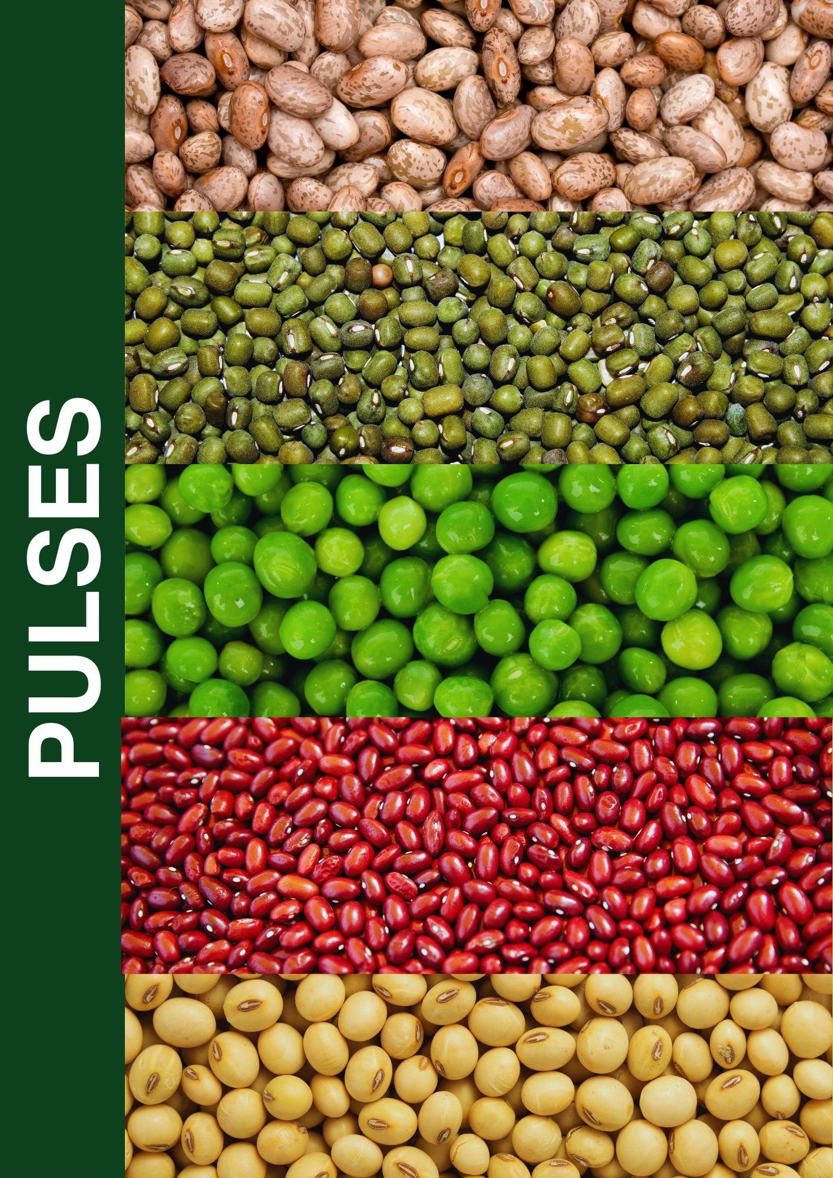

|  |
| --- |
|  |

# APPENDIX I: PROGRESS ON FOLLOW UP OF AUDITOR RECOMMENDATIONS

The following is the summary of issues raised by the external auditor and management comments that were provided to the auditor. We have nominated focal persons to resolve the various issues as shown below with the associated time frame within which we expect the issues to be resolved. This response is as stipulated in the Financial Reporting Template by Treasury

|  |  |  |  |  |  |
| --- | --- | --- | --- | --- | --- |
| **Audit Report Ref No.** | **Issue / Observations from Auditor** | **Management comments** | **Focal Point person to resolve the issue** | **Status: (Resolved / Not Resolved)** | **Expected Date of Resolution** |
| 1.1 | **Undisclosed Investment in Subsidiary**  The Company’s statement of financial position reflects investment in subsidiaries balance of Kshs.55,699,000 as disclosed in Note 18 to the financial statements. Review of records revealed that Kenya Seed Company Limited owns 100% shares in Kenya Seed Company Ltd - Rwanda which was incorporated on 19 April, 2011. Available information indicated that the share capital of the subsidiary amounts to Rwandan Francs (Rwf) 35,000,000 (5,000 shares of Rwf 7,000 each). However, the investment has not been disclosed in the financial statements of the Company. In the circumstances, the accuracy and completeness of the investment in subsidiaries balance of Kshs.55,699,000 could be confirmed. | Management has noted the observations has contracted a valuer to verify all the assets including the land. A surveyor has also been contracted to do the beaconing and correct the anomaly | Company Secretary | Not Resolved | To be confirmed |
| 1.2 | **Unconfirmed investment in subsidiaries**  The Company’s statement of financial position reflects investment in subsidiaries balance of Kshs.55,699,000 as disclosed in Note 18 to the financial statements. Review of records revealed that Kenya Seed Company Limited owns 100% shares in Kenya Seed Company Ltd - Rwanda which was incorporated on 19 April, 2011. Available information indicated that the share capital of the subsidiary amounts to Rwandan Francs (Rwf) 35,000,000 (5,000 shares of Rwf 7,000 each). However, the investment has not been disclosed in the financial statements of the Company. In the circumstances, the accuracy and completeness of the investment in subsidiaries balance of Kshs.55,699,000 could be confirmed. | Management has contracted a firm to conduct verification and revaluation process. All missing logbooks will be procured. | Company Secretary | Not Resolved | To be confirmed |
| 1.3 | **Amounts Due from Parastatals and Other Government Controlled**  **Organizations**  Analysis of the total balance indicated that the debts totalling Kshs.931,091,000 had been outstanding for over 30 days with some dating back to the year 1995 | These are from GOK-Ministry of Agriculture and Counties. Management has continued with the follow-ups process to have the debt paid | Head of Sales & Marketing | Not Resolved | To be confirmed |
| 2 | **Unreconciled Trade and Other Receivables Balance**  The consolidated statement of financial position reflects trade and other receivables amounting to Kshs.1,094,608,000 which include a balance of Kshs.623,959,000 owed to the Company, as disclosed in Note 25 to the financial statements. Review of trade and other receivables records revealed that there were balances amounting to Kshs.19,523,844 relating to variances from various branches of the Company that were reported as receivables. Management did not provide a reconciliation in support of the balances or an explanation as to why the variances remained outstanding as at 30 June, 2022.  In the circumstances, the accuracy and completeness of trade and other receivables balance of Kshs.623,959,000 could not be confirmed. | Management will expedite the disposal process | Quality Assurance Manager | Unresolved | To be confirmed |
| 3.1 | **Overstatement of Land Balance**  The balance of Kshs.4,606,774,000 includes land valued at Kshs.2,675,100,000. However, as previously reported, review of records and information from records held by the Ministry of Lands and Physical Planning revealed that there was an overstatement in the land acreage and valuation. In the circumstances, the accuracy of the land balance of Kshs.2,675,100,000 could not be confirmed. | For ex-staff, management is following up with the ex-staff to recover the amounts | Head of Finance | Unresolved | To be confirmed |
| 3.2 | **Lack of Ownership Documents for Land**  As previously reported, the land value of Kshs.2,675,100,000 includes two parcels of land valued at Kshs.281,500,000. However, title deeds for two parcels of land with an acreage of 365 acres and 192 acres respectively, in Endebess within Trans Nzoia County, were not provided for audit verification. In the circumstances, the accuracy, valuation and existence of the parcels of land valued at Kshs.281,500,000 could not be ascertained. | For ex-staff, management is following up with the ex-staff to recover the amounts | Head of Finance | Unresolved | To be confirmed |
| 3.3 | **Unconfirmed Work-in-Progress Balance**  Included in property, plant and equipment balance of Kshs.4,606,774,000 is an amount of Kshs.49,421,245 in respect of work – in - progress. However, included in the balance of of Kshs.49,421,245 are assets amounting to Kshs.24,131,245 comprising of furniture and equipment, computers and a motor vehicle bought by the Company for Kenya Seed Company Rwanda (a subsidiary). It is not clear why the assets in use by the subsidiary were included in the financial statements of the Company.  In the circumstances, the accuracy and valuation of the work-in-progress balance of Kshs.49,421,245 could not be confirmed. | Management has commenced the process of regularizing the staff terms and conditions through the SRC | Head of Human Resources | Unresolved | To be confirmed |
| 3.4 | Lack of Ownership Documents for Motor Vehicles  As previously reported, the logbooks for two (2) motor vehicles with registration numbers KBL 167G and KAN 369V were not provided for audit verification. Review of records revealed that Management had applied for the replacement of the logbooks from National Transport and Safety Authority on 25 June, 2020. However, as at 30 June, 2022 the logbooks were yet to be received by the Company. In the circumstances, ownership and valuation of the motor vehicles could not be confirmed. | Management as initiated the process of surrendering the unclaimed dividends to UFAA | Head of Finance | Unresolved | To be confirmed |

***NB: Guidance Notes:***

1. Use the same reference numbers as contained in the external audit report;
2. Obtain the “Issue/Observation” and “management comments”, required above, from final external audit report that is signed by Management;
3. Before approving the report, discuss the timeframe with the appointed Focal Point persons within your entity responsible for implementation of each issue;
4. Indicate the status of “Resolved” or “Not Resolved” by the date of submitting this report to National Treasury.





**Mr. Sammy Chepsiror Mr. Mohammed Bulle**

**Managing Director Chairman of the Board**

**30.06.2023 30.06. 202****3**



  
  
  

